# **What is Self Attention | Transformers Part 2**

### **Notes on Self-Attention**

* **Introduction:** **Self-Attention** is a mechanism that is crucial for understanding **Transformers**. If you understand Self-Attention well, you can understand Transformers well. Having control over Transformers is helpful for mastering current technologies like **LLMs** (Large Language Models) and **Generative AI**. This mechanism will be explained in detail across three videos. The first video aims to explain what Self-Attention is.
* **The Fundamental Problem in NLP:** Any **NLP application** (like sentiment analysis, named entity recognition, machine translation) requires converting words into numbers because computers do not understand words. The most important initial step for building any NLP application is efficiently representing words as numbers, also known as **vectorisation**.

* **Early Approaches to Vectorisation:**
  + **One Hot Encoding:** An original, basic technique. You identify all unique words in your vocabulary. Each unique word is represented by a vector with a '1' at the position corresponding to that word in the vocabulary list and '0' elsewhere. For example, in a vocabulary of ['Matt', 'Cat', 'Rat'], 'Matt' might be 100, 'Cat' 010, and 'Rat' 001. Sentences are represented by concatenating these vectors. This method is considered somewhat inefficient.

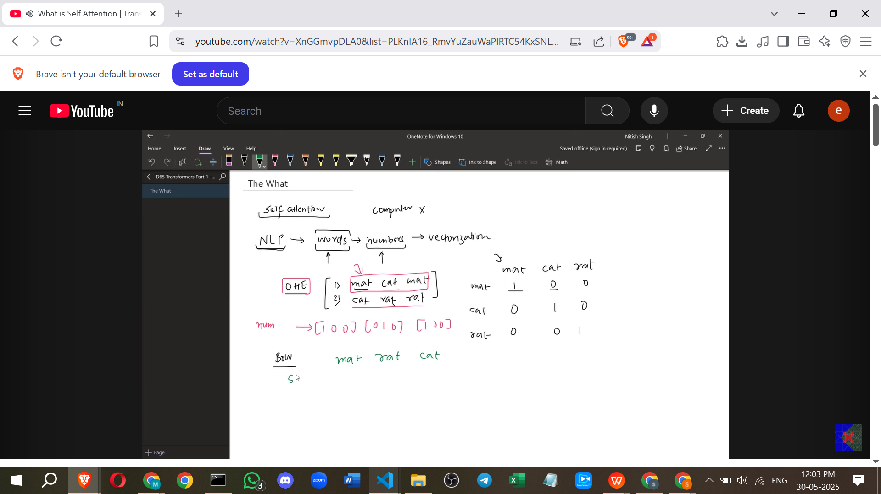

* + **Bag of Words:** A slight improvement over One Hot Encoding. It considers how many times a word appears in a sentence, not just whether it is present. Using the same vocabulary ['Matt', 'Rat', 'Cat'], the sentence "Matt Cat Matt" would be represented by counting occurrences: Matt (2), Rat (0), Cat (1) ->.

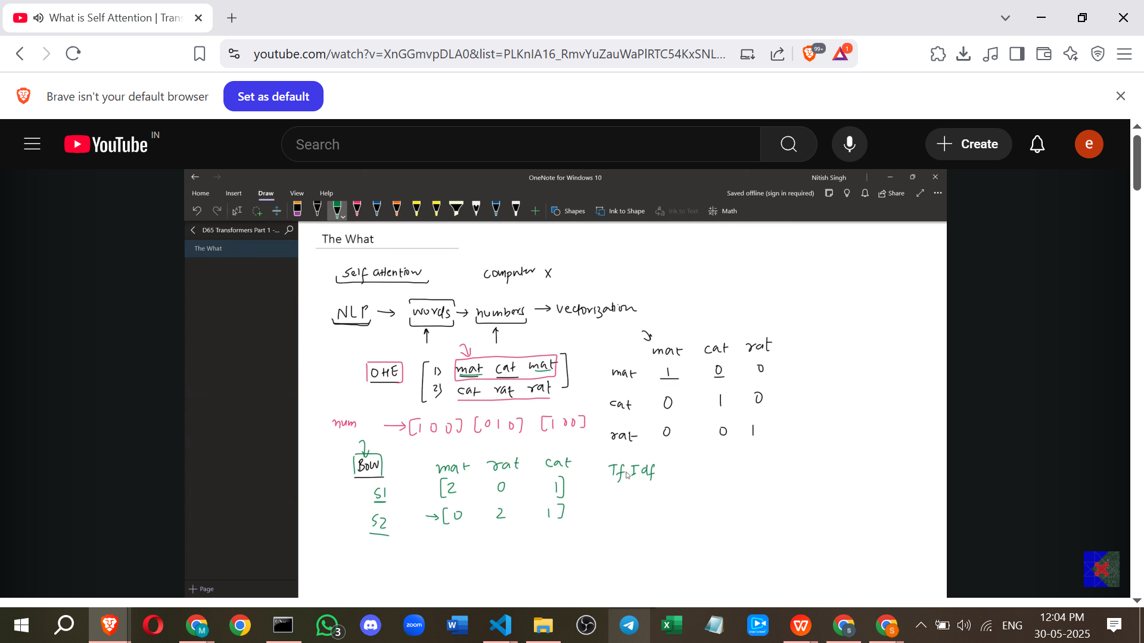

* + **TF-IDF:** Another technique that further improved upon previous methods.
* **Advanced Vectorisation: Word Embeddings:**
  + A significantly more advanced technique than the earlier ones.
  + Word Embeddings can convert words into numbers in a much better way.
  + Their key capability is capturing **semantic meaning**.
  + **How Word Embeddings are Created:** You take a large training dataset (e.g., Wikipedia articles). This data is sent through a **neural network**. The neural network learns how each word is used in different contexts. It then represents each word as an **N-dimensional vector**. The dimension 'N' can vary (e.g., 256, 512, 64).
  + **Capturing Semantic Similarity:** Because Word Embeddings capture semantic meaning, words that are very similar will have very similar vectors. Geometrically, in the N-dimensional space, their vectors will be close to each other. For example, the vectors for "King" and "Queen" would be similar, while the vector for "Cricketer" would be quite different.

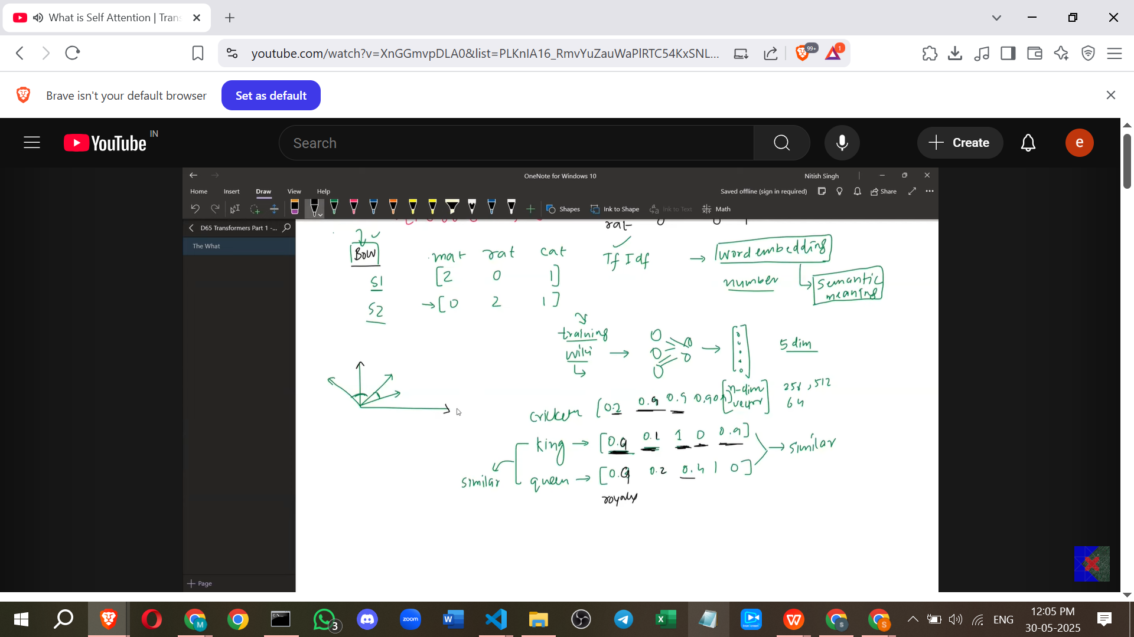

* + Each dimension in the vector might represent a specific aspect learned from the data, although we don't explicitly know what these aspects are. For instance, one dimension could represent "royalty" (high for King/Queen, low for Cricketer), another "athleticism" (high for Cricketer, low for King/Queen), and another "human" (high for all three in this example). Similarity between words is judged by the similarity across all these dimensions.
* **The Problem with Word Embeddings:**
  + Although powerful, Word Embeddings have a limitation.
  + They do not capture the *specific* meaning of a word in a given sentence; instead, they capture the **average meaning** of that word across the entire training dataset.
  + **Word Embeddings are Static:** Once a word embedding is trained and created for a word (like "Apple"), that *same* embedding is used everywhere, regardless of the context in which the word appears.
  + **Example (The "Apple" Problem):**

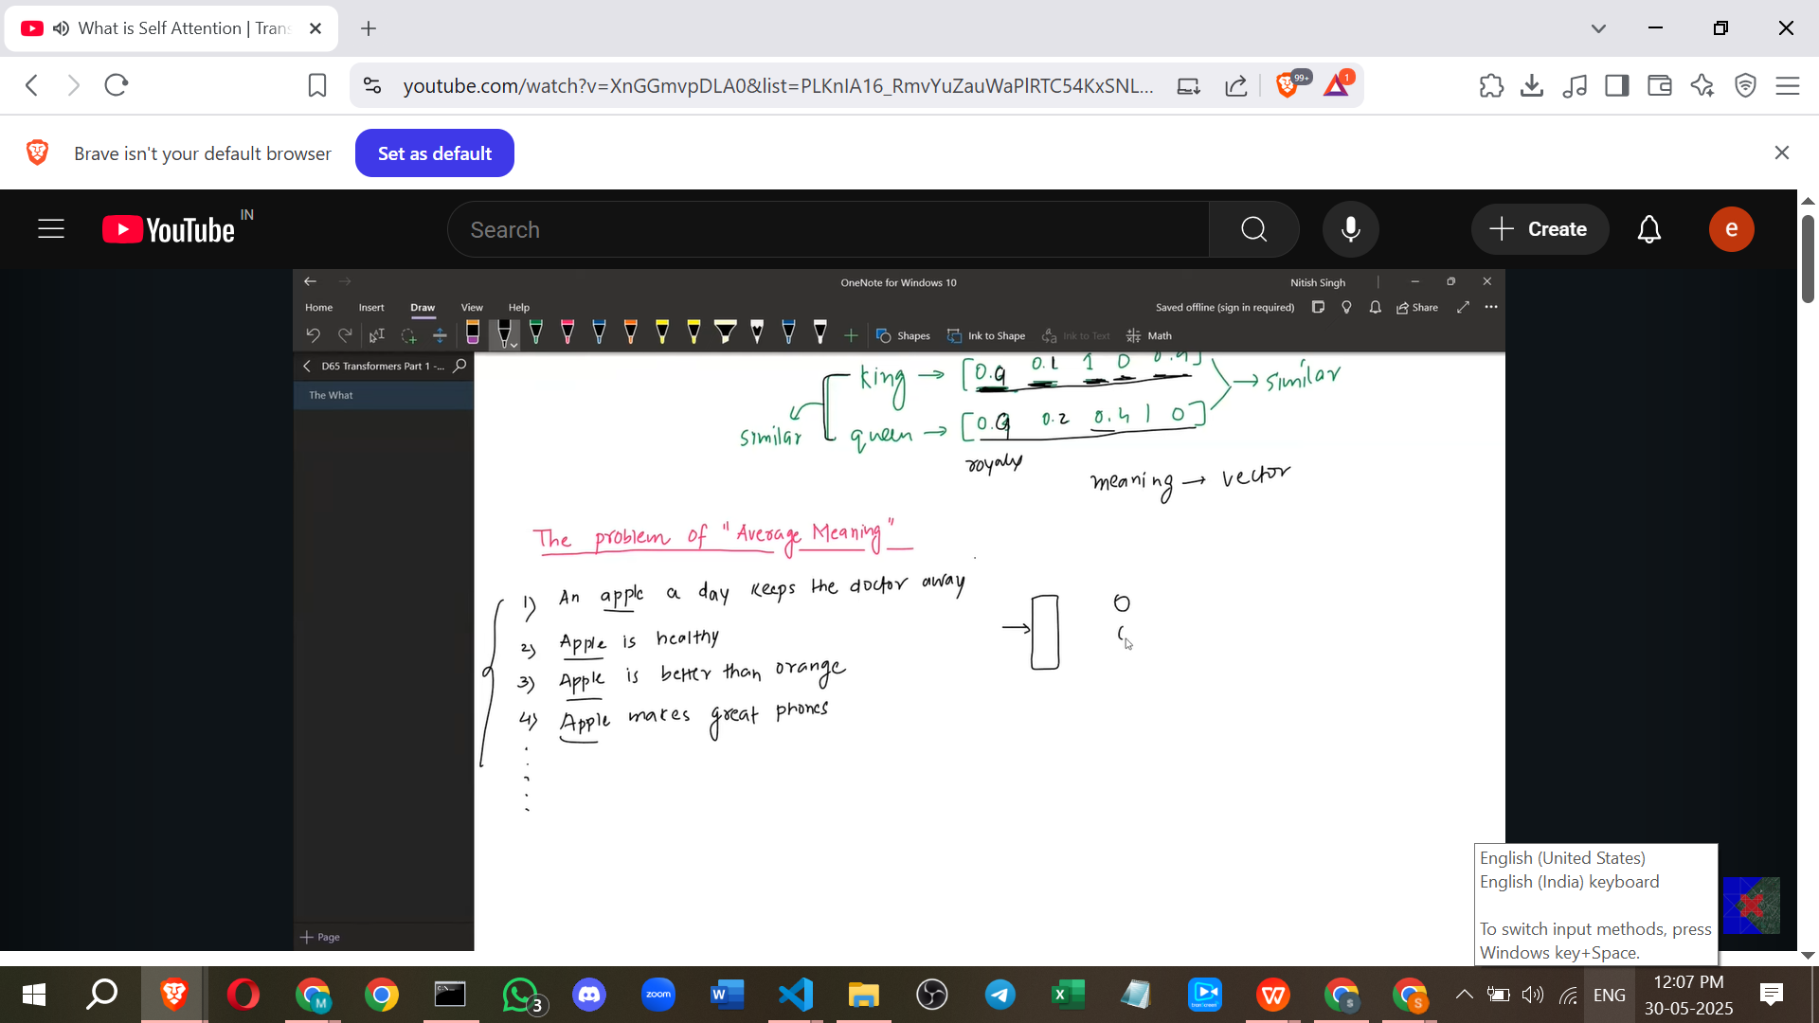

* + - Imagine training a word embedding model on data where the word "Apple" appears frequently.
    - Suppose the data contains sentences where "Apple" is used as a fruit (e.g., "An apple a day...", "Apple is healthy", "Apple is better than Orange") and sentences where "Apple" is used as a technology company (e.g., "Apple makes great phones", "Apple launched a new phone").
    - If 9000 out of 10000 sentences use "Apple" as a fruit and 1000 use it as a company, the resulting static embedding for "Apple" will reflect the *average* meaning, heavily weighted towards the fruit context. It might have a high value for a "taste" dimension and a low value for a "technology" dimension.
    - Now, consider the sentence: "Apple launched a new phone while I was eating an orange".

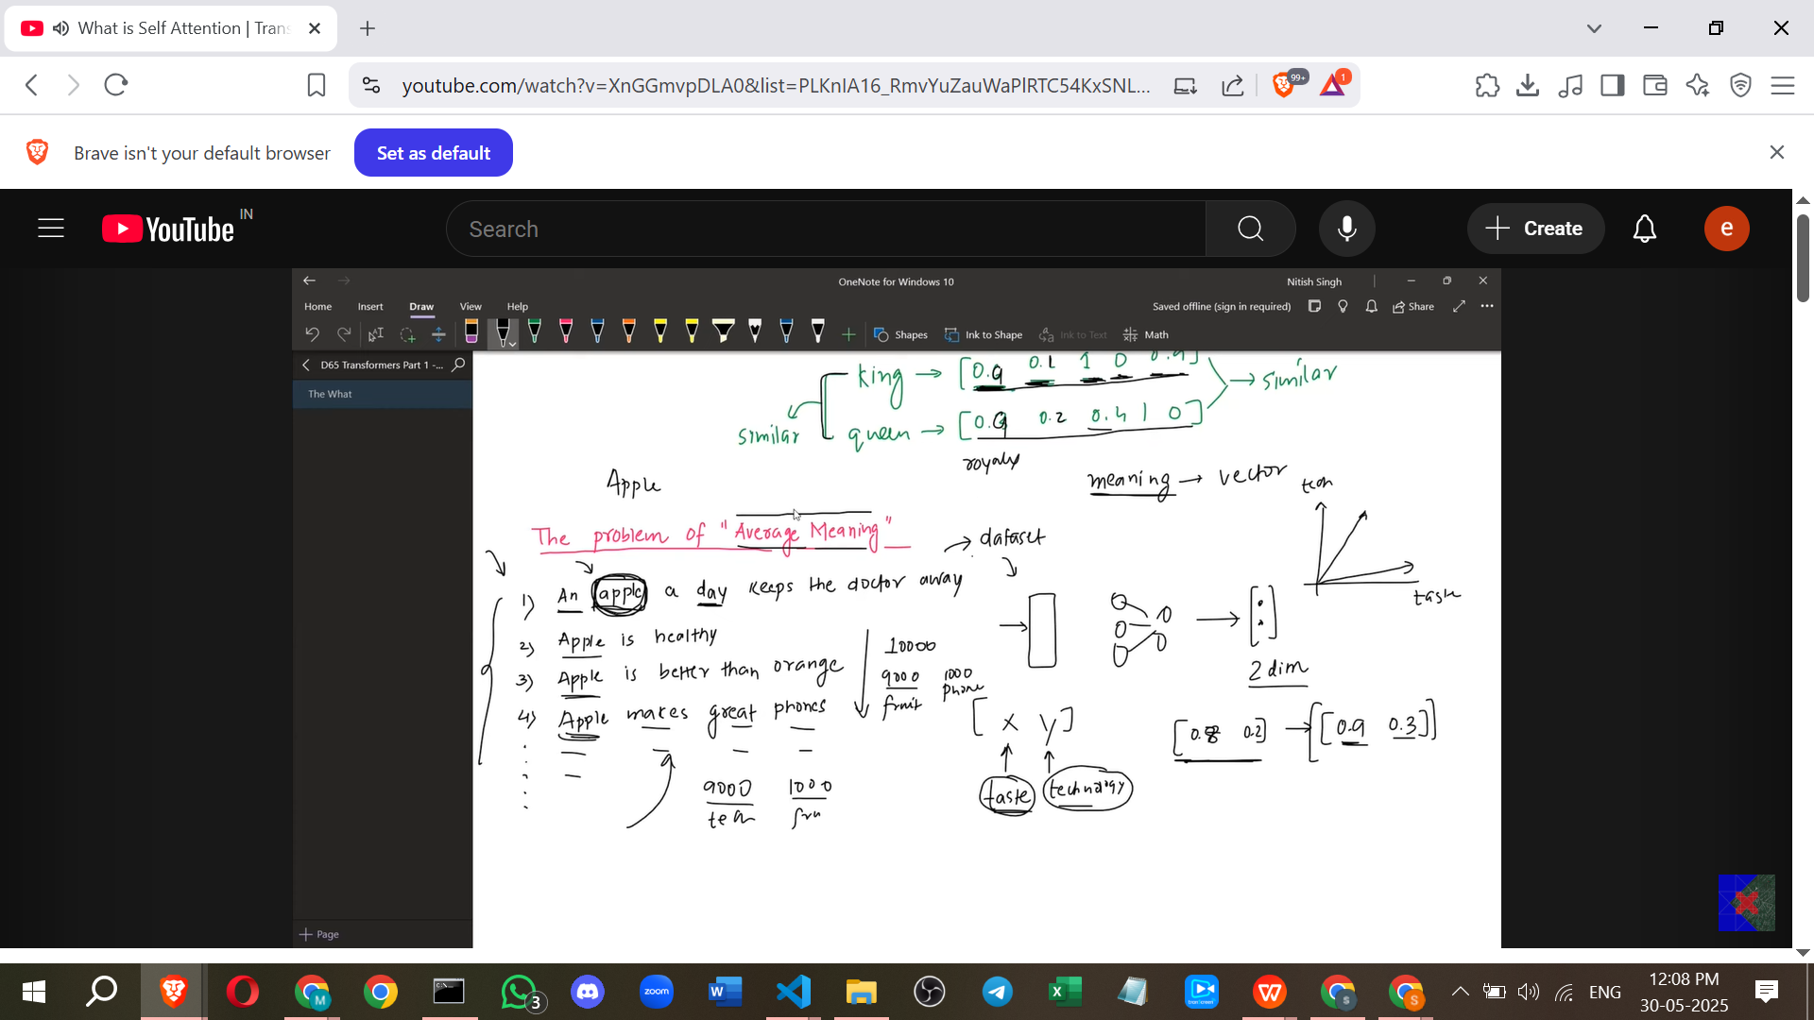

* + - When translating this sentence, the static embedding for "Apple" would be used. This embedding, biased towards the fruit meaning, incorrectly suggests that the word "Apple" here refers to the fruit, even though the context ("launched", "phone") clearly indicates it's the company.
    - Ideally, the embedding should be **contextual** – its values should change dynamically based on how the word is used in the specific sentence. It should recognise "Apple" as a company here and adjust its representation accordingly, without being confused by the presence of "orange" (which is a fruit) in the same sentence.

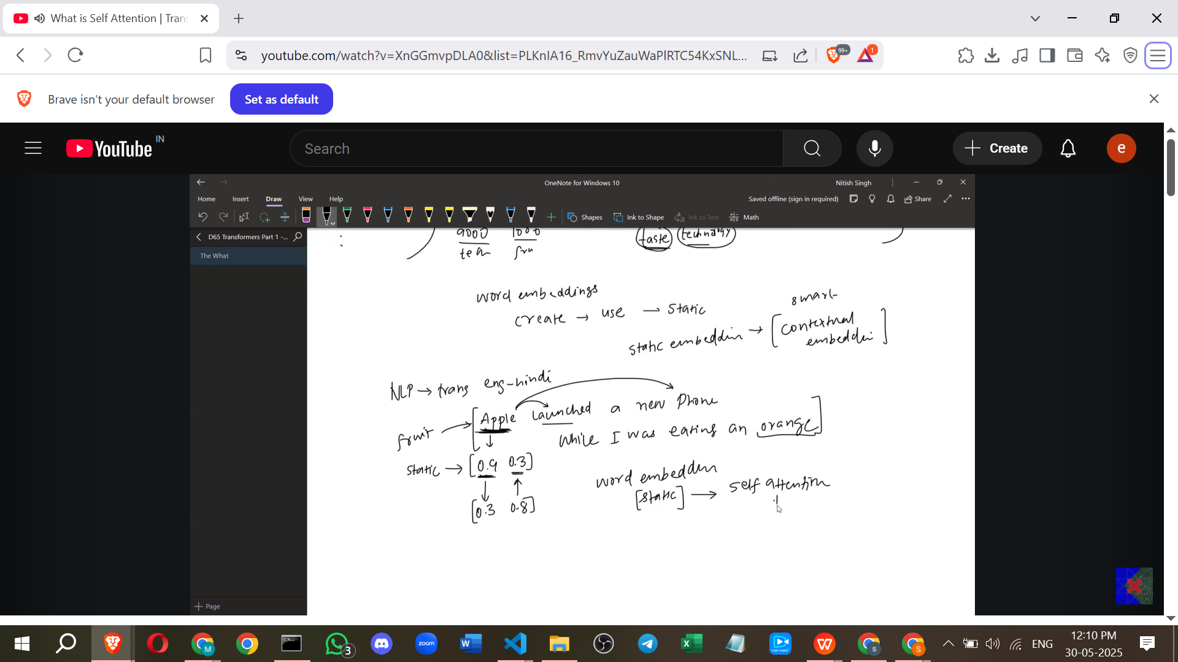

* **Self-Attention as the Solution:**

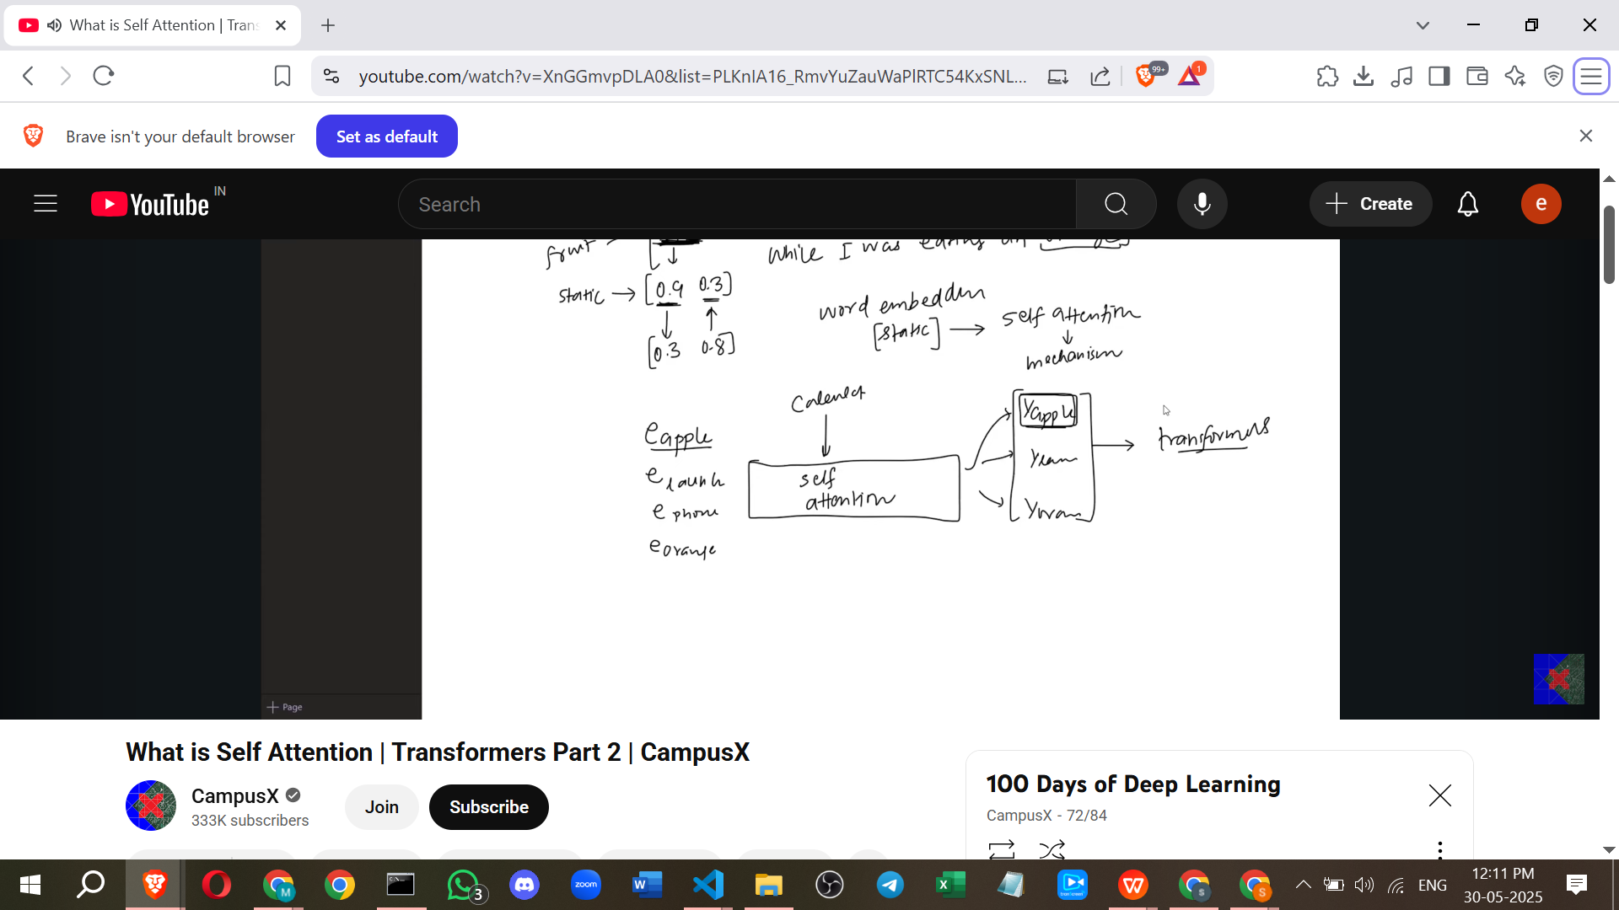

* + **Self-Attention** is introduced to solve the problem of static embeddings.
  + It is a mechanism that takes static word embeddings as input and generates **smart contextual embeddings** as output.
  + You can think of Self-Attention as a function. You send the static embeddings of all words in a sentence into this function (e.g., the embeddings for "Apple", "launched", "phone", "orange" from the example sentence).
  + Inside the Self-Attention mechanism, calculations occur.
  + The output is new embeddings for each word. These output embeddings are **dynamic** and capture the specific meaning of each word *within the context of that particular sentence*. For the sentence "Apple launched a new phone...", the output embedding for "Apple" would correctly reflect its use as a technology company.
  + These better contextual embeddings are then used in architectures like **Transformers**.
* **Next Steps:** The upcoming videos in the series will delve into *how* Self-Attention works, explaining the calculations involved and concepts like Query, Key, and Value vectors.

### **Notes from my side**

* The ability of **Self-Attention** to create **contextual embeddings** is a significant advancement over previous methods like static **Word Embeddings**. Static embeddings could only represent the general meaning of a word, leading to ambiguity in sentences where words have multiple meanings (like "bank" or "apple").
* By considering the other words in the sentence, Self-Attention allows the representation of a word to be dynamically adjusted to reflect its specific role and meaning *in that exact context*. This is crucial for accurately understanding nuances in language, handling polysemy (words with multiple meanings), and improving performance on various NLP tasks.
* The **Transformers** architecture leverages these contextual embeddings generated by Self-Attention to achieve state-of-the-art results in tasks like translation, text generation, and question answering. This explains why understanding Self-Attention is key to understanding modern large language models.

==============================================================

# 

# **Class 2. Self Attention in Transformers | Deep Learning | Simple Explanation with Code!**

Okay, here are notes on Self-Attention in Transformers, based on the source provided, including examples and some additional points for clarity.

### **Notes on Self-Attention in Transformers**

**I. Introduction: Importance of Self-Attention**

* **Generative AI** is a technology that has significantly penetrated the market recently.
* At the centre of Generative AI technology is the **Transformer architecture**.
* At the centre of the Transformer architecture is **Self-Attention**.
* Understanding Self-Attention is critical for learning Generative AI.

**II. The Problem: Static vs. Contextual Embeddings**

* To build any **Natural Language Processing (NLP)** application, it is crucial for machines to understand how to represent words as numbers.
* Techniques like One-Hot Encoding and Bag-of-Words exist, but **Word Embeddings** are particularly useful as they convert the semantic meaning of words into numbers.
* However, a major problem with standard Word Embeddings is that they are **static**. This means once they are trained, the same embedding is used repeatedly for a word regardless of its context.
  + **Example:** In the sentences "Money **bank** grows" and "River **bank** flows," the word "**bank**" is used in different contexts (financial institution vs. river edge). Despite the different meanings, a static word embedding for "bank" would be exactly the same in both cases.

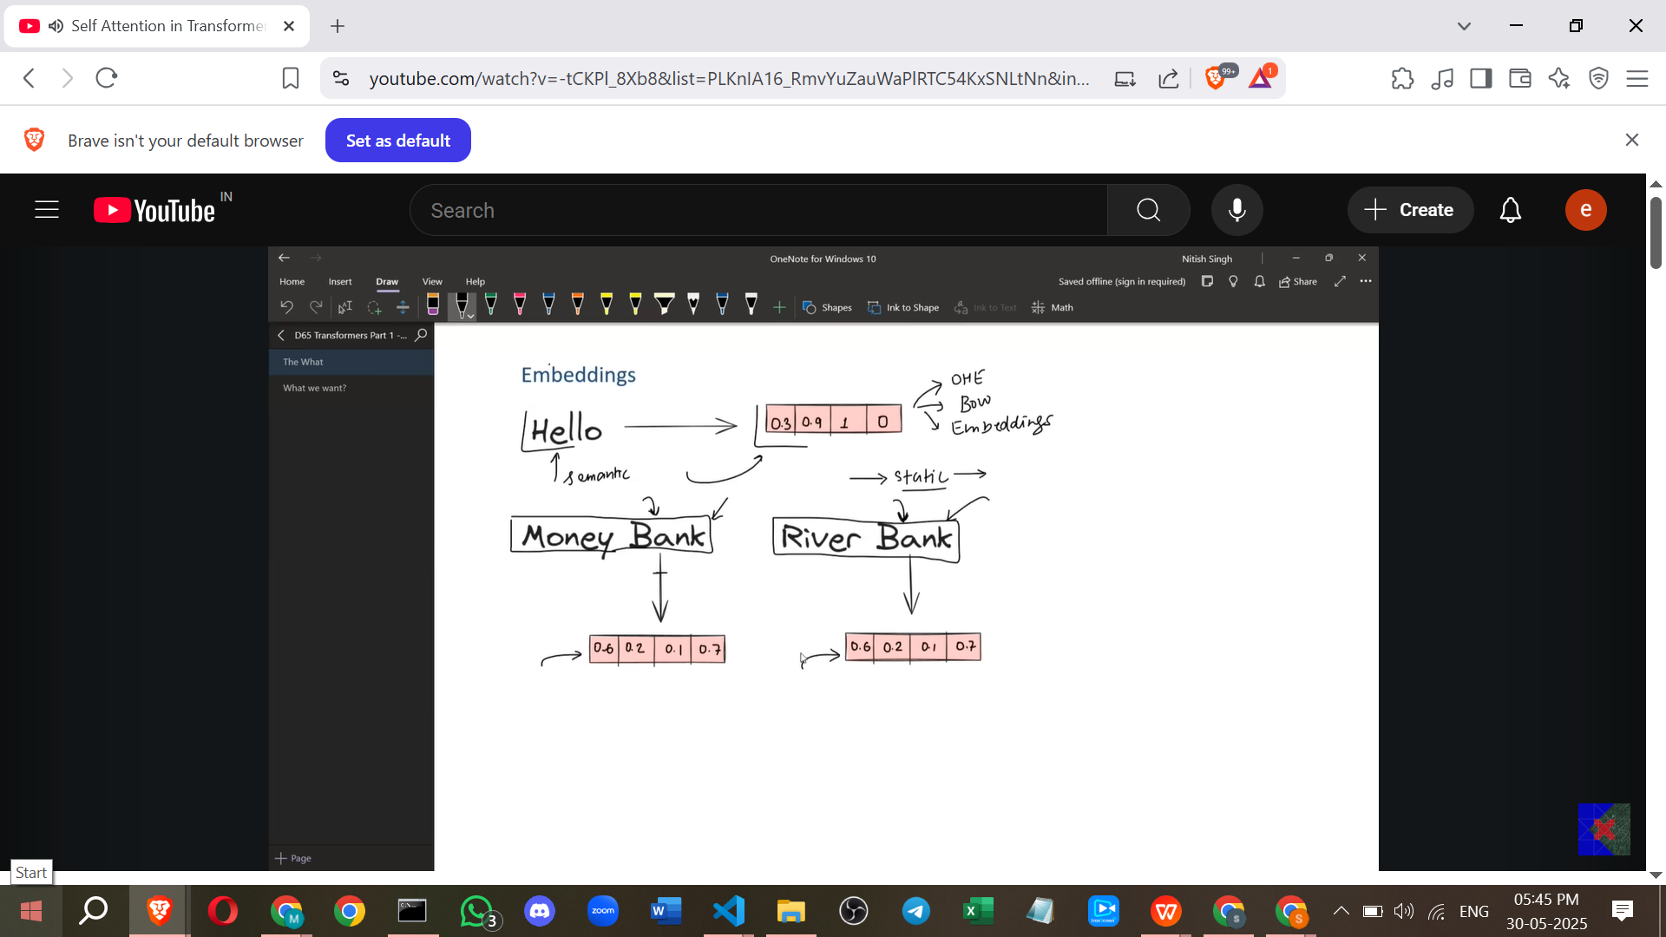

* This static representation is not a good starting point for NLP tasks that rely on understanding the meaning of words in context.
* To solve this, **contextual embeddings** are needed.
* Contextual embeddings should be **dynamic**, changing based on the context in which a word is used in a sentence.
  + **Example:** The embedding for "bank" in "Money bank" should be different from the embedding for "bank" in "River bank".
* **Self-Attention** is a mechanism that helps convert static word embeddings into dynamic contextual embeddings.

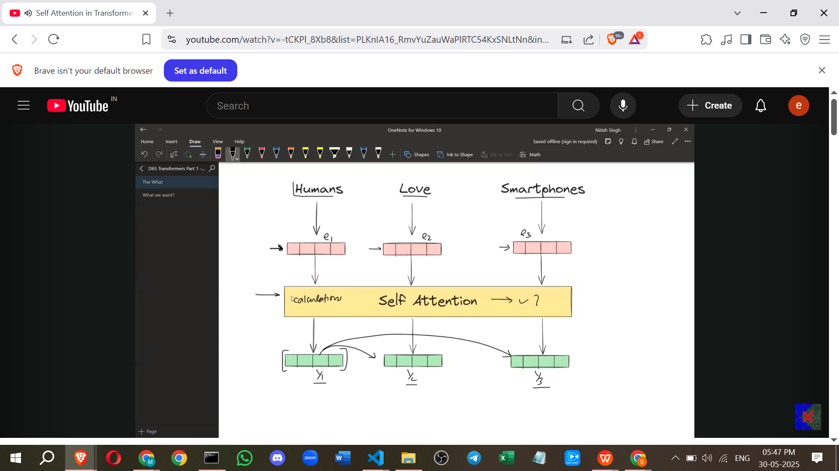

**III. Initial Self-Attention Approach (First Principles)**

* The goal is to understand how Self-Attention converts static embeddings into dynamic, contextual ones.
* **Concept:** One way to get a contextual meaning for a word is to represent it as a combination (specifically, a weighted sum) of the meanings of all the words in the sentence.  
  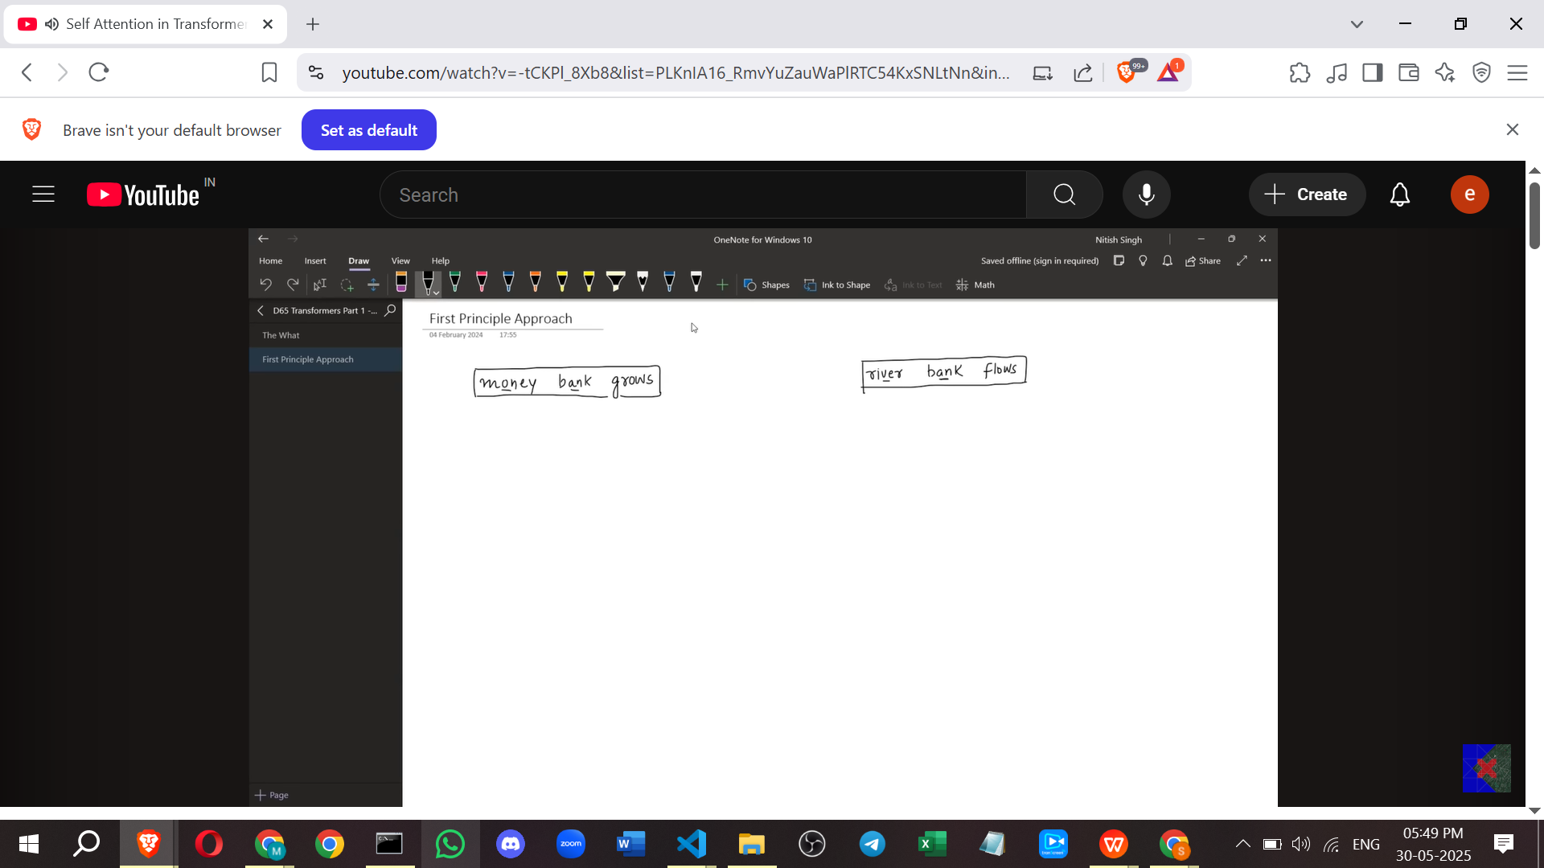
  + **Example:** For the sentence "Money bank grows," the word "**bank**" could be represented as a weighted sum of the meanings of "Money," "bank," and "grows". The weights would reflect how much each other word contributes to the meaning of "bank" in this specific sentence.

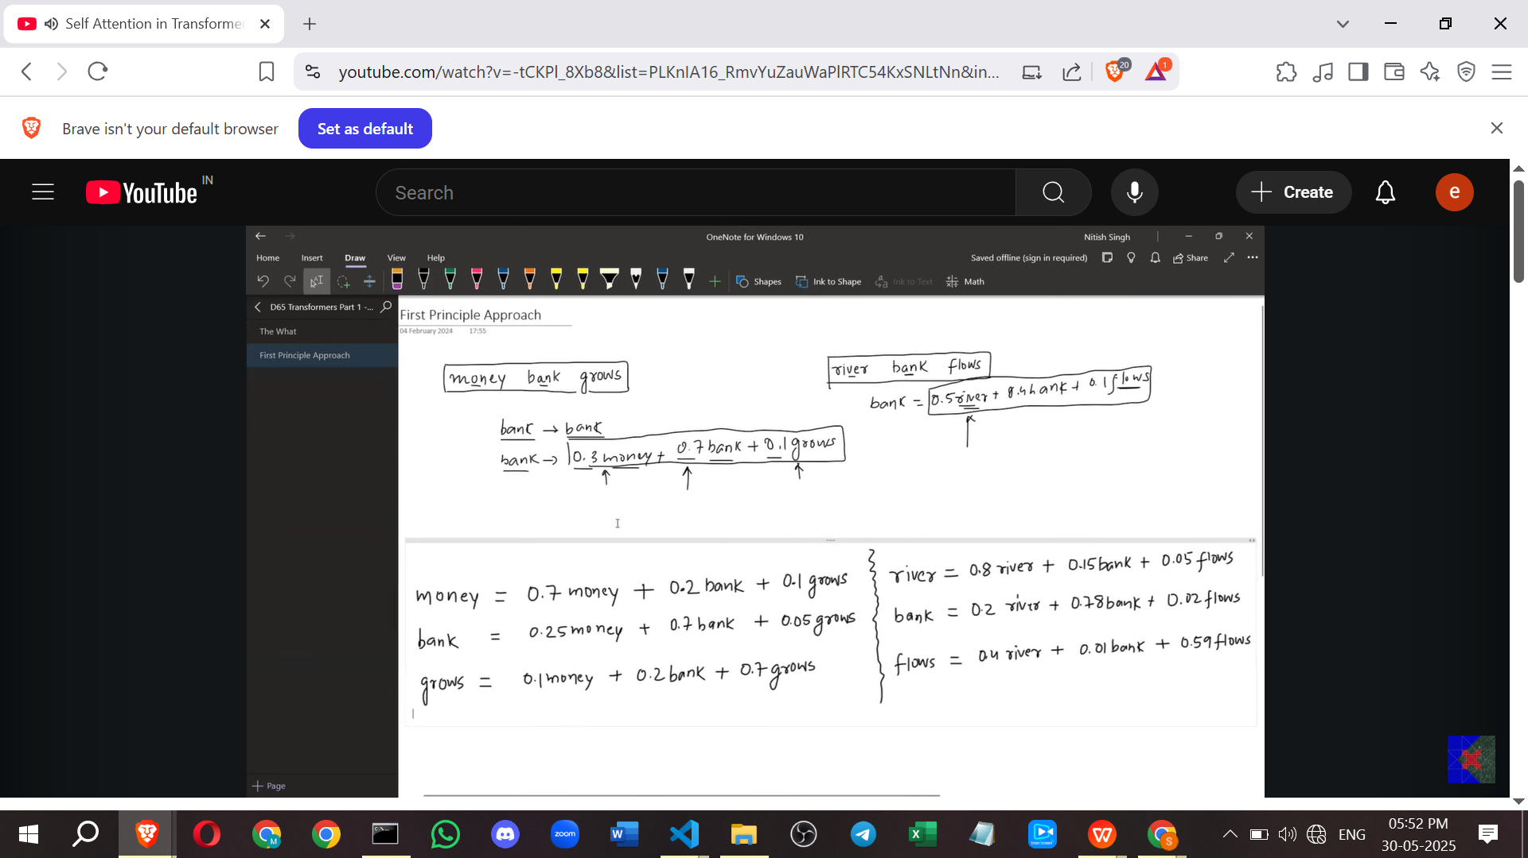

* Using word embeddings, this means the new, contextual embedding of "bank" would be a weighted sum of the static embeddings of "Money," "bank," and "grows". These embeddings are N-dimensional vectors, and their weighted sum is also an N-dimensional vector.

* **Calculation:**
  + How are the weights determined? The weights represent the **similarity** between the word whose embedding is being calculated and the other words in the sentence.
  + Similarity between two word embedding vectors can be calculated using the **dot product**. A higher dot product suggests greater similarity.

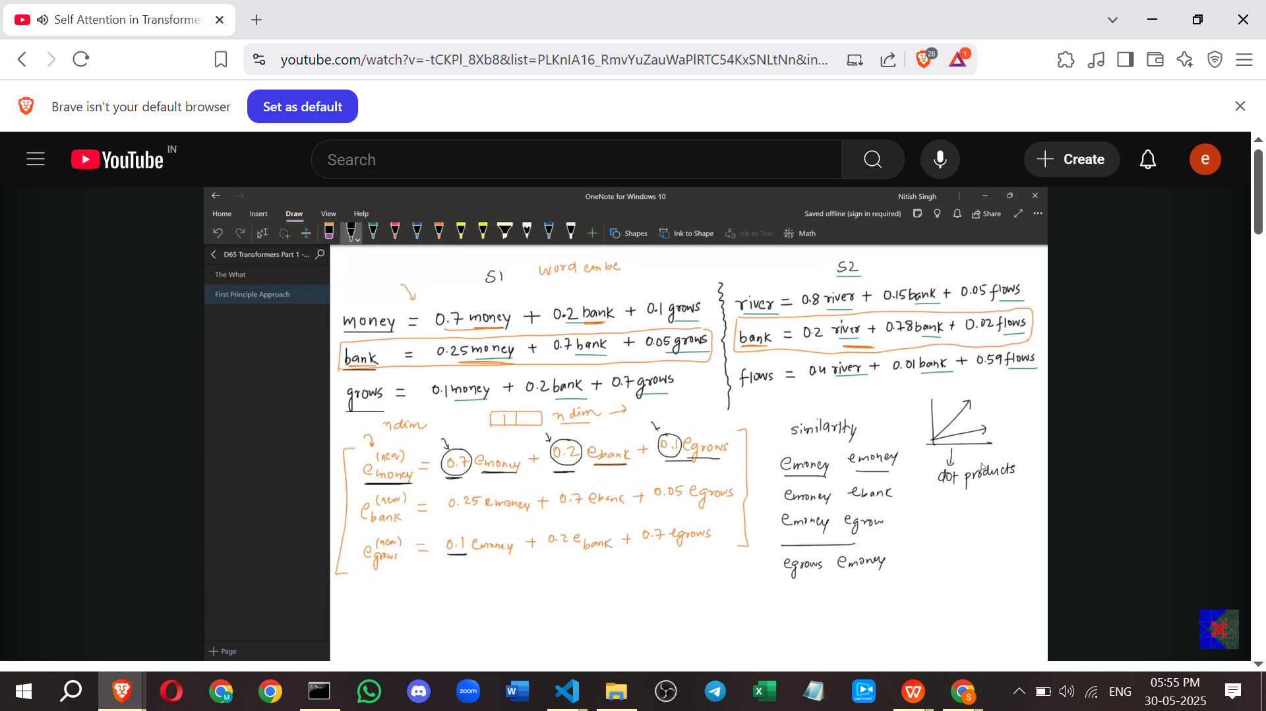

* + - *Point from my side:* The dot product is a measure that indicates how much two vectors point in the same direction. For normalized vectors, it corresponds to the cosine of the angle between them (Cosine Similarity). For non-normalized vectors, it also incorporates magnitude, but still captures directional similarity, making it a suitable measure for conceptual similarity between word embeddings. (This explanation is not directly from the source but clarifies the concept of dot product as similarity).

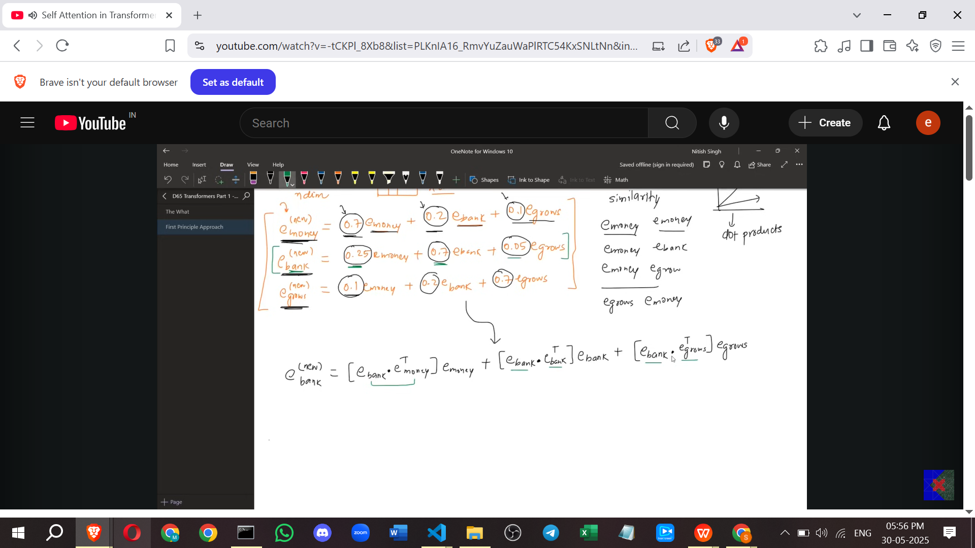

* + So, for a word like "bank," the weights would be the dot products of the static embedding of "bank" with the static embeddings of "Money," "bank" (itself), and "grows".
  + The resulting dot products (similarity scores) for a given word need to be **normalized** so that they sum up to 1. This is useful for interpretation, as it can represent the "probability" or degree to which the word is composed of other words' meanings.
  + The **softmax function** is used to normalize these similarity scores. It converts a vector of arbitrary real numbers into a probability distribution, where each element is between 0 and 1, and all elements sum to 1.
* **Generating New Embeddings:** The normalized similarity scores (weights) from the softmax function are then used to perform a **weighted sum** of the original static embeddings.  
  + **Example:** The new contextual embedding for "bank" (y₂) is calculated as: (Softmax weight for bank-money similarity) * (embedding of Money) + (Softmax weight for bank-bank similarity) * (embedding of Bank) + (Softmax weight for bank-grows similarity) * (embedding of Grows).

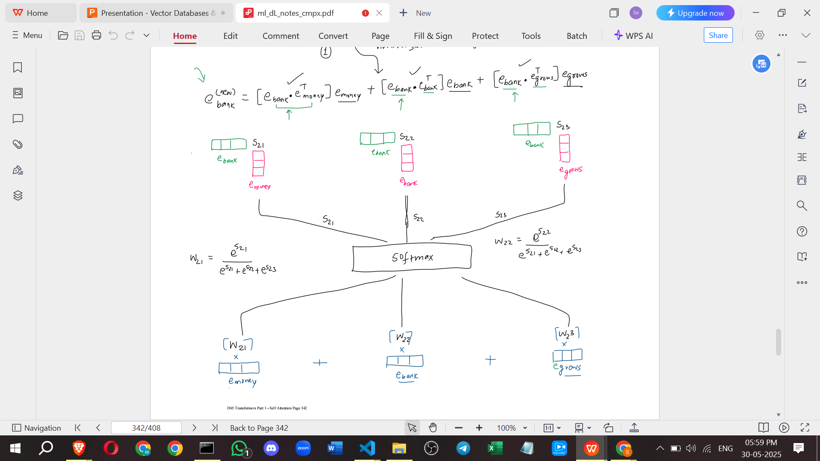

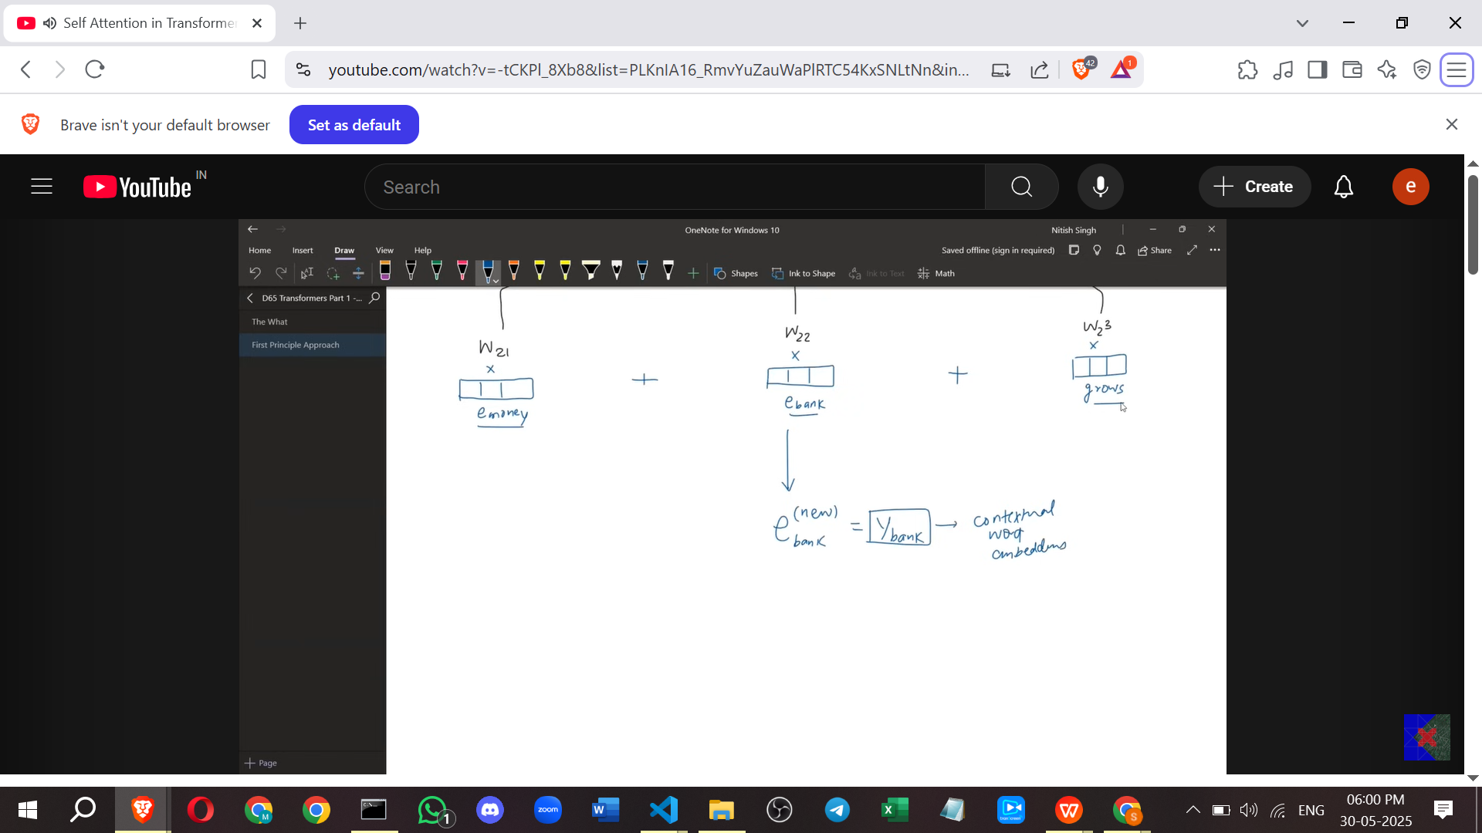

* This process is repeated for every word in the sentence to get a new, contextual embedding for each word.

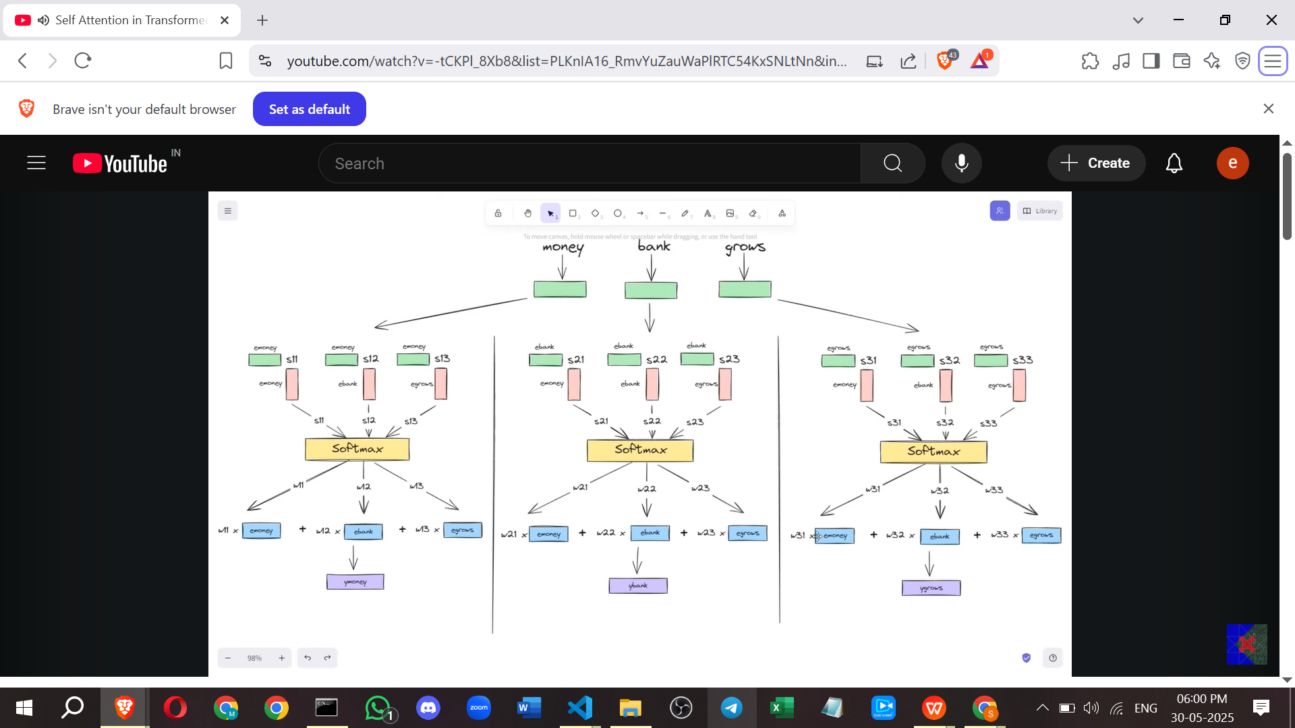

* **Parallel Computation:** This entire process can be performed simultaneously for all words in the sentence. There is no dependency between the calculation of a new embedding for one word and the calculation for another.  
  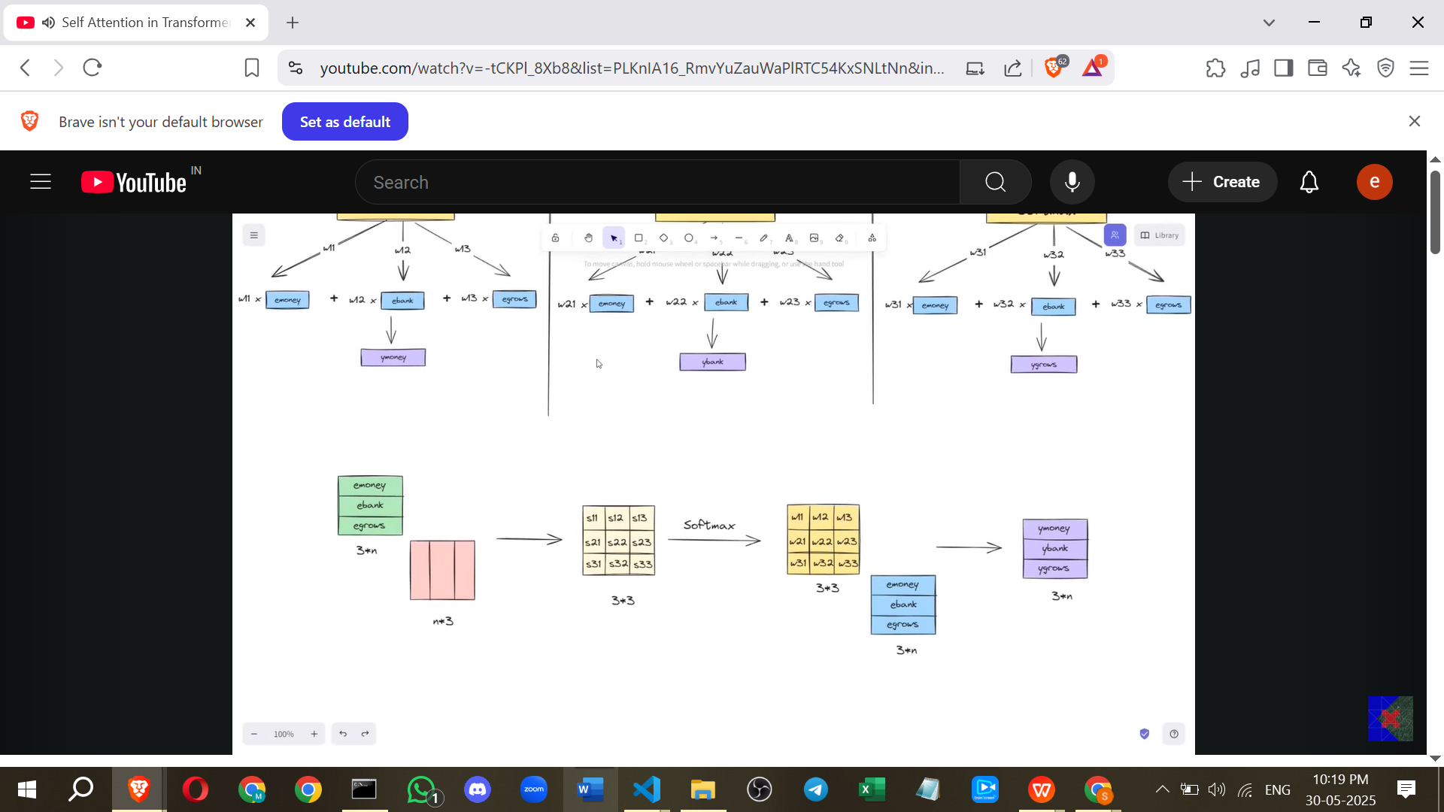
  + This parallelisation can be achieved efficiently using **linear algebra** and **matrix operations**.
  + Static word embeddings for all words in a sentence can be put into a single matrix. The dot product calculations, softmax, and the final weighted sum can all be expressed as matrix multiplications and operations.
  + This parallel nature is a major advantage, allowing for very fast computation, especially on hardware like **GPUs**.
* **Analysis of the Initial Approach:**

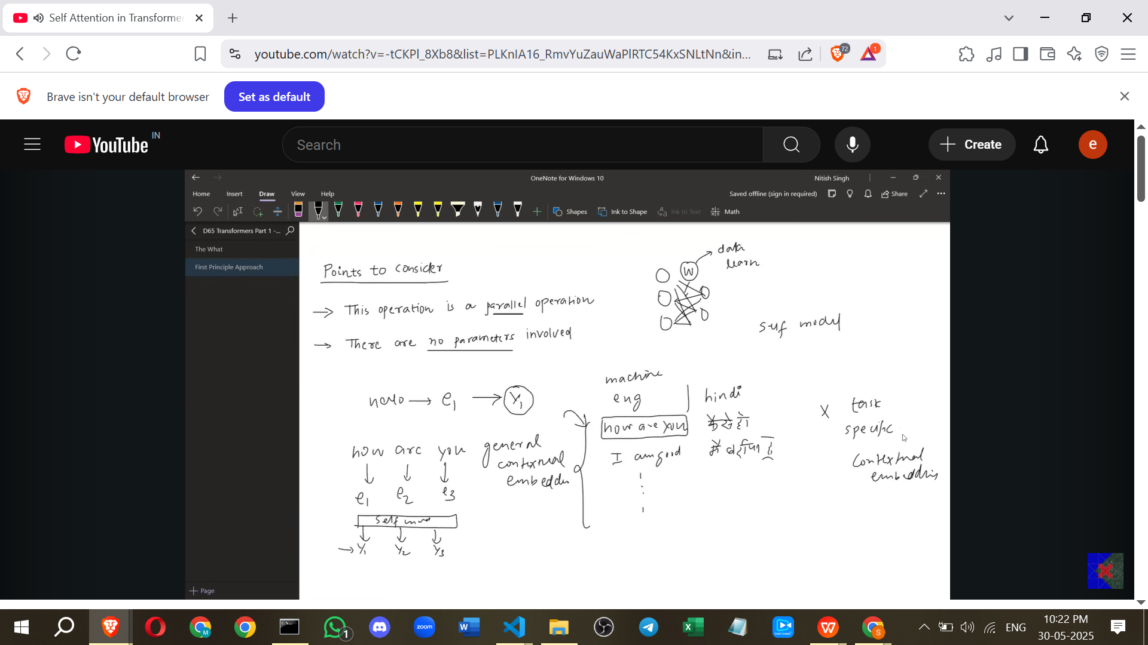

* + **Advantage:** **Speed** due to parallel computation.
  + **Disadvantage 1:** Loss of **sequence information**. While the calculation for all words can be done in parallel, the process itself doesn't inherently know the original order of the words in the sentence. Sequence information is important in textual data. (Note: Transformers address this separately, typically with positional encodings, but this specific Self-Attention calculation as described here loses it).
  + **Disadvantage 2:** Lack of **learning parameters**. The calculations (dot product, softmax, weighted sum) are fixed operations; there are no weights or biases that can be adjusted during training.
  + This means the contextual embeddings generated are **general**, based only on the current sentence's words and their inherent similarity. They are not influenced by the specific NLP task being performed or the training data.

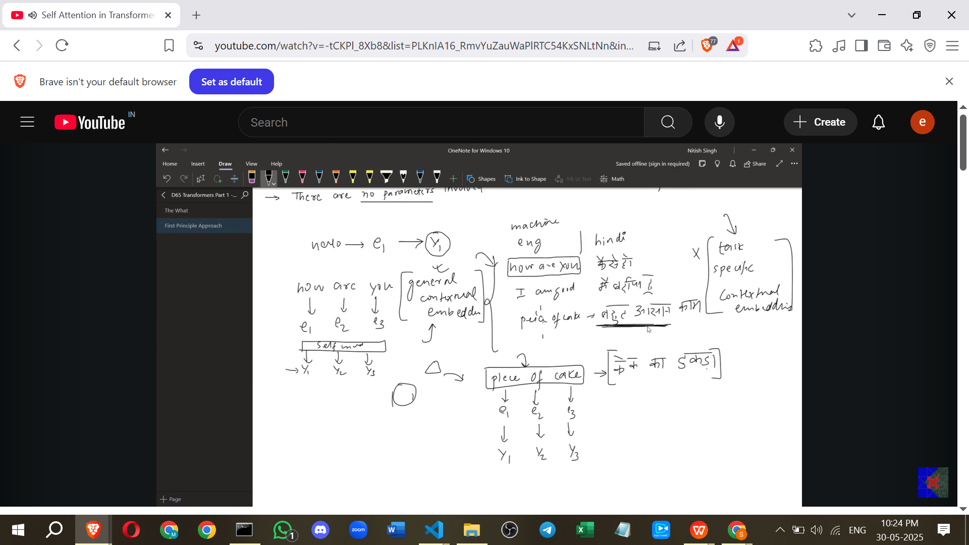

* + - **Example:** In machine translation, "piece of cake" can mean "a small slice of cake" or "a very easy task". A general contextual embedding might only capture the literal meaning ("केक का टुकड़ा"), failing to learn the idiomatic meaning ("बहुत आसान काम") that might be present in the training data. Similarly, "break a leg" might be translated literally ("टांग तोड़ दो") instead of idiomatically ("शुभकामनाएं").

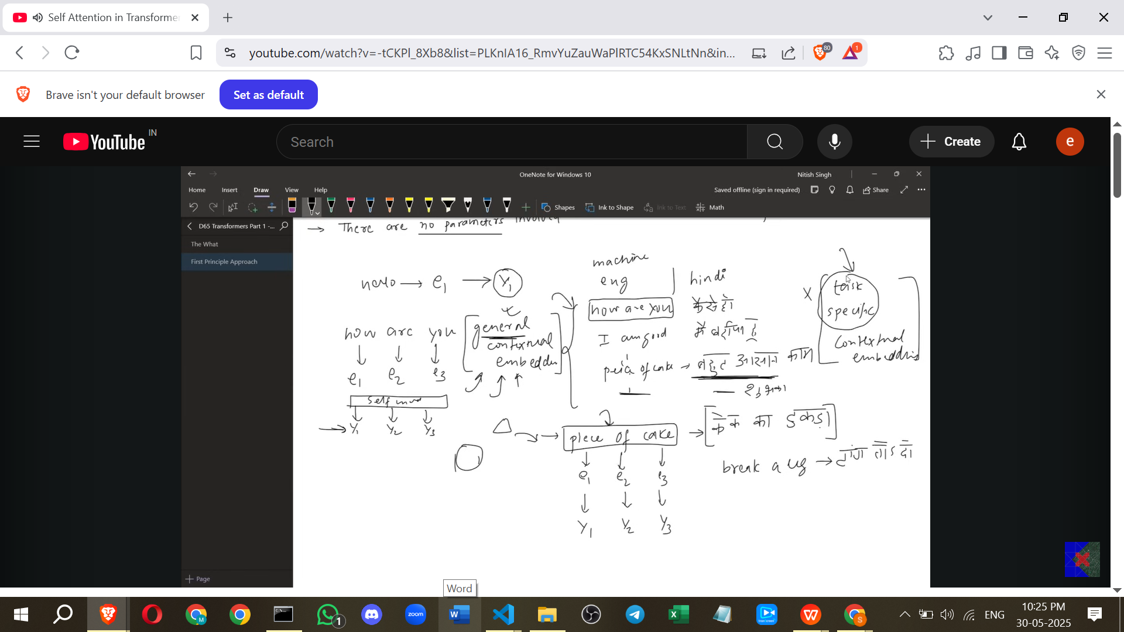

* What is needed are **task-specific contextual embeddings**, where the embeddings are generated based on the context *and* learned from the data related to the specific task (e.g., machine translation data).

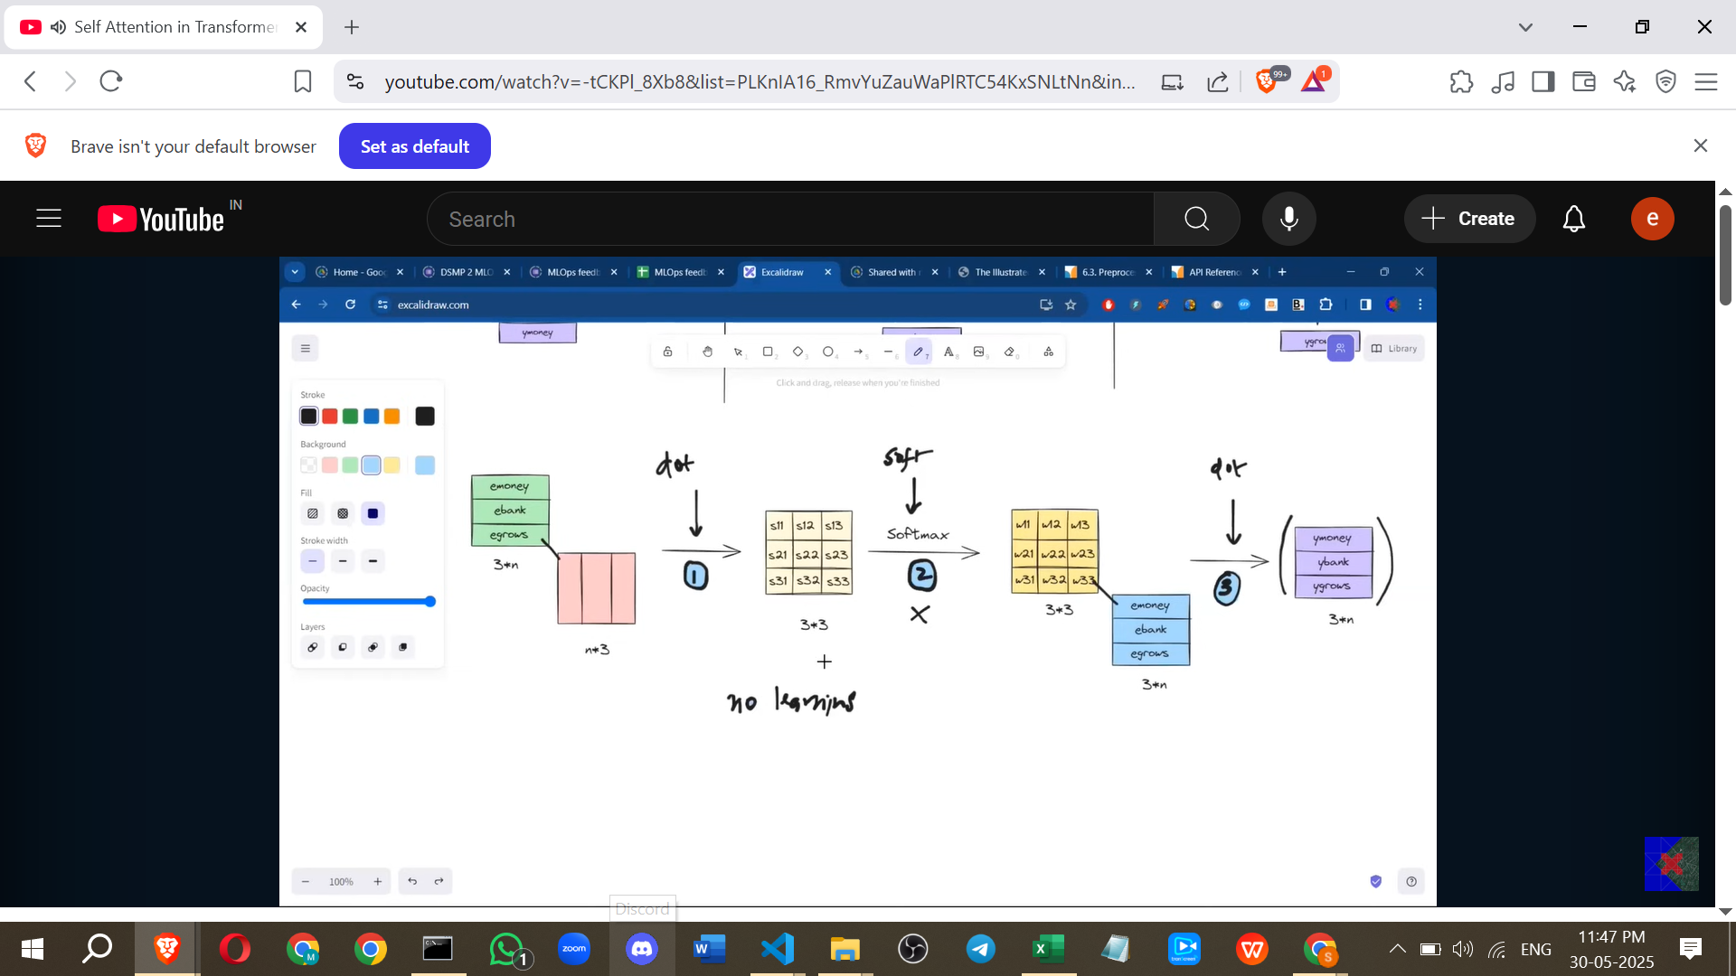

**IV. Need for Task-Specific Embeddings & Learning**

* To get task-specific contextual embeddings, the Self-Attention process must incorporate **learnable parameters** (weights and biases). These parameters can be adjusted during training based on the task's data to improve the quality of the contextual embeddings for that specific task.
* The learnable parameters must be introduced into the mathematical operations. The softmax operation itself doesn't allow for weights, leaving the dot product steps as potential places to introduce them.

**V. The Refined Self-Attention (Query, Key, Value)**

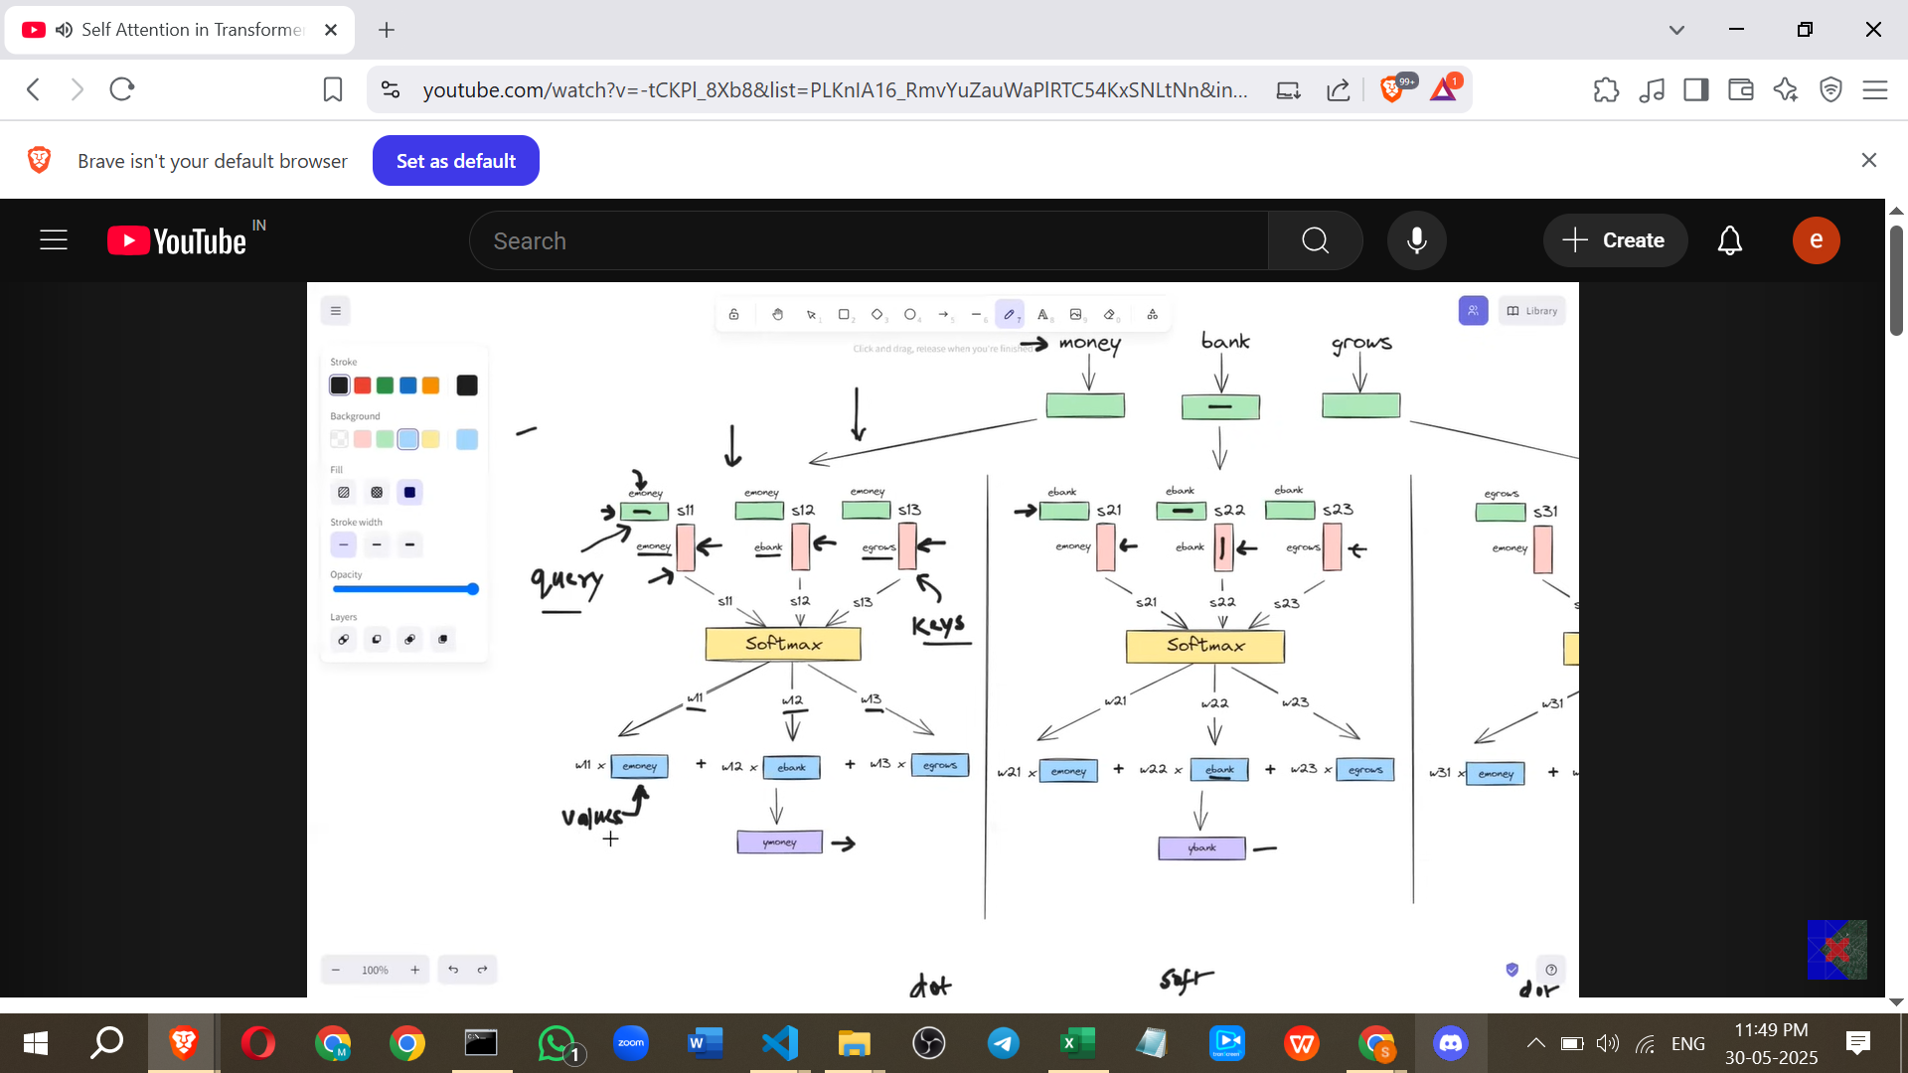

* **Realizing Different Roles:** Upon reviewing the initial process, it's observed that each word's embedding vector plays different roles.

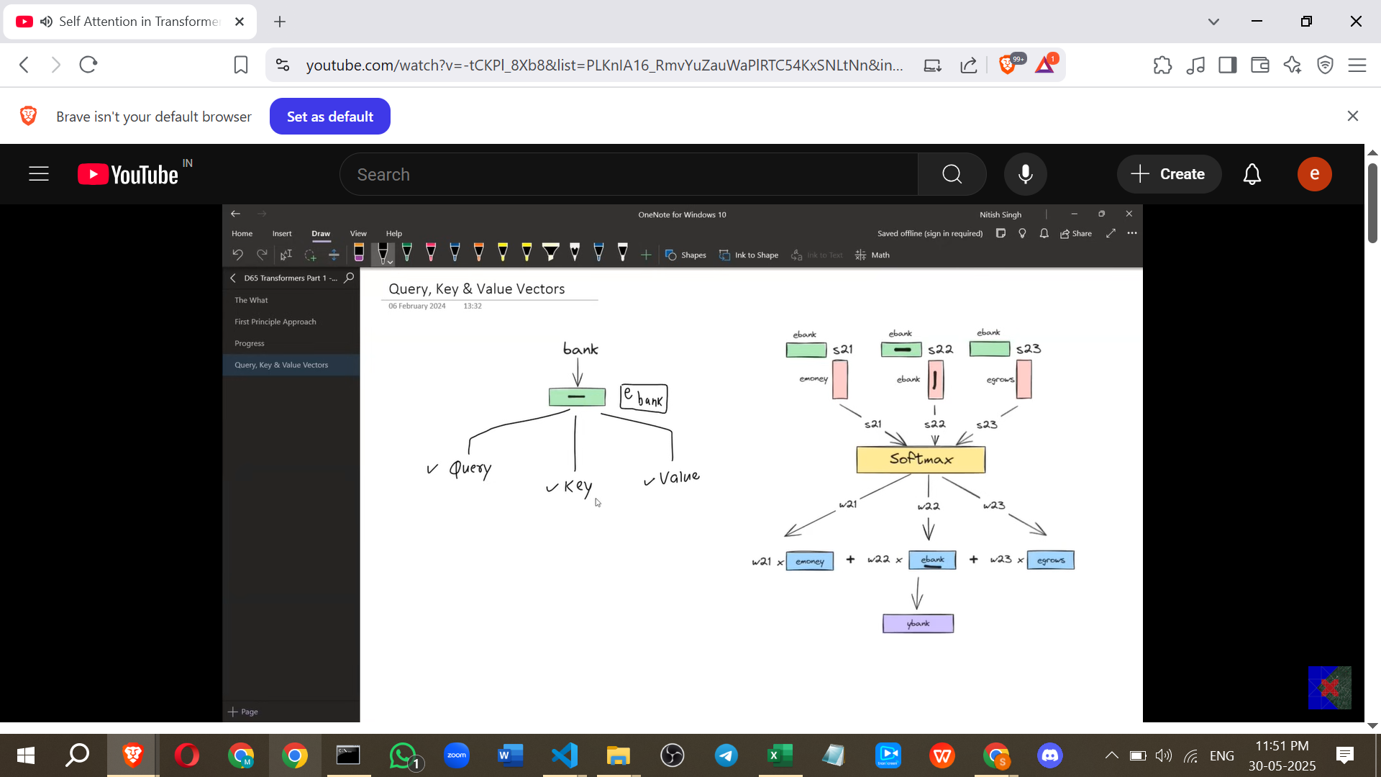

* + When calculating the new embedding for a word (e.g., "Money"), its static embedding (e.g., E-Money) is used in three ways:
    1. To **query** or ask other words about their similarity to it (used in the dot product calculation alongside other word embeddings).
    2. To act as a **key** or something other words can query against to find similarity.
    3. To act as a **value** whose embedding is potentially included in the weighted sum based on similarity scores.
  + *Point from my side:* This is analogous to a dictionary where a "query" looks up a "key" to retrieve a "value". In Self-Attention, a word's "query" interacts with other words' "keys" to determine similarity, and these similarities are used as weights to combine the other words' "values."

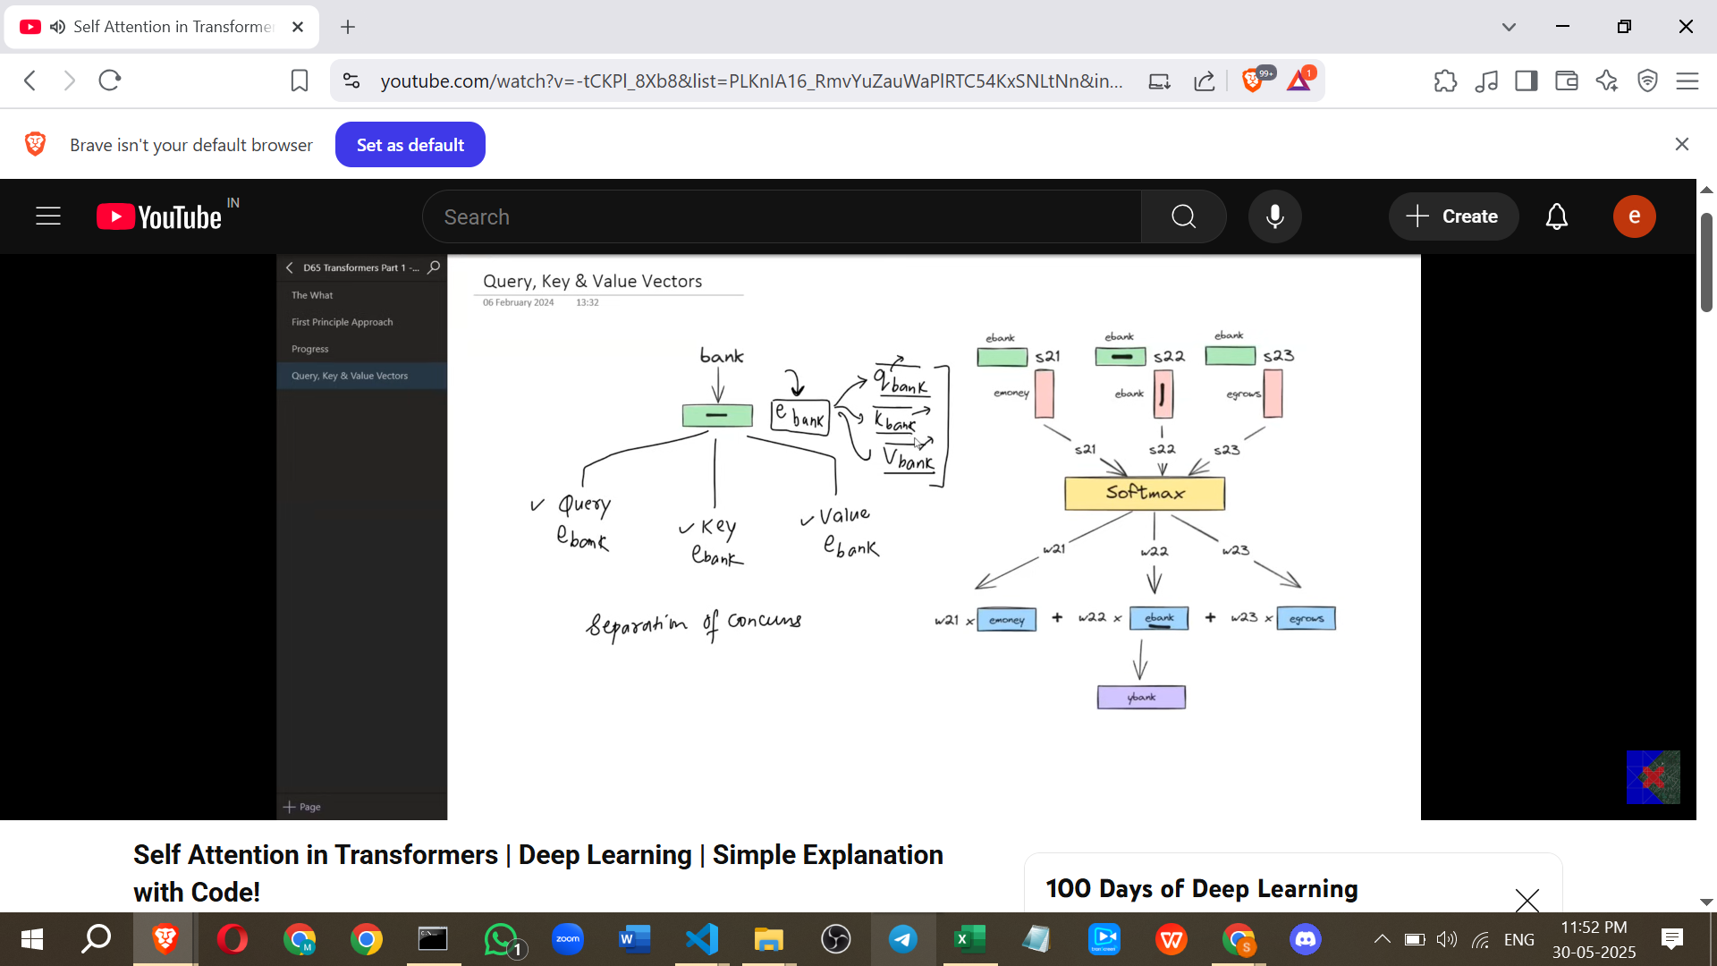

* **Problem with Single Vector Role:** The initial approach uses the *same* static embedding vector for all three roles (Query, Key, Value). This isn't ideal because each role requires the vector to highlight different aspects of the word's meaning.
  + **Example/Intuition:** Imagine an author's detailed autobiography representing their static word embedding. Using this entire autobiography directly for every purpose on a matrimonial website (profile, search query, initial conversation) is inefficient and counterproductive.

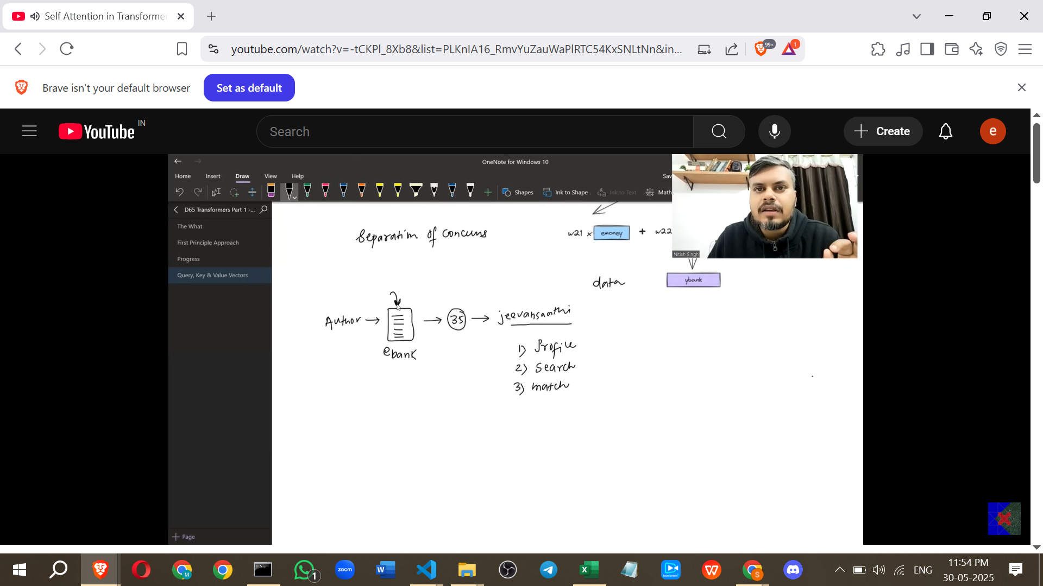

* + Instead, you'd want a specially crafted **Profile** (Key) highlighting the best aspects, a specific **Search Query** optimized for finding a partner, and a carefully selected set of information for initial conversation (**Value**). All this information comes *from* the autobiography, but it's transformed and optimised for its specific task.

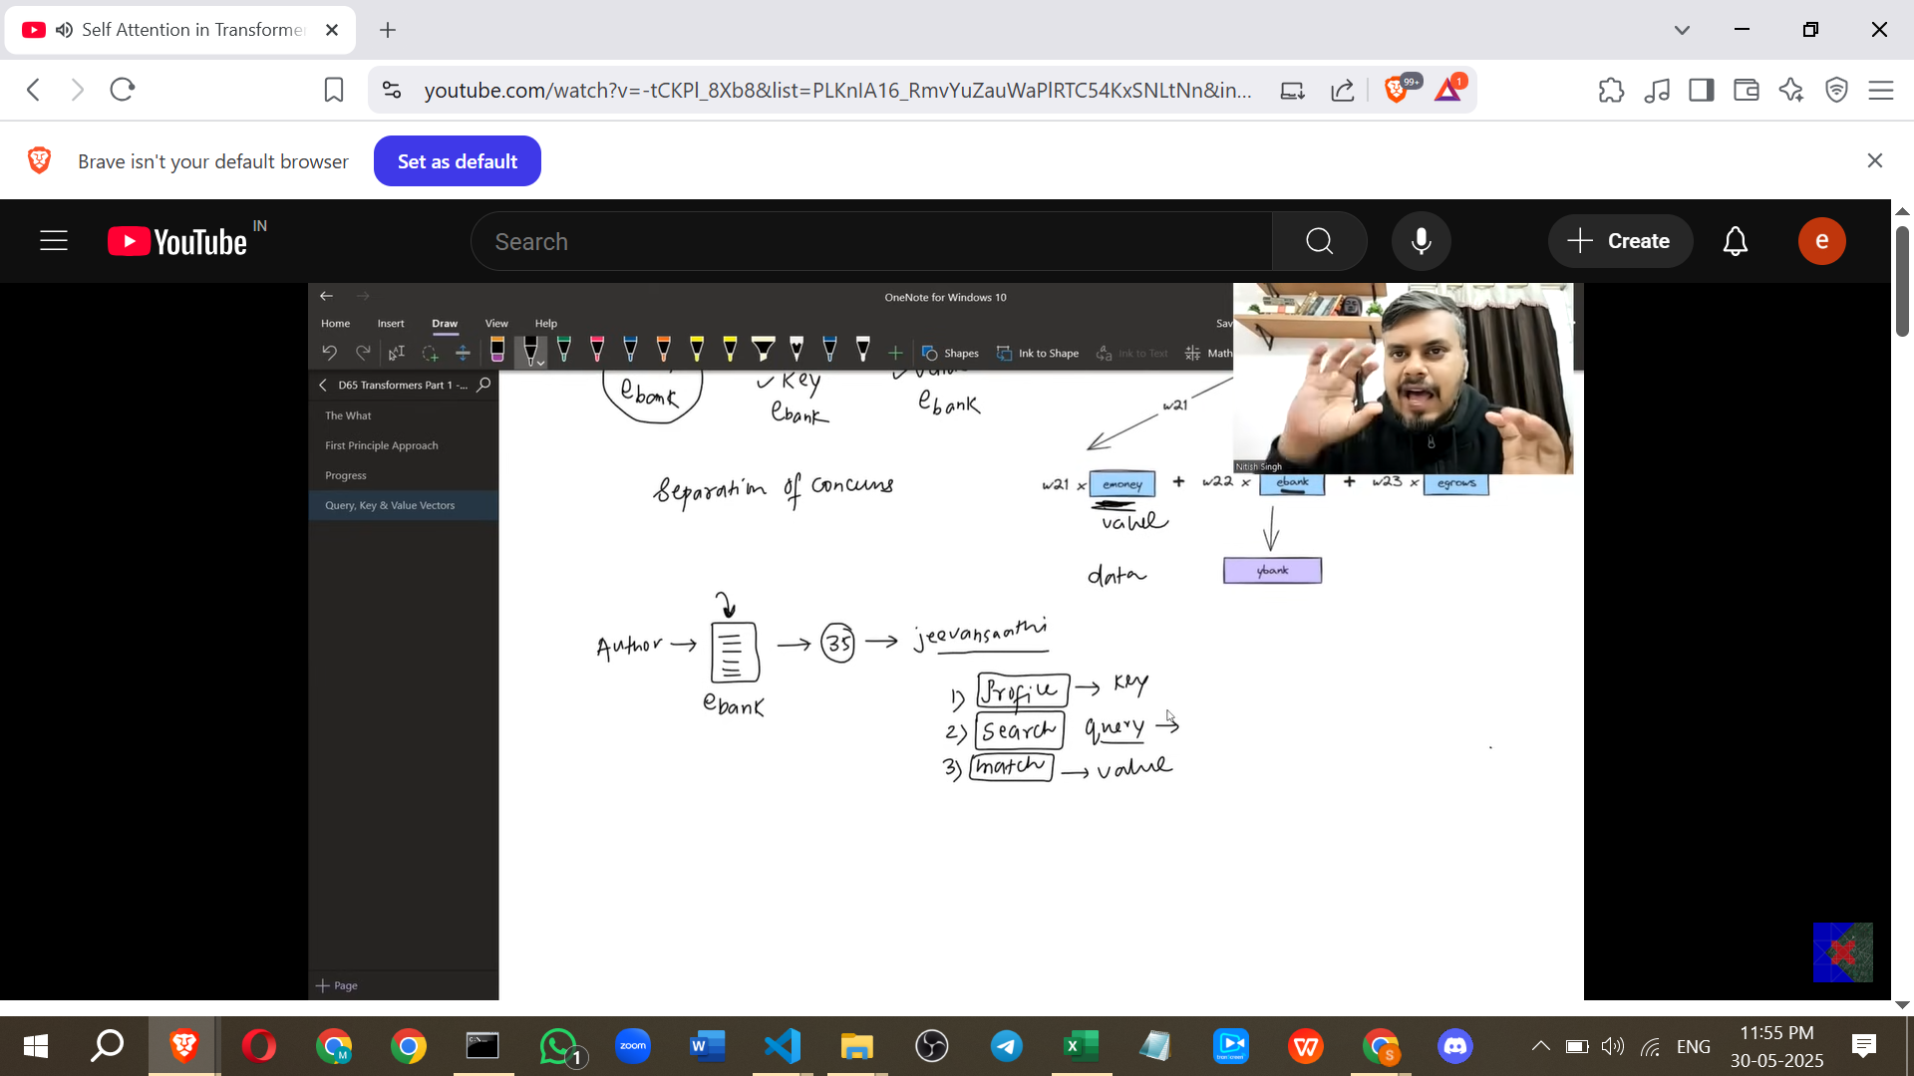

* **Generating Q, K, V Vectors:** Similarly, in Self-Attention, the single static word embedding should be transformed into three distinct vectors: a **Query vector (Q)**, a **Key vector (K)**, and a **Value vector (V)**.
* How are these new Q, K, V vectors generated from the original static embedding? Using **linear transformations**.

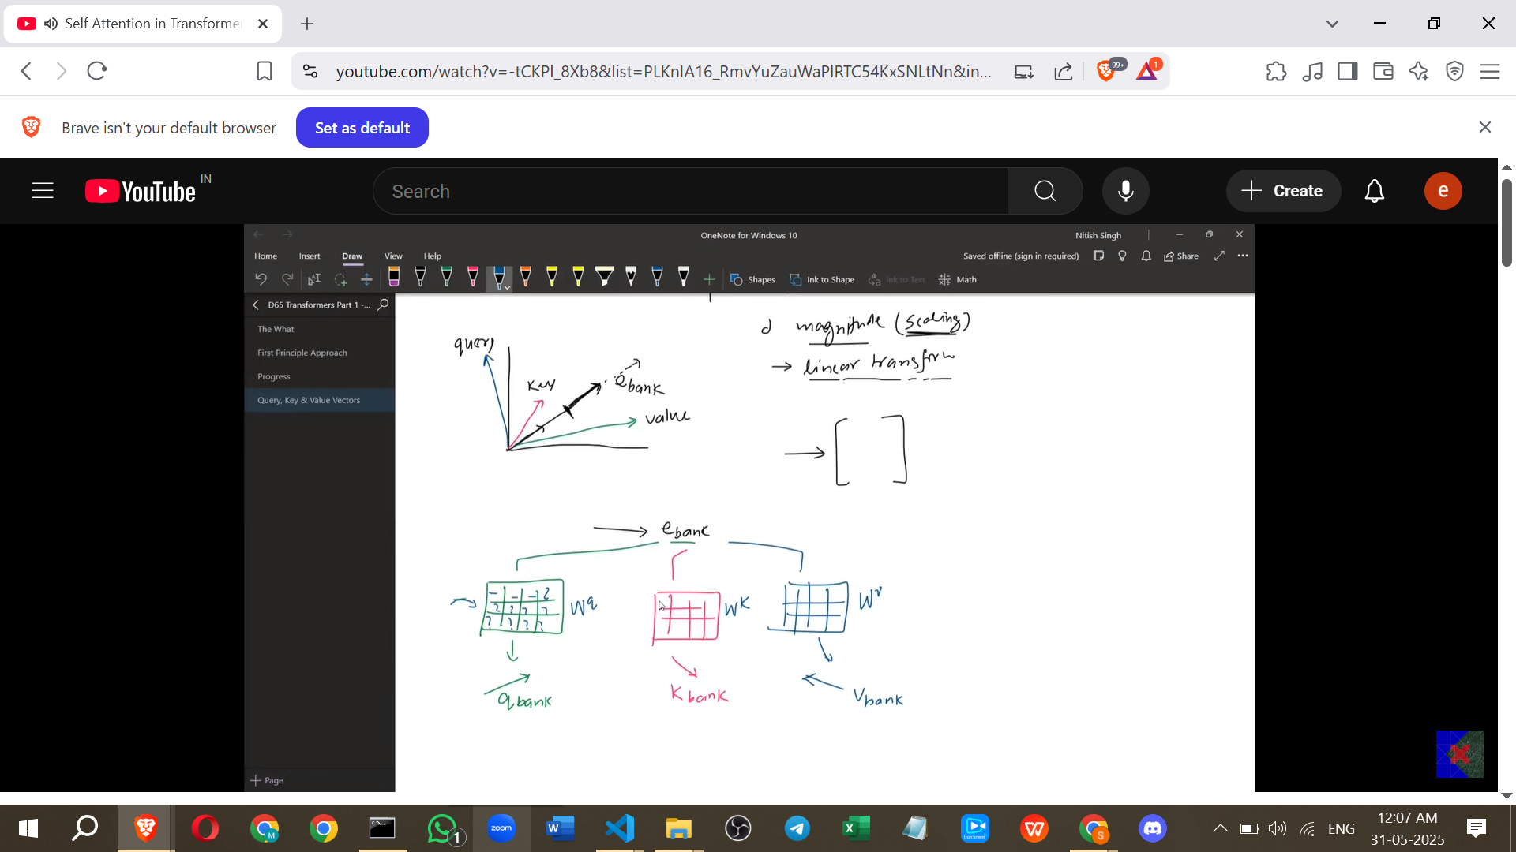

* + *Point from my side:* A linear transformation in this context is achieved by multiplying the input vector (the static word embedding) by a matrix (a weight matrix). This changes the vector's magnitude and/or direction.
  + Three separate weight matrices are used: **Wq** for generating the Query vector, **Wk** for generating the Key vector, and **Wv** for generating the Value vector.
  + For each word embedding E, the Query vector Q = E * Wq, the Key vector K = E * Wk, and the Value vector V = E * Wv.
* **Learning the Weight Matrices:** The values inside the weight matrices Wq, Wk, and Wv are **learnable parameters**. They are not fixed but are initialised randomly and then learned during the training process based on the specific NLP task and its data.

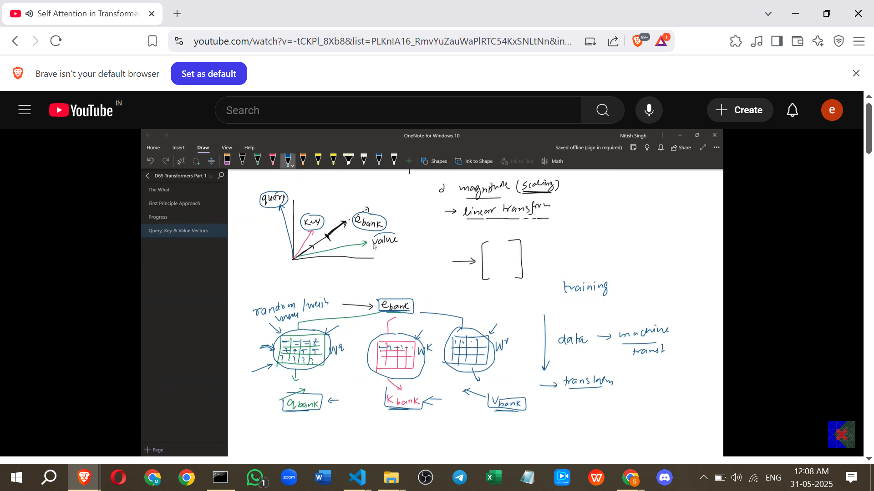

* + **Example/Intuition:** What information from the autobiography should go into the profile (Key)? You learn this by seeing which profile elements result in good matches. Similarly, the network learns the optimal values for Wq, Wk, Wv through backpropagation based on the loss of the downstream task (e.g., translation accuracy).
* **Refined Self-Attention Calculation:** With the Q, K, and V vectors generated for all words in the sentence, the calculation for a word's new contextual embedding proceeds as follows:

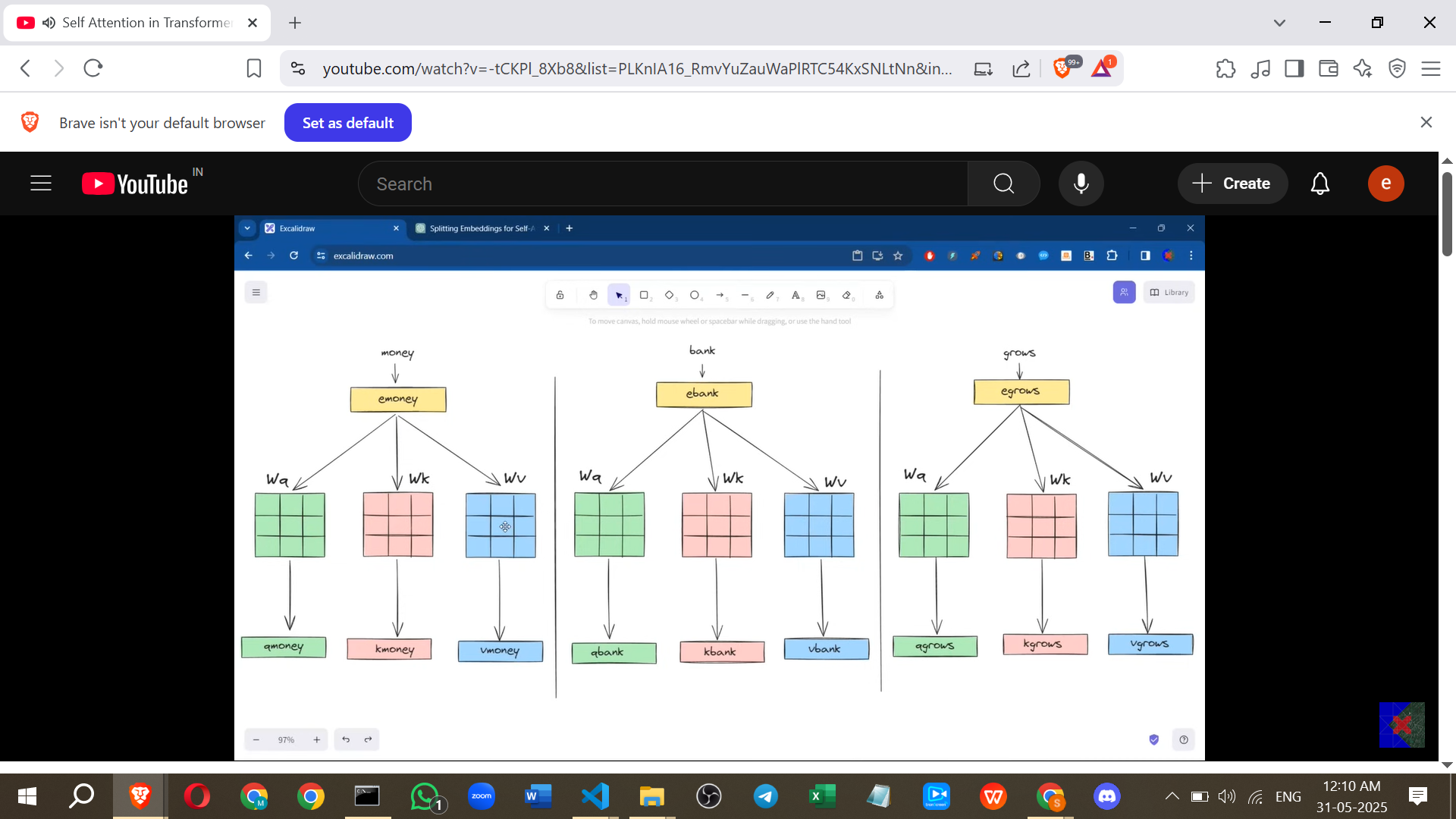

* + Calculate similarity scores between the word's Query vector (Q) and the Key vectors (K) of all words in the sentence (including itself). This is done using dot products: Q_word1 * K_word1, Q_word1 * K_word2, ..., Q_word1 * K_wordN.
  + Apply the **softmax function** to the similarity scores to get normalized weights.
  + Calculate a weighted sum of the **Value vectors (V)** of all words in the sentence, using the normalized weights from step 2.
  + The result is the new, task-specific, contextual embedding for the word.
* This process is repeated for every word in the sentence.
* Crucially, the *same* Wq, Wk, and Wv matrices are used for *every* word in the sentence.
* **Parallel Computation of Refined Model:** Just like the initial approach, this refined Self-Attention calculation can also be performed in parallel for all words using matrix operations.

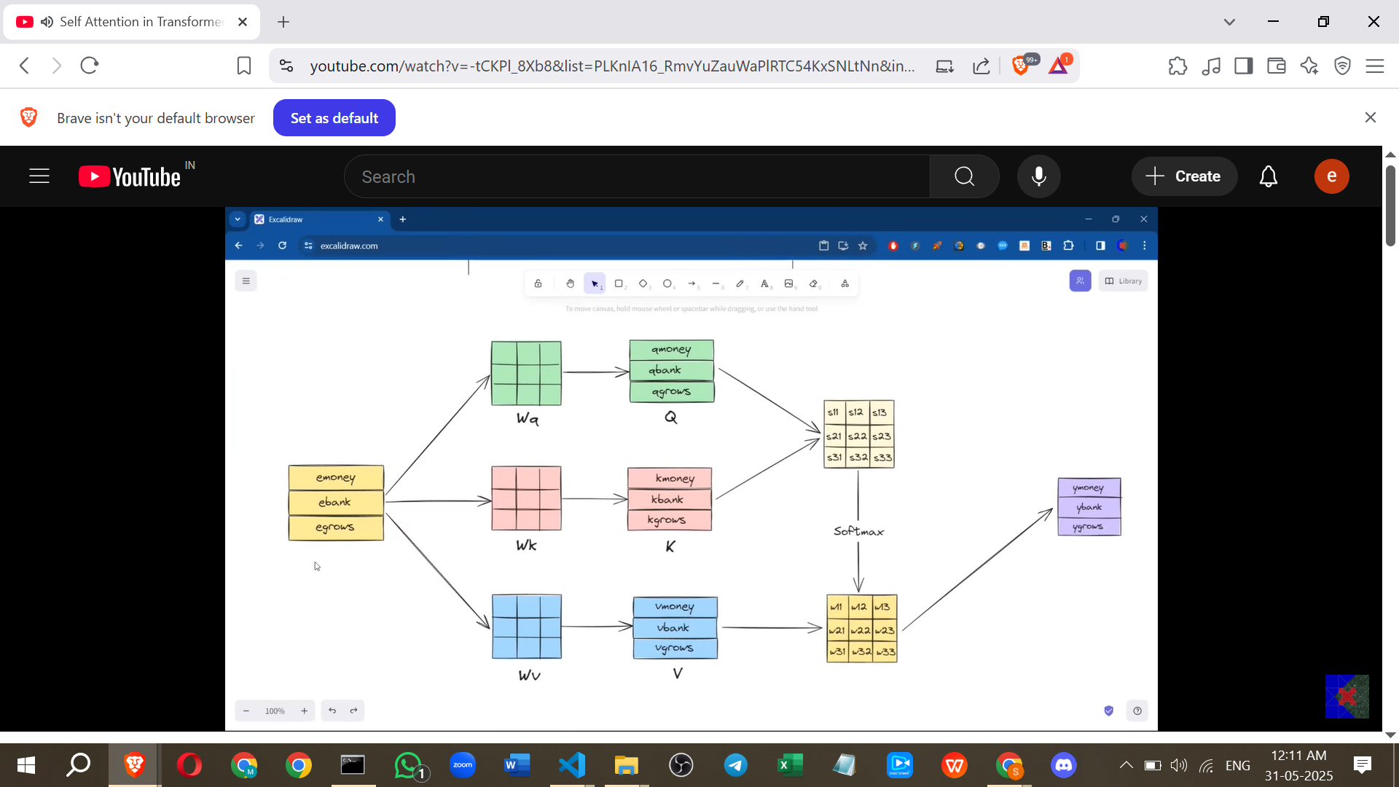

* + All Query vectors for the sentence form a matrix (Capital Q), all Key vectors form a matrix (Capital K), and all Value vectors form a matrix (Capital V).
  + The similarity scores matrix is obtained by multiplying Q and the transpose of K (or similar, the source shows Q*K which might imply dimension matching or different matrix layout).
  + Softmax is applied to this similarity matrix.
  + The final matrix of new contextual embeddings is obtained by multiplying the softmax output matrix by the Value matrix (V).

**VI. Conclusion**

* The refined Self-Attention mechanism successfully generates **task-specific contextual embeddings** by introducing learnable weight matrices (Wq, Wk, Wv) that transform static word embeddings into Query, Key, and Value vectors.
* These weight matrices are learned during training, allowing the model to adapt to the specific data and task.
* The entire process remains highly **parallelizable** using matrix operations, making it computationally efficient.
* This refined Self-Attention mechanism is the one used in the **Transformer architecture** today.

====================================================

# **Class 3. Scaled Dot Product Attention | Why do we scale Self Attention?**

**Scaled Dot Product Attention: Notes**

This concept builds upon the Self Attention mechanism and addresses a specific issue related to training stability, especially with high-dimensional vectors. The key difference introduced in the famous "Attention Is All You Need" paper is a scaling factor.

**1. Recap of Self Attention Calculation (Standard)**

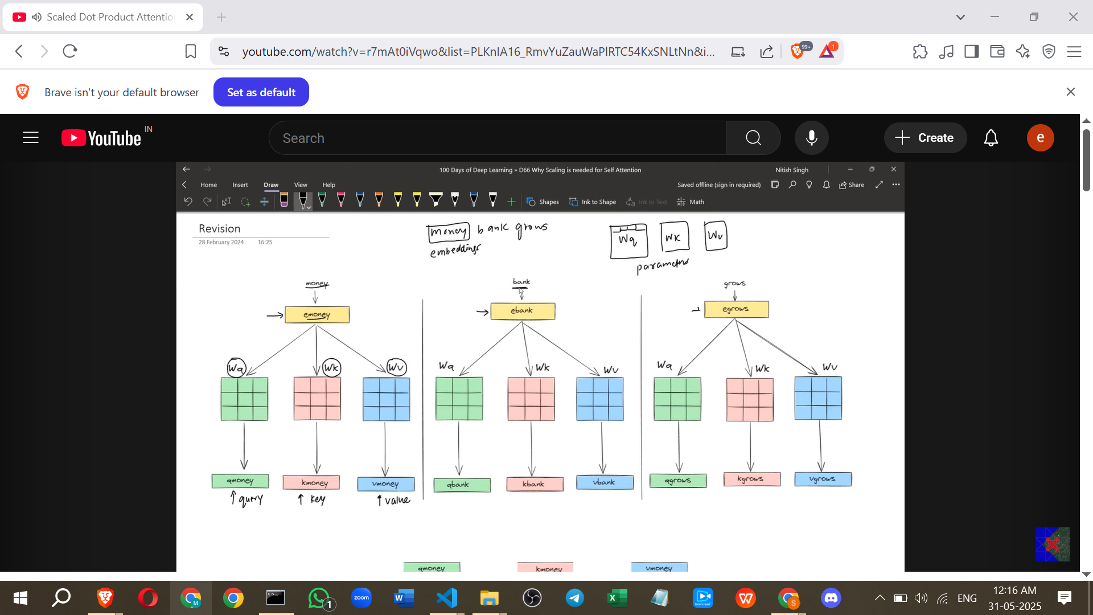

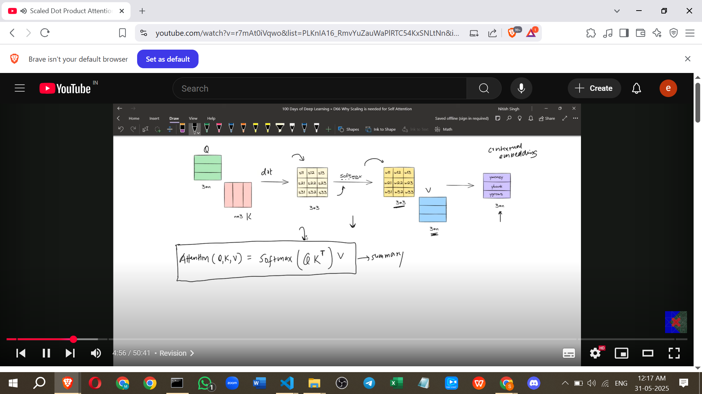

* **Input:** A sentence, e.g., "Money bank grows".
* **Embeddings:** Each word is converted into a numerical vector embedding (e.g., E_Money, E_Bank, E_Grows).
* **Linear Transformations:** The embeddings are multiplied by three learned weight matrices (Wq, Wk, Wv) to create Query (Q), Key (K), and Value (V) vectors for each word.
  + E_Money * Wq -> Q_Money vector.
  + E_Money * Wk -> K_Money vector.
  + E_Money * Wv -> V_Money vector.
  + This is repeated for all words (Bank, Grows).
* **Matrix Creation:** The individual Q, K, V vectors are stacked to form Query (Q), Key (K), and Value (V) matrices.
* **Attention Scores (Dot Product):** The Q matrix is matrix-multiplied with the transpose of the K matrix (Q * Kᵀ). This results in a matrix where each element represents the dot product between a query vector and a key vector.
* **Softmax:** The Softmax function is applied to the Q * Kᵀ matrix. This converts the scores into probabilities, indicating the relevance of each key to each query.
* **Weighted Values:** The resulting probability matrix is matrix-multiplied with the V matrix. This produces the final contextual embeddings, where each word's embedding is a weighted sum of the value vectors of all other words, with weights given by the Softmax probabilities.
* **Formula:** The process can be summarised as: Attention(Q, K, V) = Softmax(Q * Kᵀ) * V.

**2. Introduction of Scaling**

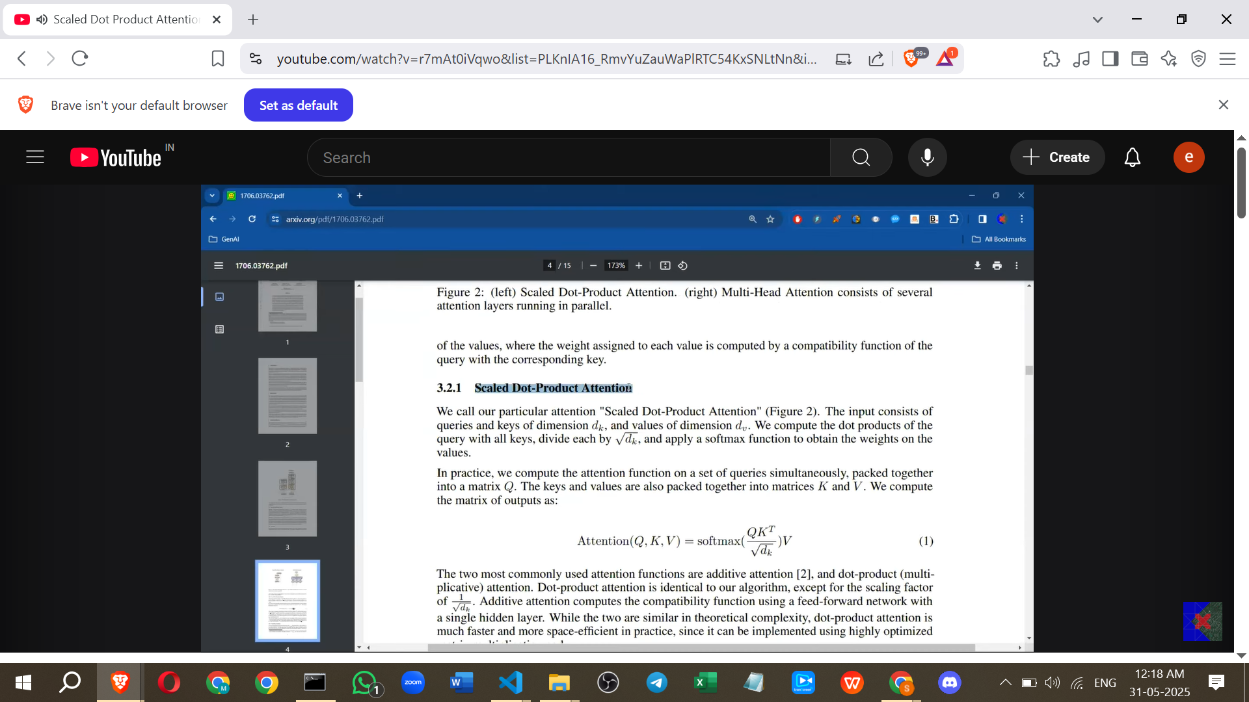

* Comparing the derived formula Softmax(Q * Kᵀ) * V to the formula in the "Attention Is All You Need" paper reveals a difference: the term Q * Kᵀ is divided by the square root of d_k.
* The formula in the paper is: Attention(Q, K, V) = Softmax(Q * Kᵀ / √d\_k) * V.
* This modified operation is called **Scaled Dot Product Attention**.

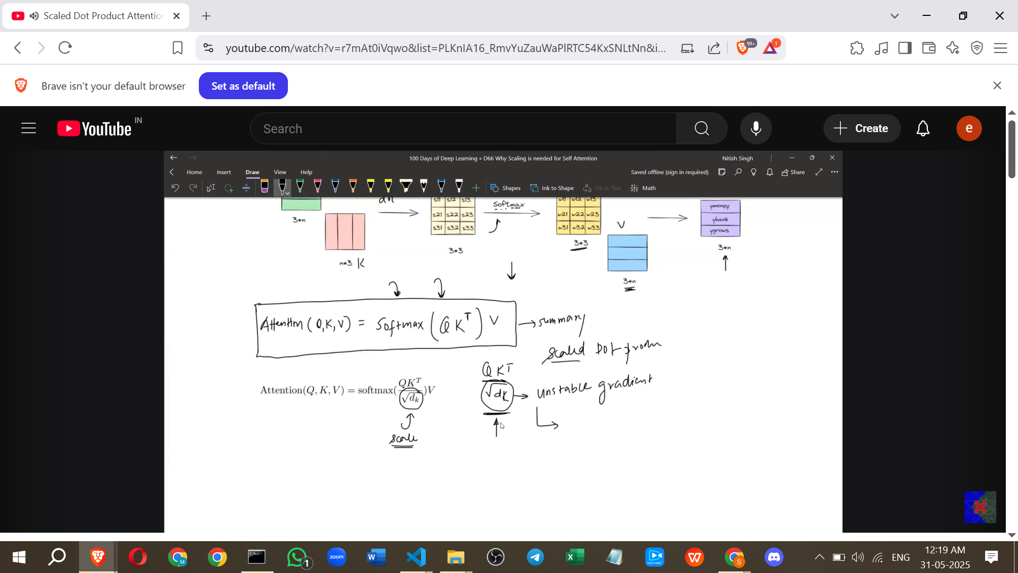

**3. What is d_k?**

* **d_k represents the dimension of the Key vector**.
* The dimension of the Key vector is determined by the dimension of the input embedding and the shape of the Wk matrix.
* **Example:** If the word embeddings are 3-dimensional (1x3 vector) and the Wq, Wk, Wv matrices are 3x3, then the resulting Q, K, and V vectors will also be 1x3, meaning their dimension is 3. In this case, d_k = 3. The formula would involve dividing by √3.
* In standard implementations, the dimensions of the Q, K, and V vectors are often the same (d_q = d_k = d_v).

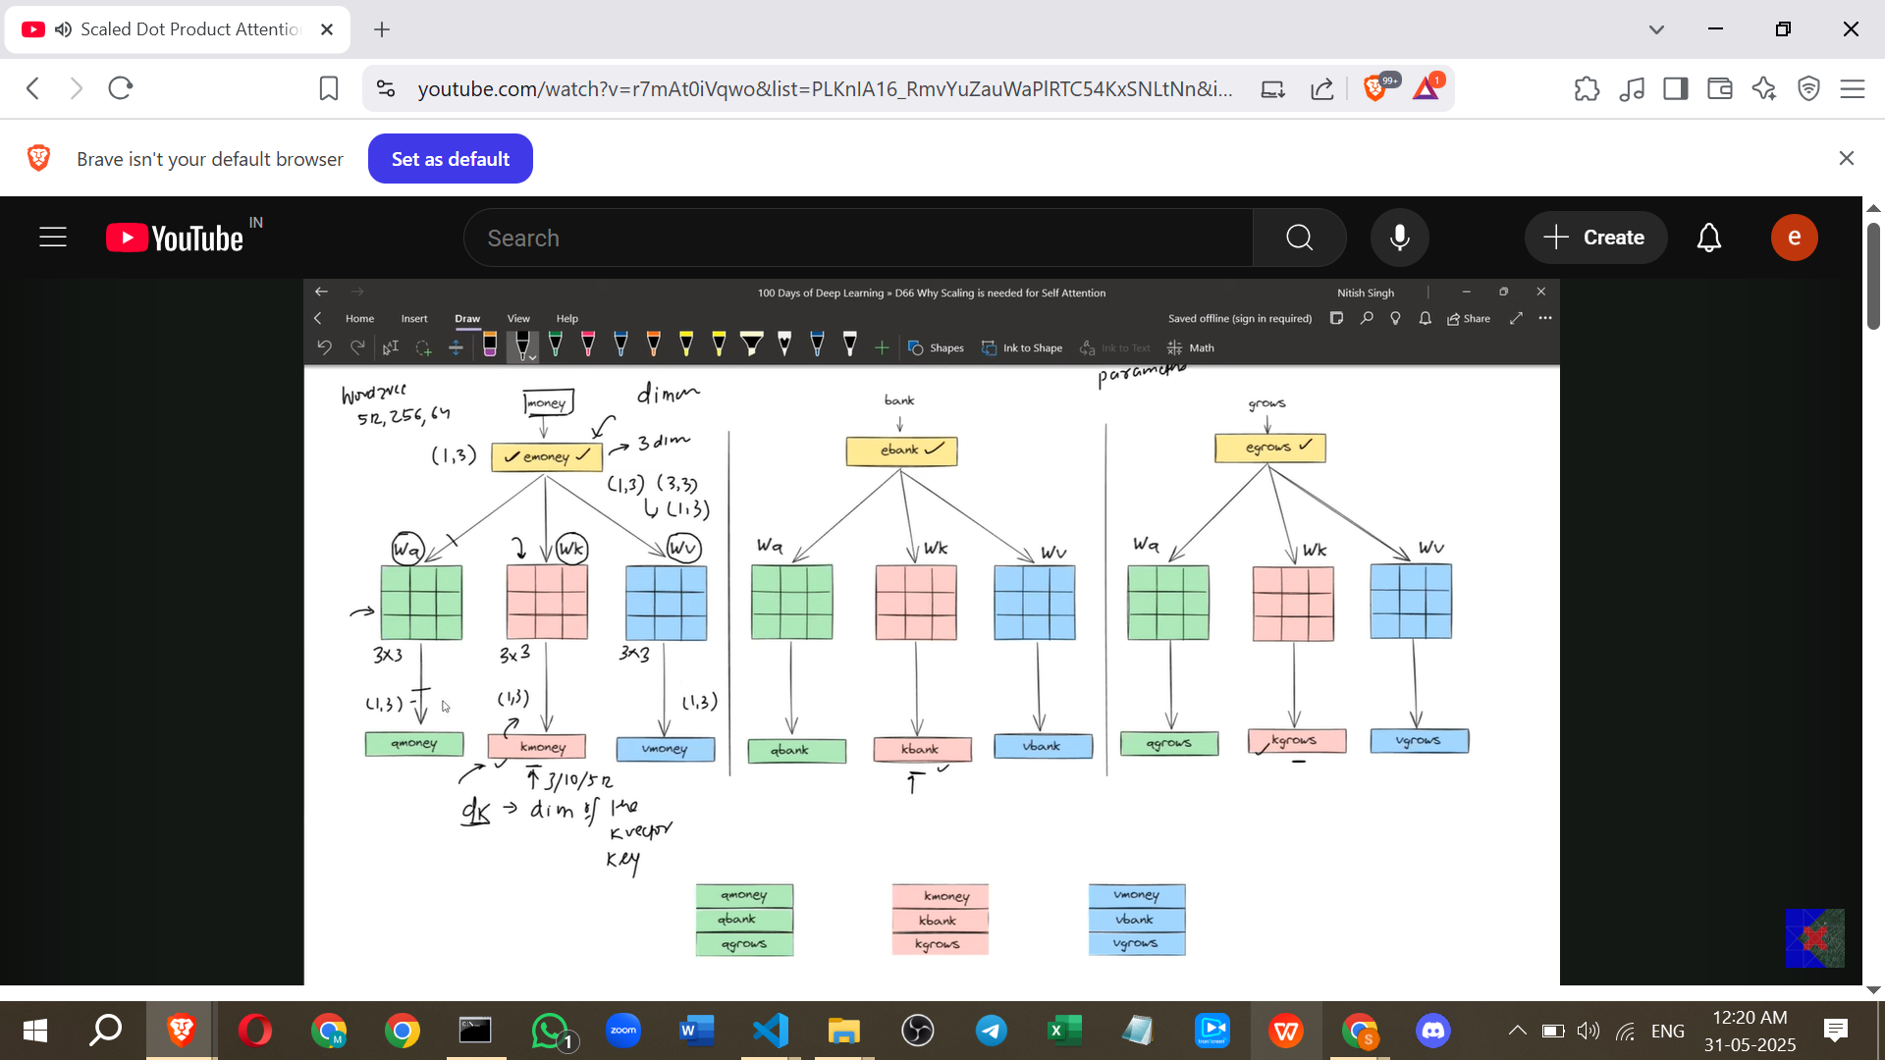

**4. Why Scale by √d_k? (The Core Problem)**

* The primary reason for scaling is the **nature of the dot product**, specifically how its magnitude and variance behave with increasing vector dimensions.

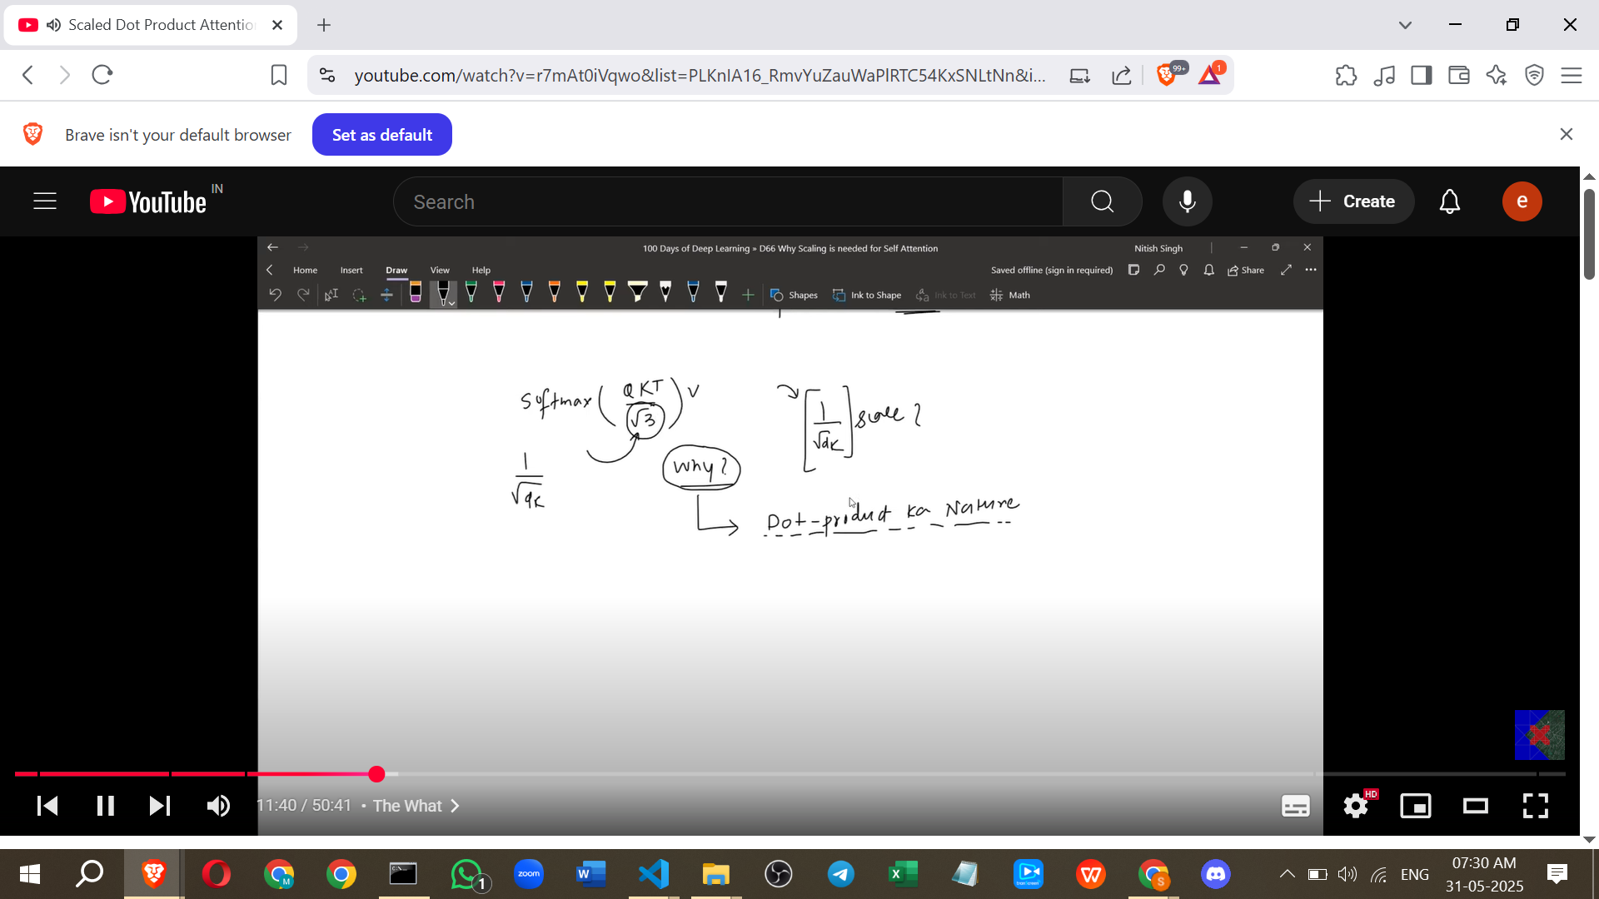

* **Problem:** When calculating the Q * Kᵀ matrix, we are performing many vector-vector dot products (e.g., each row of Q with each column of Kᵀ).
* **Dot Product Variance vs. Dimension:**
  + **Low Dimensions:** The dot product of low-dimensional vectors results in values with relatively low variance.
  + **High Dimensions:** The dot product of high-dimensional vectors results in values with high variance. This was demonstrated experimentally by plotting histograms of dot product values from vectors of different dimensions (3D, 100D, 1000D), showing a wider spread (higher variance) for higher dimensions.

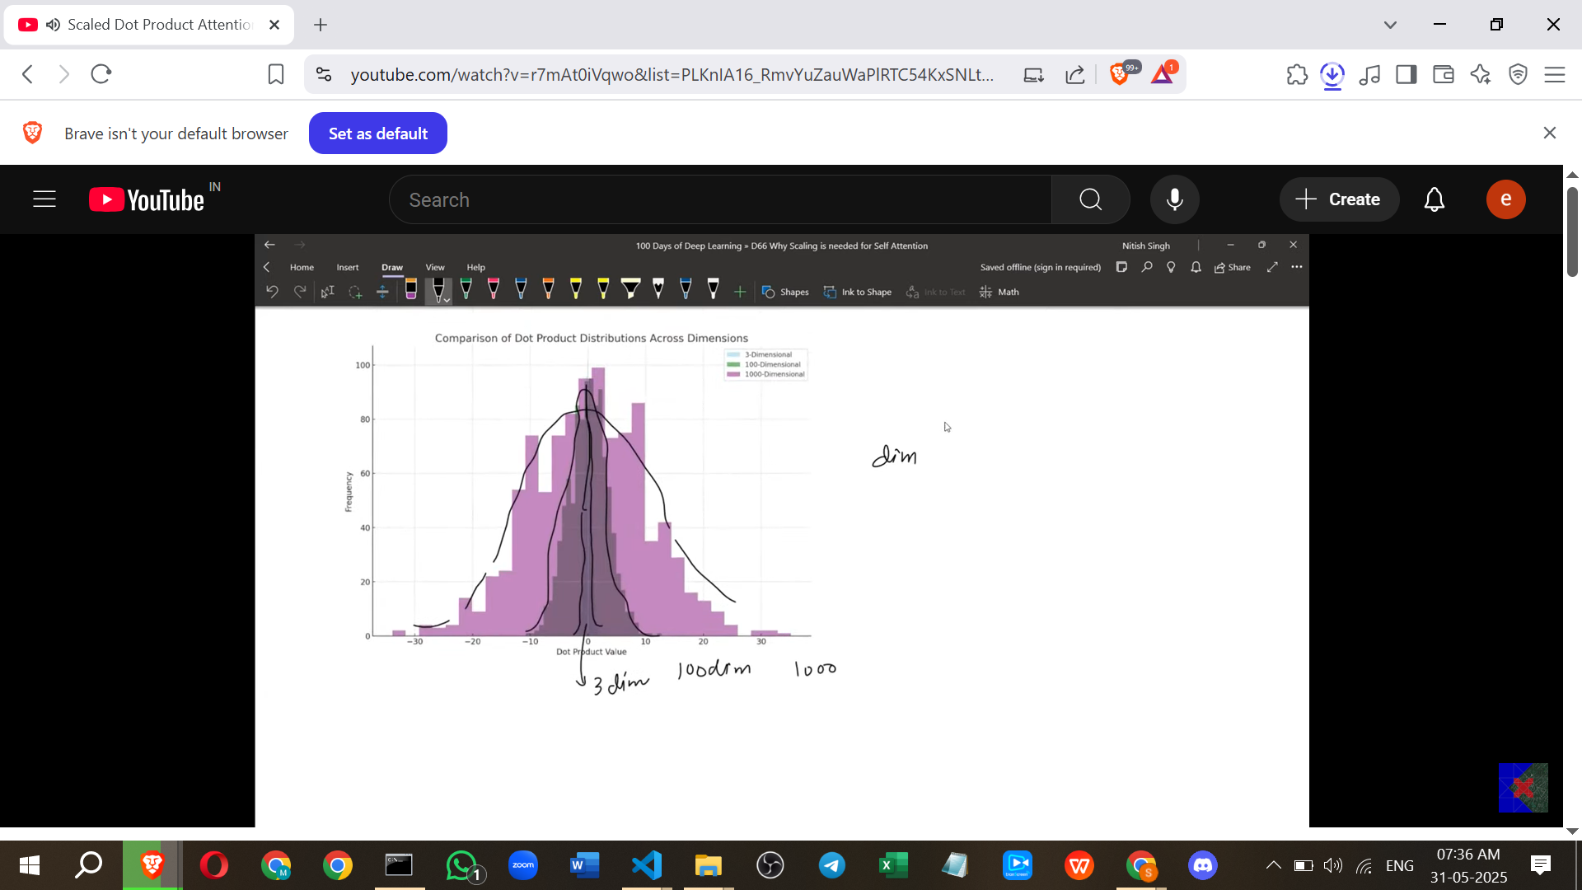

* **The Consequence of High Variance on Softmax:**
  + The Q * Kᵀ matrix contains numbers from these dot products. If they have high variance, some numbers will be very large, and others will be very small.
  + The Softmax function, which uses exponents, is sensitive to the magnitude of its inputs.
  + **Nature of Softmax:** For inputs with high variance, Softmax tends to assign a very high probability to the largest input and very low probabilities to the smaller inputs.

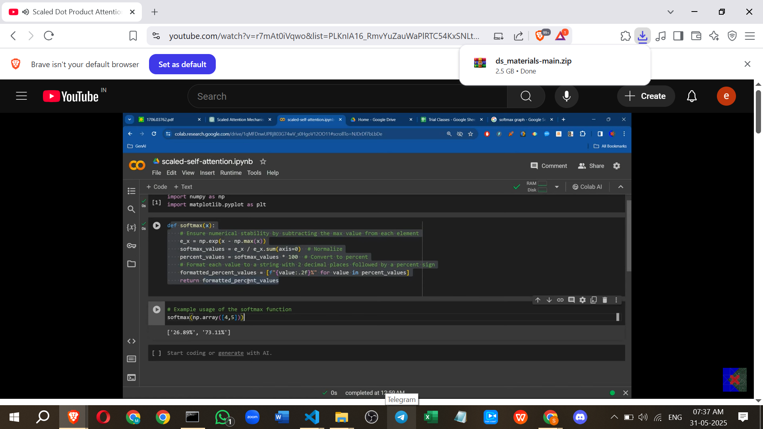

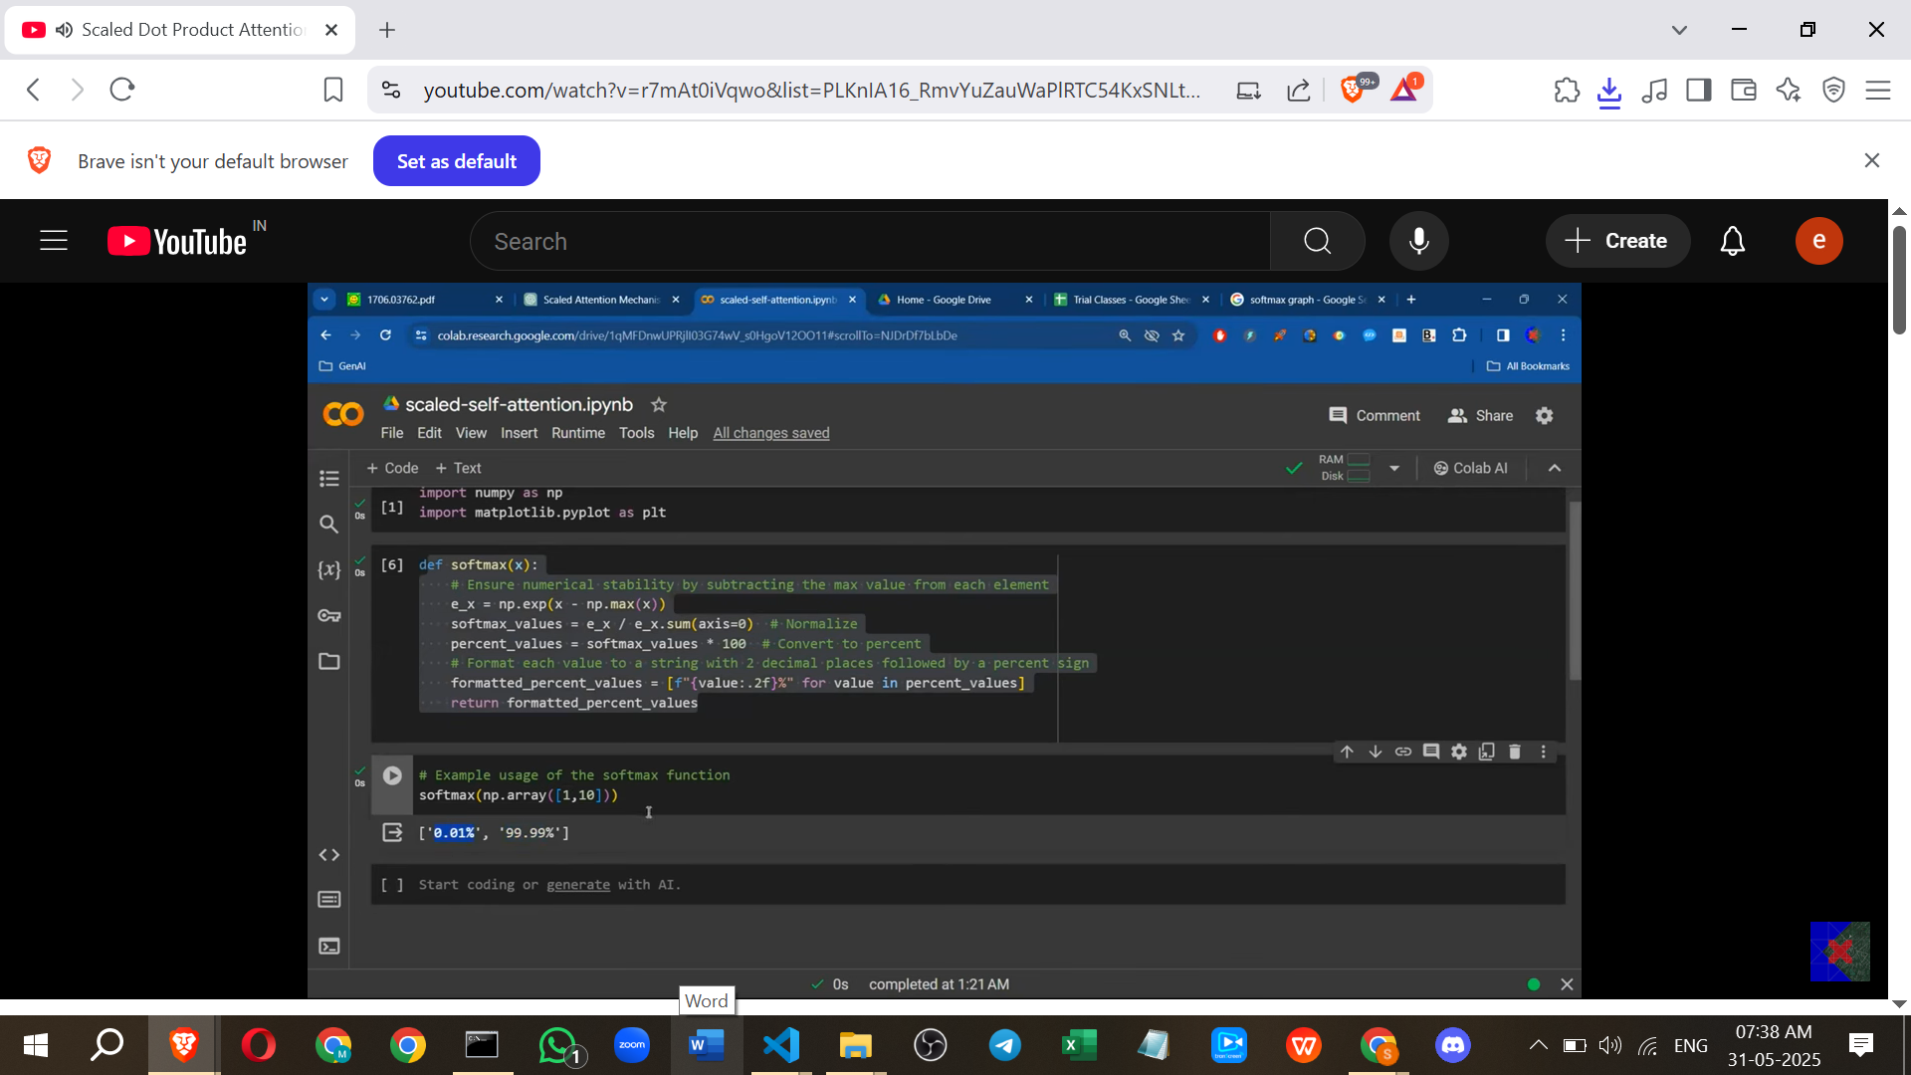

* + **Example:** Softmax() will produce probabilities close to `` (e.g., [0.000045, 0.99995] when rounded). Softmax() will produce [0.5, 0.5]. Softmax pushes outputs towards extremes for inputs with large differences.
* **The Consequence of Extreme Probabilities on Training:**
  + The resulting probability matrix from the Softmax will have some values very close to 1 and many values very close to 0.
  + During training using backpropagation, gradients are calculated to update the model's parameters (Wq, Wk, Wv).
  + Extreme probabilities mean that the gradient signal will primarily flow through the connections corresponding to the high probabilities (the "large" numbers in the Q*Kᵀ matrix).
  + The gradients for parameters associated with the very low probabilities (the "small" numbers) will be very small or zero, leading to the **Vanishing Gradient Problem**. These parameters won't update effectively, hindering the learning process.
  + **Analogy:** Like a teacher in a classroom with students of vastly different heights. When students raise their hands (representing the magnitude of dot products), the teacher only sees and addresses the tall ones (high scores), ignoring the short ones (low scores), resulting in uneven learning.
* **Goal:** The goal of scaling is to reduce the variance of the dot product values *before* applying Softmax. This ensures that the Softmax probabilities are less extreme, allowing the training process to pay more balanced attention to all components.

**5. How Scaling by √d_k Achieves This**

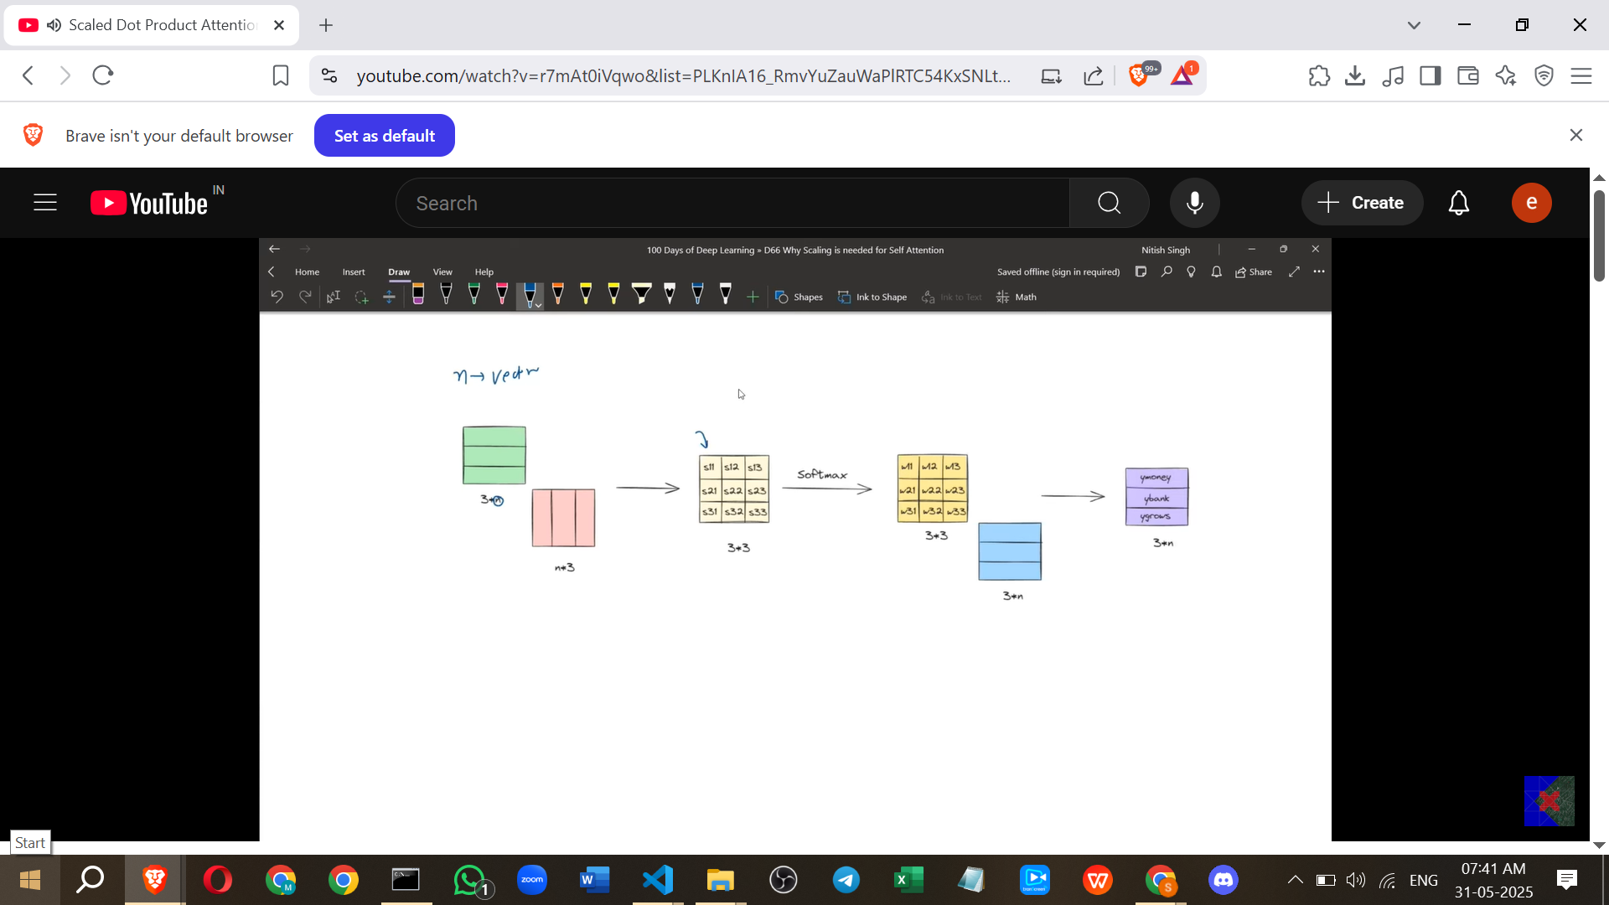

* **Reducing Variance:** A simple way to reduce the variance of a set of numbers is to divide them by a constant.
* **Finding the Correct Factor:** The variance of dot products for D-dimensional vectors is roughly D times the variance of dot products for 1-dimensional vectors (Var(X)). So, variance scales linearly with dimension.
* **Mathematical Property:** If a random variable Y is created by scaling a random variable X by a constant c (Y = cX), its variance is Var(Y) = c² * Var(X).

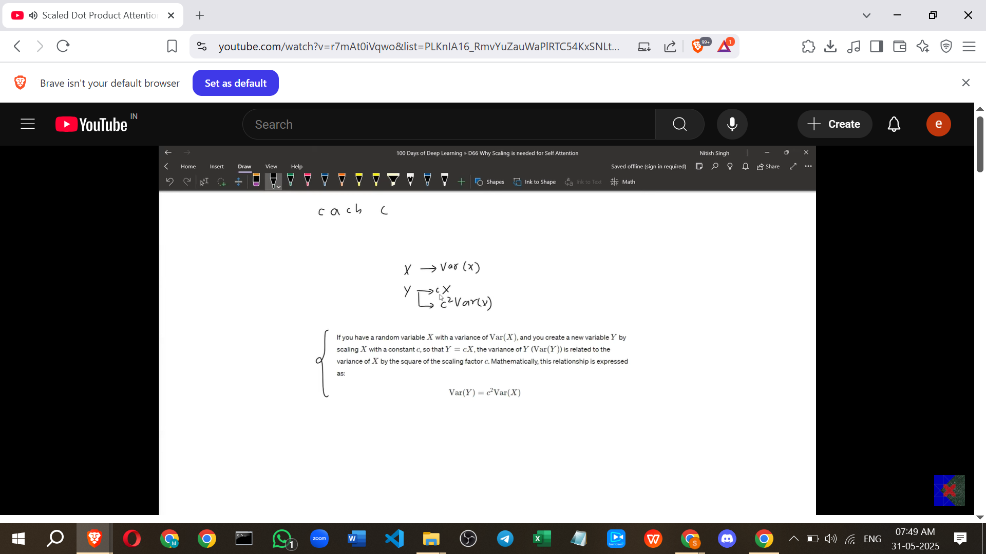

* **Applying the Property:** We have a variance roughly proportional to d_k (specifically, d_k * Var(X) where Var(X) is the 1D case variance). We want the variance to remain constant (like Var(X)) regardless of d_k.

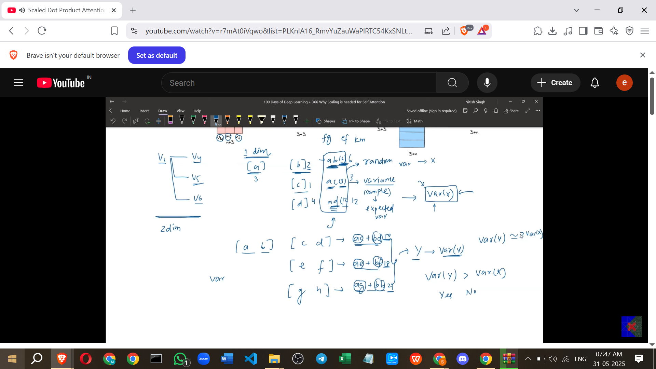

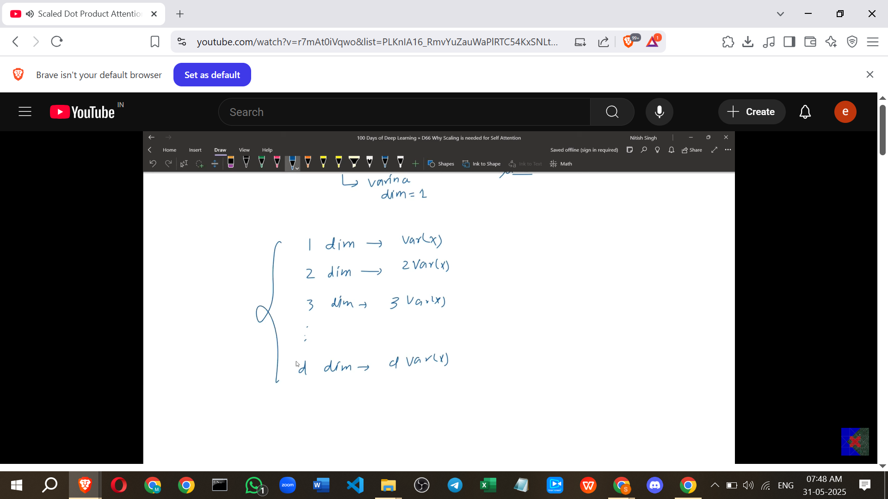

* To achieve this, we need to divide the dot product results by a constant 's' such that the new variance is the desired constant variance.
* The original variance is roughly d_k * Var(X). If we divide by s, the new variance becomes (1/s)² * (d_k * Var(X)).
* To make this equal to Var(X), we need (1/s)² * d_k = 1.
* Solving for s: (1/s)² = 1 / d_k -> 1/s = 1 / √d_k -> s = √d_k.
* Therefore, dividing each value in the Q * Kᵀ matrix by √d_k normalises the variance, making it roughly constant regardless of the vector dimension.

**6. Final Scaled Dot Product Attention Formula**

* The final formula used in Transformers is: Attention(Q, K, V) = Softmax( (Q * Kᵀ) / √d\_k ) * V.
* This scaling step happens **before** the Softmax operation.

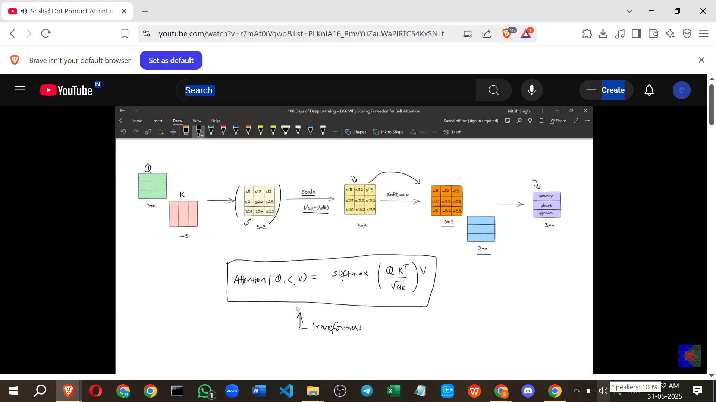

**7. Additional Insights (Beyond Source)**

* **Normalisation:** The scaling by √d_k can be seen as a form of normalising the input to the Softmax layer. Normalising inputs to layers is a common technique in neural networks to improve training stability (e.g., Batch Normalisation, Layer Normalisation).
* **Gradient Stability:** By controlling the variance of the Softmax inputs, the scaling helps prevent the gradients from becoming too small (vanishing) or too large (exploding), leading to more stable and effective training.
* **Why d_k?** The scaling factor depends on the dimension of the vectors involved in the dot product (Q and K). Since Q and K must have the same dimension for matrix multiplication (Q * Kᵀ), d_q = d_k. The dimension of V (d_v) does not affect the Q * Kᵀ calculation or its variance. The paper uses d_k, but d_q would be equivalent.

In summary, scaling the dot product of Q and K by √d_k is a crucial step in Scaled Dot Product Attention that counteracts the increase in variance of dot products with high-dimensional vectors. This prevents the Softmax function from producing extreme probabilities, thereby stabilising gradients and enabling effective training of transformer models.

==========================================================

# **Class 4.Self Attention Geometric Intuition | How to Visualize Self Attention**

**Self-Attention Geometric Intuition**

* This video continues a playlist on the Transformer architecture, focusing specifically on **Self-Attention**, which is described as the most important component.
* The goal is to provide a **geometric intuition** for Self-Attention, explaining what happens mathematically behind the scenes when Self-Attention is applied to a word. This aims to provide a clear visual picture.
* Understanding Transformers is considered incredibly important in the current day and age.

**Recap: Self-Attention Mathematical Formulation**

* The process starts with a sentence, for example, "Money Bank".
* The first step is to obtain the **embedding vectors** for each word (e.g., E_Money and E_Bank). These can be obtained using techniques like Word2Vec.
* You also need three matrices: **Wq, Wk, and Wv**. These matrices are typically learned during training.
* For each original embedding vector (e.g., E_Money), you perform a **dot product** with each of the three matrices (Wq, Wk, Wv).
* This produces three new vectors for each word: a **Query vector (Q)**, a **Key vector (K)**, and a **Value vector (V)**. So, for "Money Bank", you get Q_Money, K_Money, V_Money, and Q_Bank, K_Bank, V_Bank.
* To determine the contextual embedding for a word (e.g., Y_Money or Y_Bank), you use these six vectors.
* For Y_Bank, you calculate the **similarity** between the Query vector of the target word (Q_Bank) and the Key vectors of all words in the sentence (K_Money and K_Bank) using the **dot product**. These are similarity scores.
* These similarity scores are then **scaled** by dividing by the square root of the dimension of the Key vectors (√d_k).
* The scaled scores are **normalised** using the **Softmax function** to get the attention **weights** (e.g., w21 and w22 for Y_Bank, where w21 is the weight for V_Money and w22 is the weight for V_Bank). These weights sum to 1.
* Finally, the contextual embedding (Y_Bank) is computed as a **weighted sum** of the **Value vectors (V_Money and V_Bank)**, using the calculated weights (w21 and w22). The same process is repeated for Y_Money.

**Geometric Intuition: Visualisation**

* Word embeddings can be imagined as **vectors in a multi-dimensional space**.
* Visualisation techniques like PCA or UMAP are used to reduce the high dimensionality (e.g., 200D) to 2D or 3D so they can be plotted on a graph.

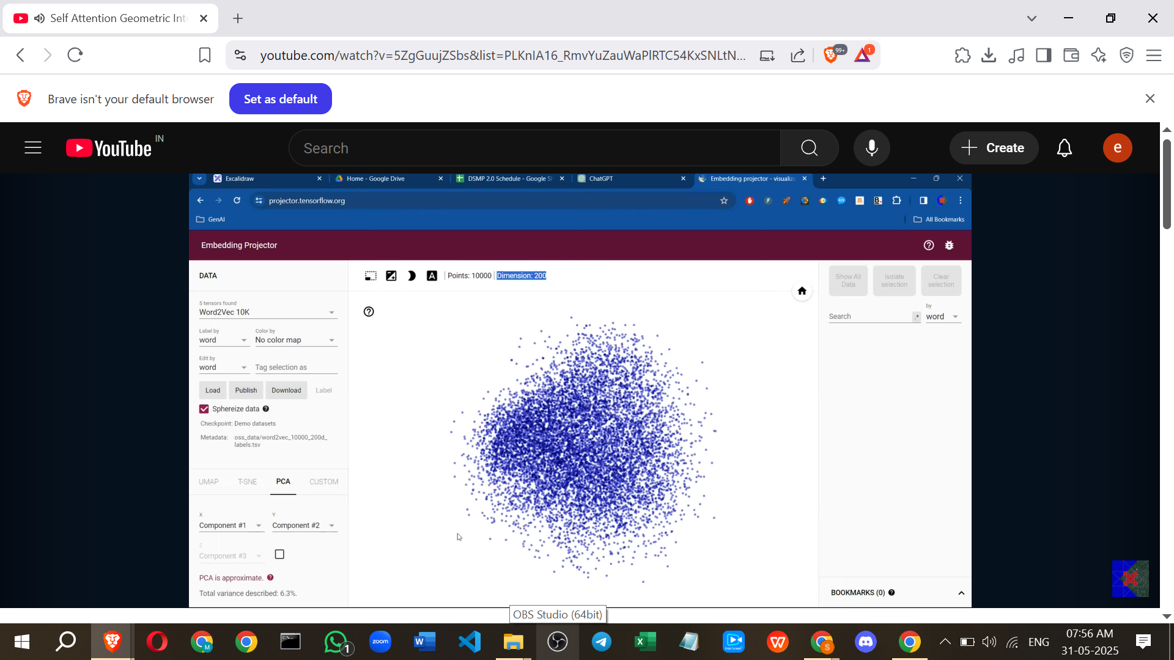

* When visualised, words with **similar semantic meanings** tend to be located close together.

**Geometric Intuition: Step-by-Step Visualisation**

1. **Starting Embeddings:** The original word embeddings (E_Money, E_Bank) are plotted as vectors on a graph. In the example, they are assumed to be 2D vectors for simplicity.

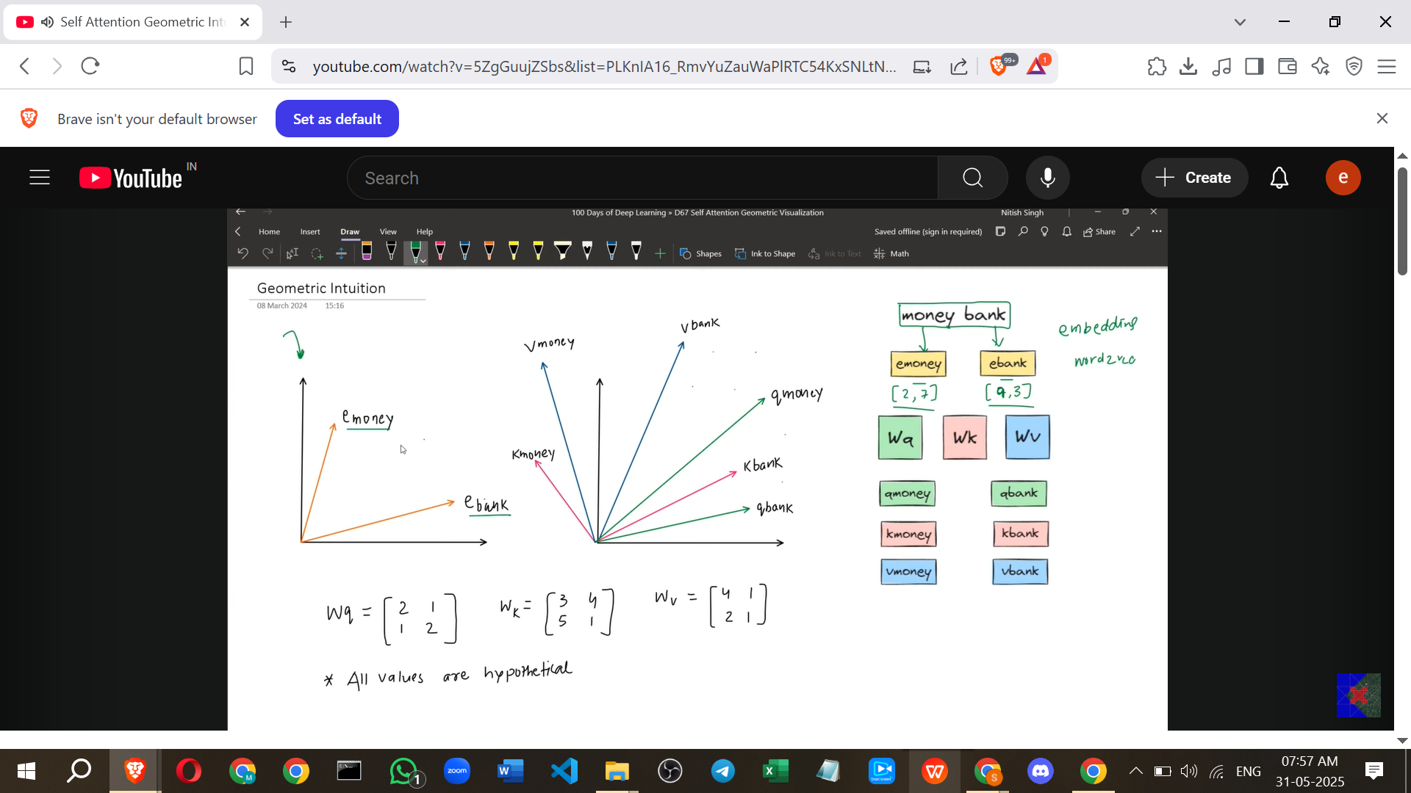

1. **Generating Q, K, V Vectors:** Applying the matrices Wq, Wk, and Wv to an embedding vector (via dot product) is a **linear transformation**. Geometrically, this means the original embedding vector is **moved or transformed** to a new position in space, resulting in the Q, K, and V vectors for each word. You start with two vectors (E_Money, E_Bank) and end up with six vectors (Q_Money, K_Money, V_Money, Q_Bank, K_Bank, V_Bank).

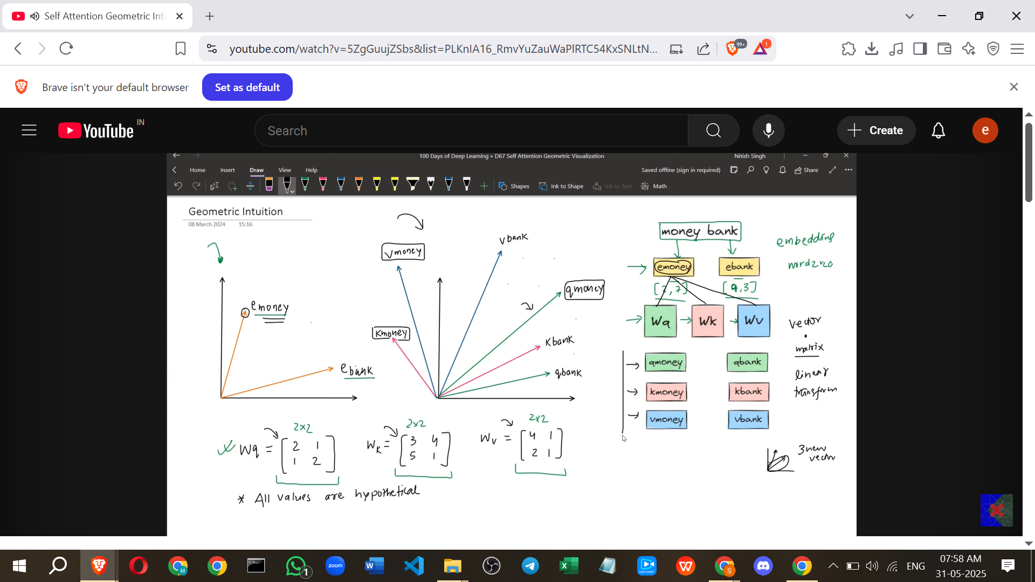

1. **Calculating Similarity (Dot Product of Q and K):** The dot product between the Query vector (Q_Bank) and Key vectors (K_Money, K_Bank) is calculated. Geometrically, the **dot product of two vectors gives a measure of their similarity or alignment**. If two vectors point in roughly the same direction (small angle between them), their dot product is large. If they are nearly perpendicular, the dot product is close to zero. If they point in opposite directions, it's negative.

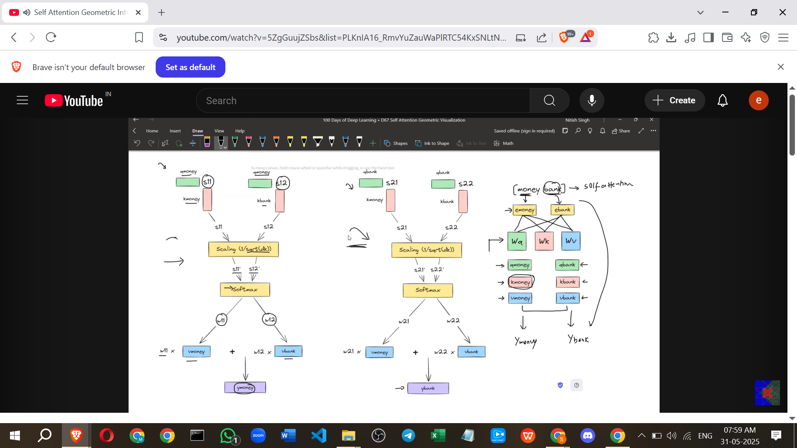

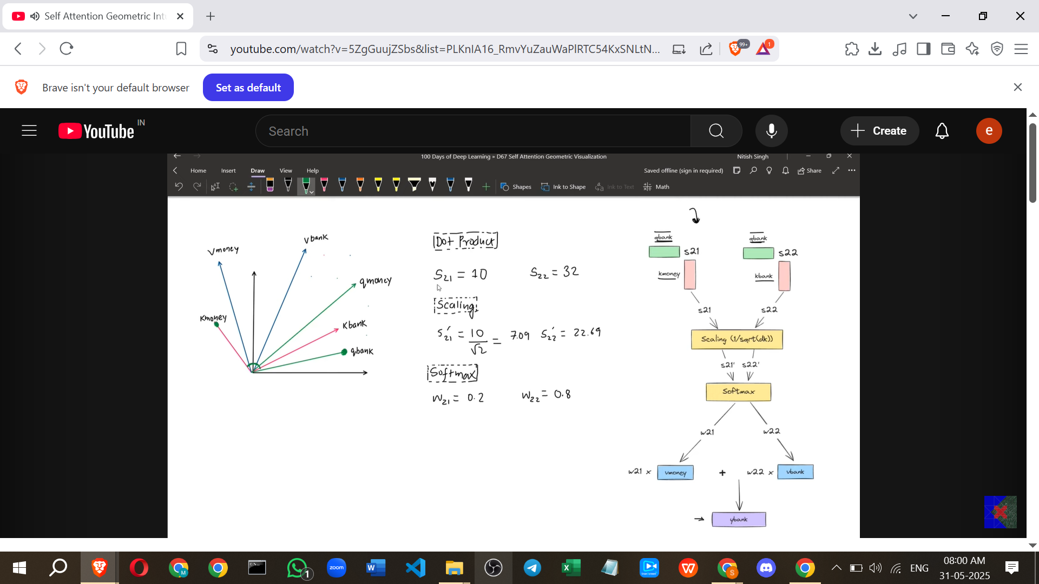

1. **Scaling and Normalisation (Softmax):** Scaling the similarity scores and applying Softmax converts these similarity measures into **weights** that determine how much attention the target word (Bank) should pay to each other word (Money and Bank itself).

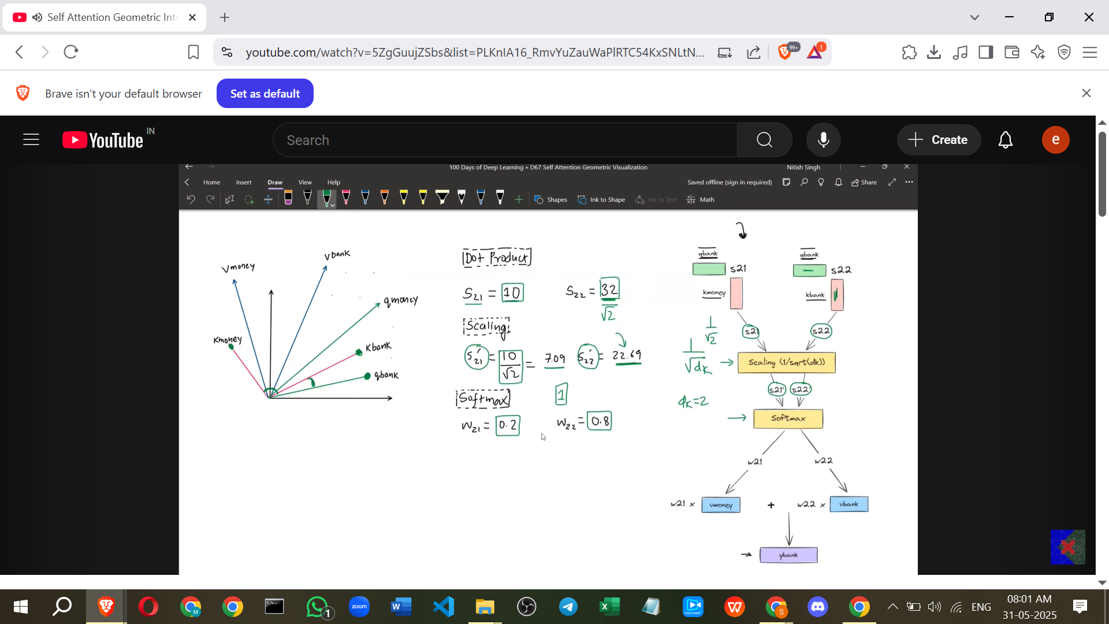

1. **Weighted Sum of Value Vectors:**
   * The weights (e.g., w21, w22) are used to **scale the Value vectors** (V_Money, V_Bank). This is a **scalar multiplication**, which means the length of the V vector is adjusted (shortened if the weight is < 1, lengthened if > 1 - though Softmax weights are typically < 1) while keeping its direction the same. The resulting vectors are the scaled Value vectors.

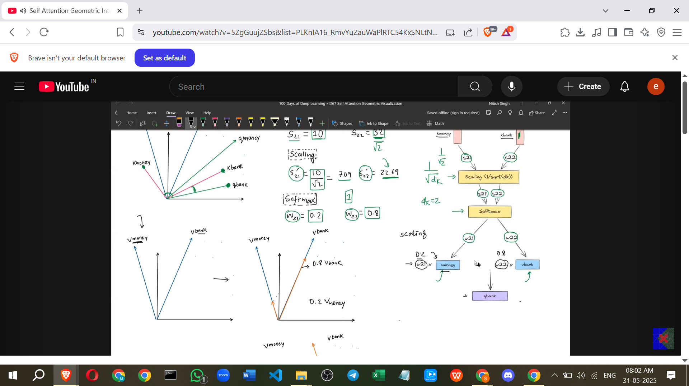

* + These scaled Value vectors (e.g., w21 * V_Money and w22 * V_Bank) are then **added together using vector addition**. Vector addition can be visualised using the parallelogram law or triangle law.

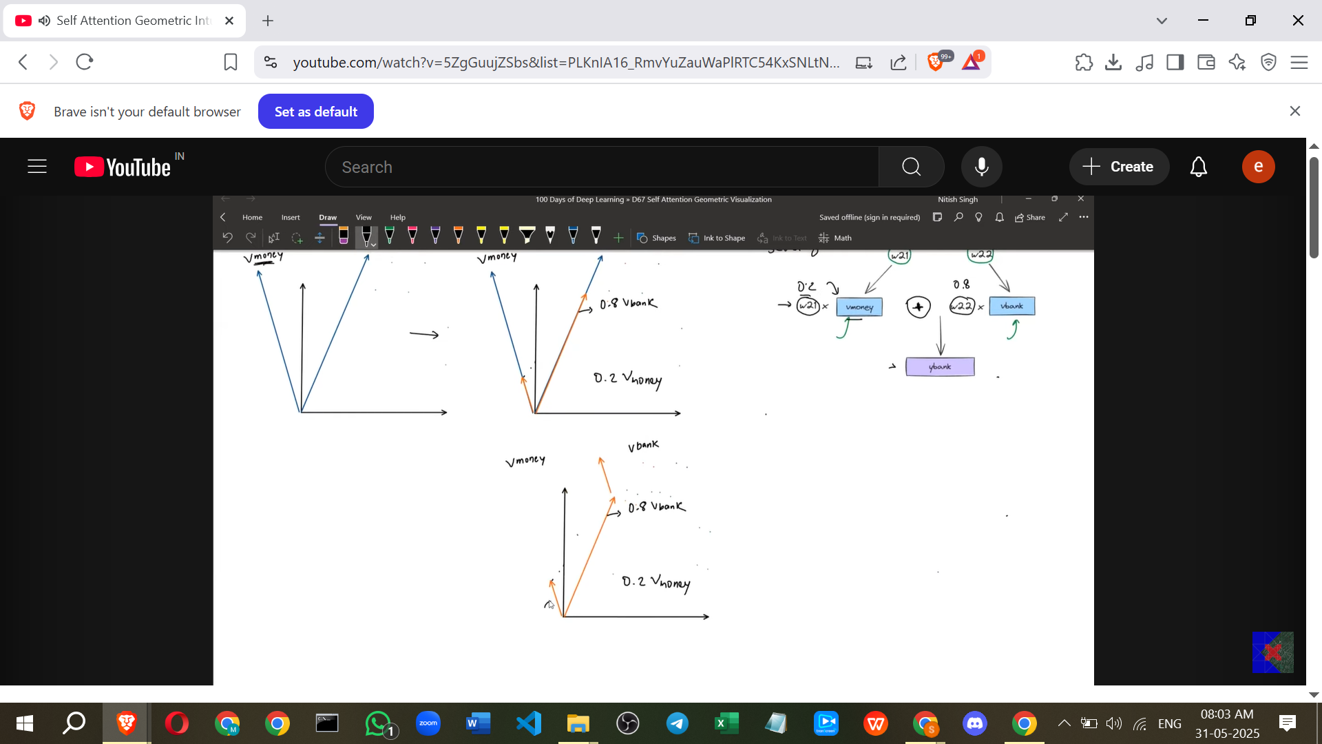

* + The **resultant vector** from this vector addition is the final **contextual embedding** for the target word (Y_Bank).

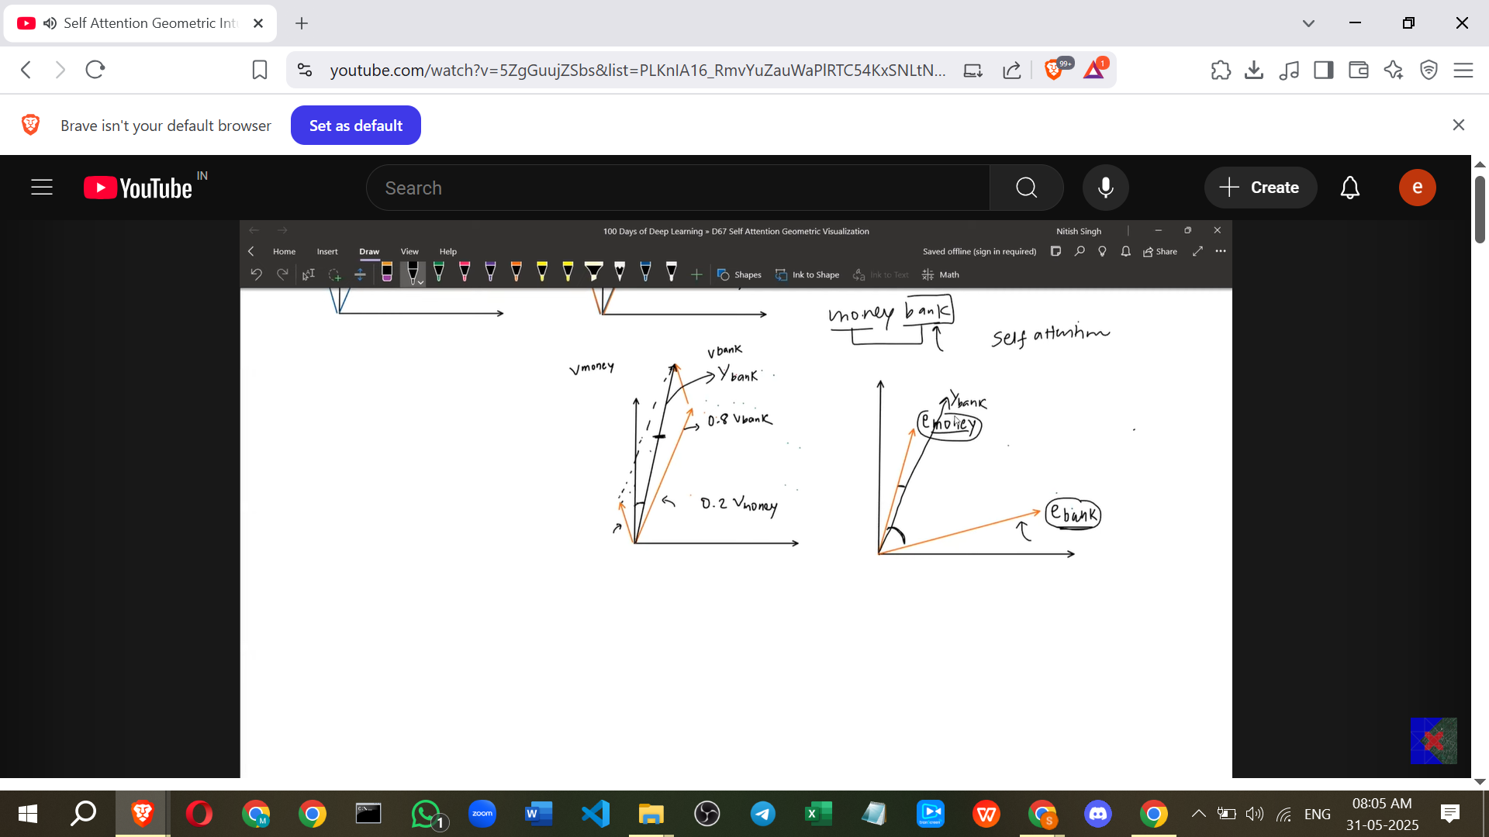

**Key Insight: Contextualisation and Gravity**

* Comparing the original embedding (E_Bank) and the new contextual embedding (Y_Bank), the Y_Bank vector is shown to have **moved in space** compared to E_Bank.
* Specifically, Y_Bank moves **closer to the embedding of the other word** (E_Money) in the sentence.
* Self-Attention is described as acting like **gravity**. In the "Money Bank" example, the "Money" word **pulled** the "Bank" word's contextual embedding towards it.
* This is the brilliance of Self-Attention: it generates embeddings based on the **context** – which other words are used in the sentence.
* The contextual embedding of "Bank" in "Money Bank" will be **different** from the contextual embedding of "Bank" in "River Bank". In "River Bank", "Bank" would be pulled towards the "River" embedding instead of the "Money" embedding.
* This means Self-Attention is **context-aware** and represents a word in terms of the other words available in the sentence.

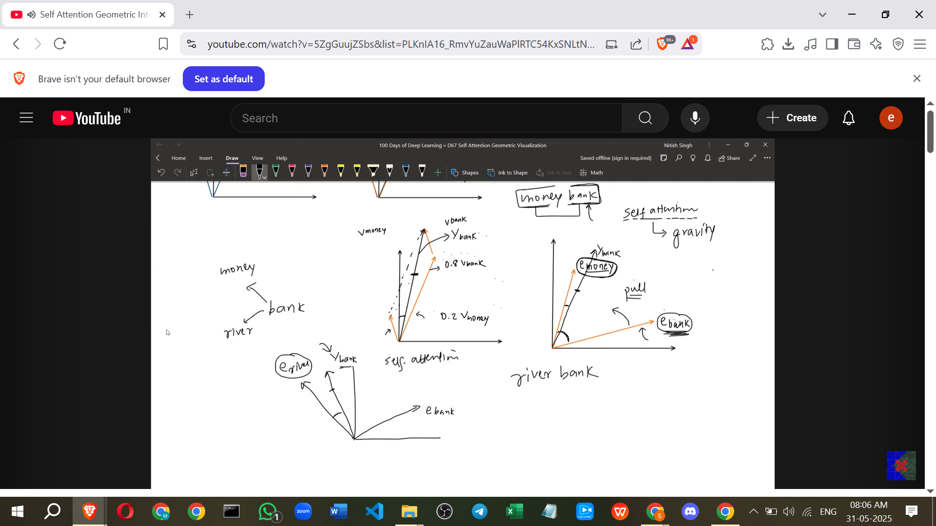

* The specific "pull" or contextual adjustment is based on the **patterns learned from the dataset** during training.

**Additional Points to Enhance Understanding (from my side)**

* **Why Geometry?** Visualising Self-Attention geometrically helps understand *how* the model incorporates context. It's not just abstract math; it's about vectors moving and interacting in a meaningful space.
* **Linear Transformations:** The Wq, Wk, Wv matrices perform linear transformations. Think of these as operations that can stretch, squish, rotate, or shear the original vectors. Each matrix transforms the input vector in a different way to give it a specific 'role' (Query, Key, or Value).
* **Roles (Q, K, V):** You can think of the process like this: The **Query** vector of the current word (e.g., Q_Bank) is used to **query** or look up relevant information from the **Key** vectors (K_Money, K_Bank) of all words in the sentence. The dot product measures how well a Key matches the Query. The scores determine how much importance is placed on the corresponding **Value** vectors (V_Money, V_Bank), which contain the 'content' or information to be aggregated.
* **High Dimensions:** While the visualisation is often 2D, the actual embedding and Q, K, V spaces are much higher dimensional (e.g., 256D). The geometric principles (dot product, vector addition, linear transformation) still apply, even if we can't easily visualise them. The clustering and pulling effects happen in this high-dimensional space.

**Examples**

* **"Bank" Ambiguity:** The classic example is the word "bank".
  + In "**Money bank**", the context (Money) makes the meaning clear (financial institution). Self-Attention will cause the contextual embedding of "bank" to move closer to the embedding space associated with finance, money, etc.
  + In "**River bank**", the context (River) makes the meaning clear (edge of a river). Self-Attention will cause the contextual embedding of "bank" to move closer to the embedding space associated with geography, nature, rivers, etc.
  + The geometric interpretation shows this: the Y_Bank vector is pulled towards E_Money in the first sentence and towards E_River (hypothetical) in the second sentence.
* **"Apple" Ambiguity:** Consider "Apple".
  + "**Apple released a new iPhone**." The context "released", "iPhone" signals the company. The contextual embedding of "Apple" will be influenced by these words, moving towards the 'technology company' region of the embedding space.
  + "**I ate an apple for lunch.**" The context "ate", "lunch" signals the fruit. The contextual embedding of "apple" will be influenced by these words, moving towards the 'food/fruit' region of the embedding space.

These examples illustrate how Self-Attention dynamically adjusts the meaning of a word based on its surrounding words, effectively creating context-aware embeddings.

=================================================\\\

# **Class 5. Why is Self Attention called "Self"? | Self Attention Vs Luong Attention in Depth Lecture |**

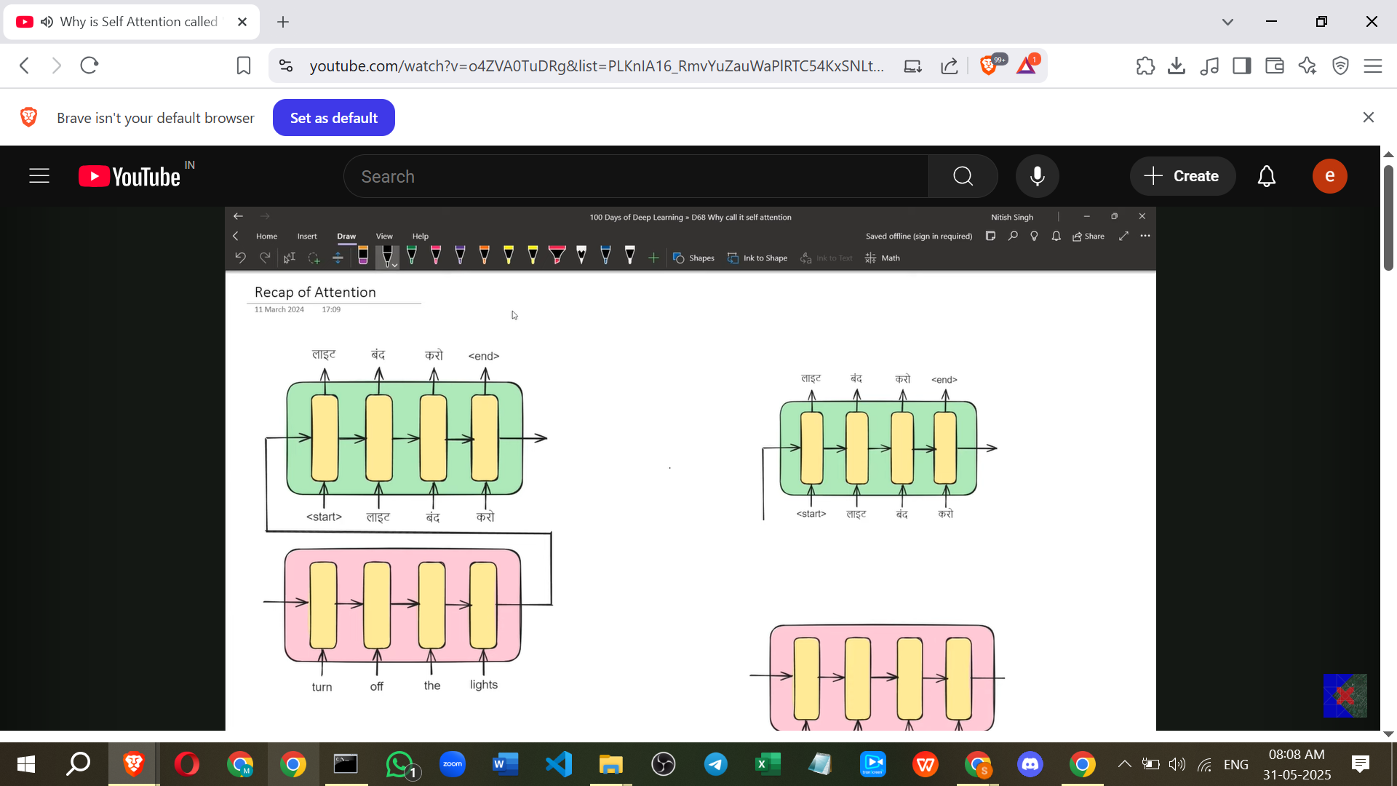

### **Notes on Self-Attention**

The video aims to explain **why Self-Attention is called "Self"** and is presented as an important interview question. The creator emphasises that spending time understanding Self-Attention is like sharpening an axe before cutting a tree (the Transformer architecture).

The plan is to first understand **why Self-Attention is considered an attention mechanism** at all, and then address why it's called "Self".

**1. Why is Self-Attention an Attention Mechanism?**

To understand this, we first revisit the standard Attention Mechanism, particularly in the context of Language Translation using an **Encoder-Decoder architecture**.

* **Problem with traditional Encoder-Decoder:** In the standard approach, the entire input sentence is processed by the encoder into a single **context vector** (like h4 in the example) which is supposed to summarise all information. This single vector is then passed to the decoder. A major problem arises with **long input sentences** (more than 30 words), as the single context vector struggles to effectively summarise all the necessary information, leading to a degradation in translation quality.
* **Solution: Attention Mechanism:** Instead of relying on a single context vector, the attention mechanism suggests sending **different context vectors** to the decoder at each output time step. For instance, to print the first word, a specific context vector (c1) is used; for the second word, a different one (c2) is used, and so on.
* **How Context Vectors (C) are Calculated:** Each context vector is a **weighted sum** of the encoder's hidden states (h). For example, c1 = α11*h1 + α12*h2 + α13*h3 + α14*h4. The weights (α) determine how much importance is given to each input word's hidden state when generating a specific output word.
* **How Weights (α) are Calculated:** The weights (αij) are obtained by applying a **softmax** function to corresponding **alignment scores** (eij). αij = Softmax(eij).
* **How Alignment Scores (e) are Calculated (Luong Attention Example):** In Luong Attention, the alignment score (eij) between the decoder's hidden state at time step 'i' (si) and the encoder's hidden state at time step 'j' (hj) is calculated using a **dot product**. eij = si ⋅ hj.
  + *Example:* To find e11, you calculate the dot product of s1 (decoder state at step 1) and h1 (encoder state for word 1). To find e12, it's s1 ⋅ h2, and so on.
  + These alignment scores quantify the similarity or relevance between the current output word being generated and each of the input words.

So, the standard attention mechanism calculates context vectors using a weighted sum of encoder states, where weights are derived from alignment scores obtained by comparing decoder states with encoder states.

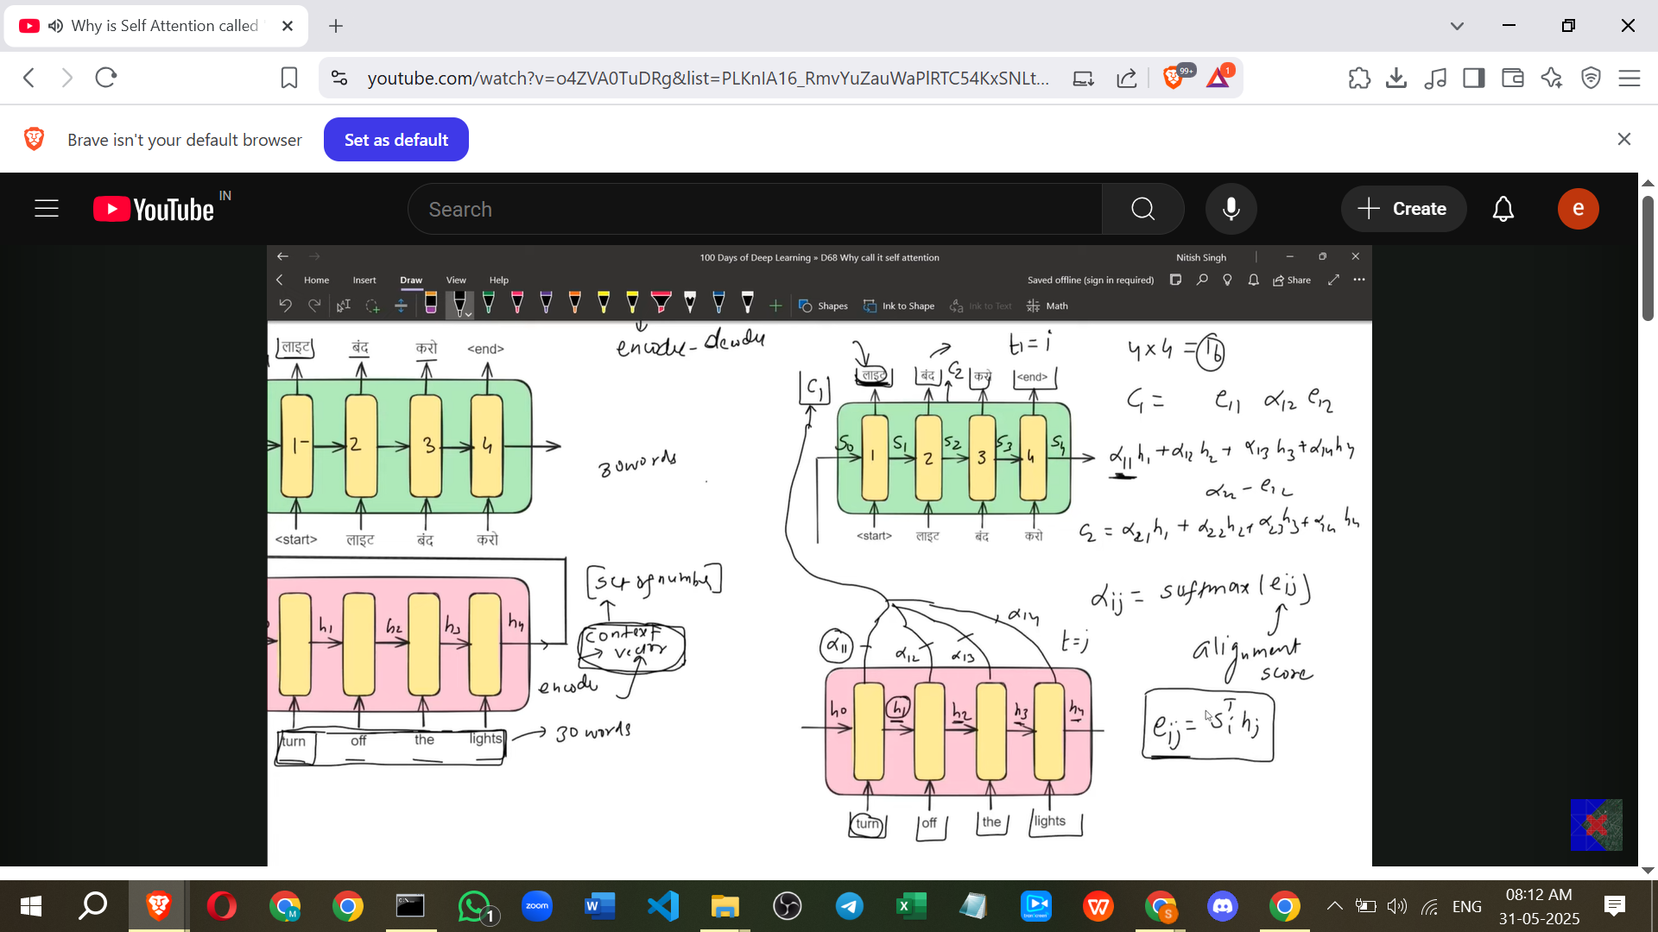

Now, let's look at Self-Attention and compare it.

* **Self-Attention Setup:** Unlike the Encoder-Decoder setup with two sequences (input and output), Self-Attention works with a **single sequence**. The example used is just the sentence "Turn off the lights".
* **Goal in Self-Attention:** To generate **contextual embeddings** for each word in the sequence. These contextual embeddings incorporate information from other words in the *same* sentence.

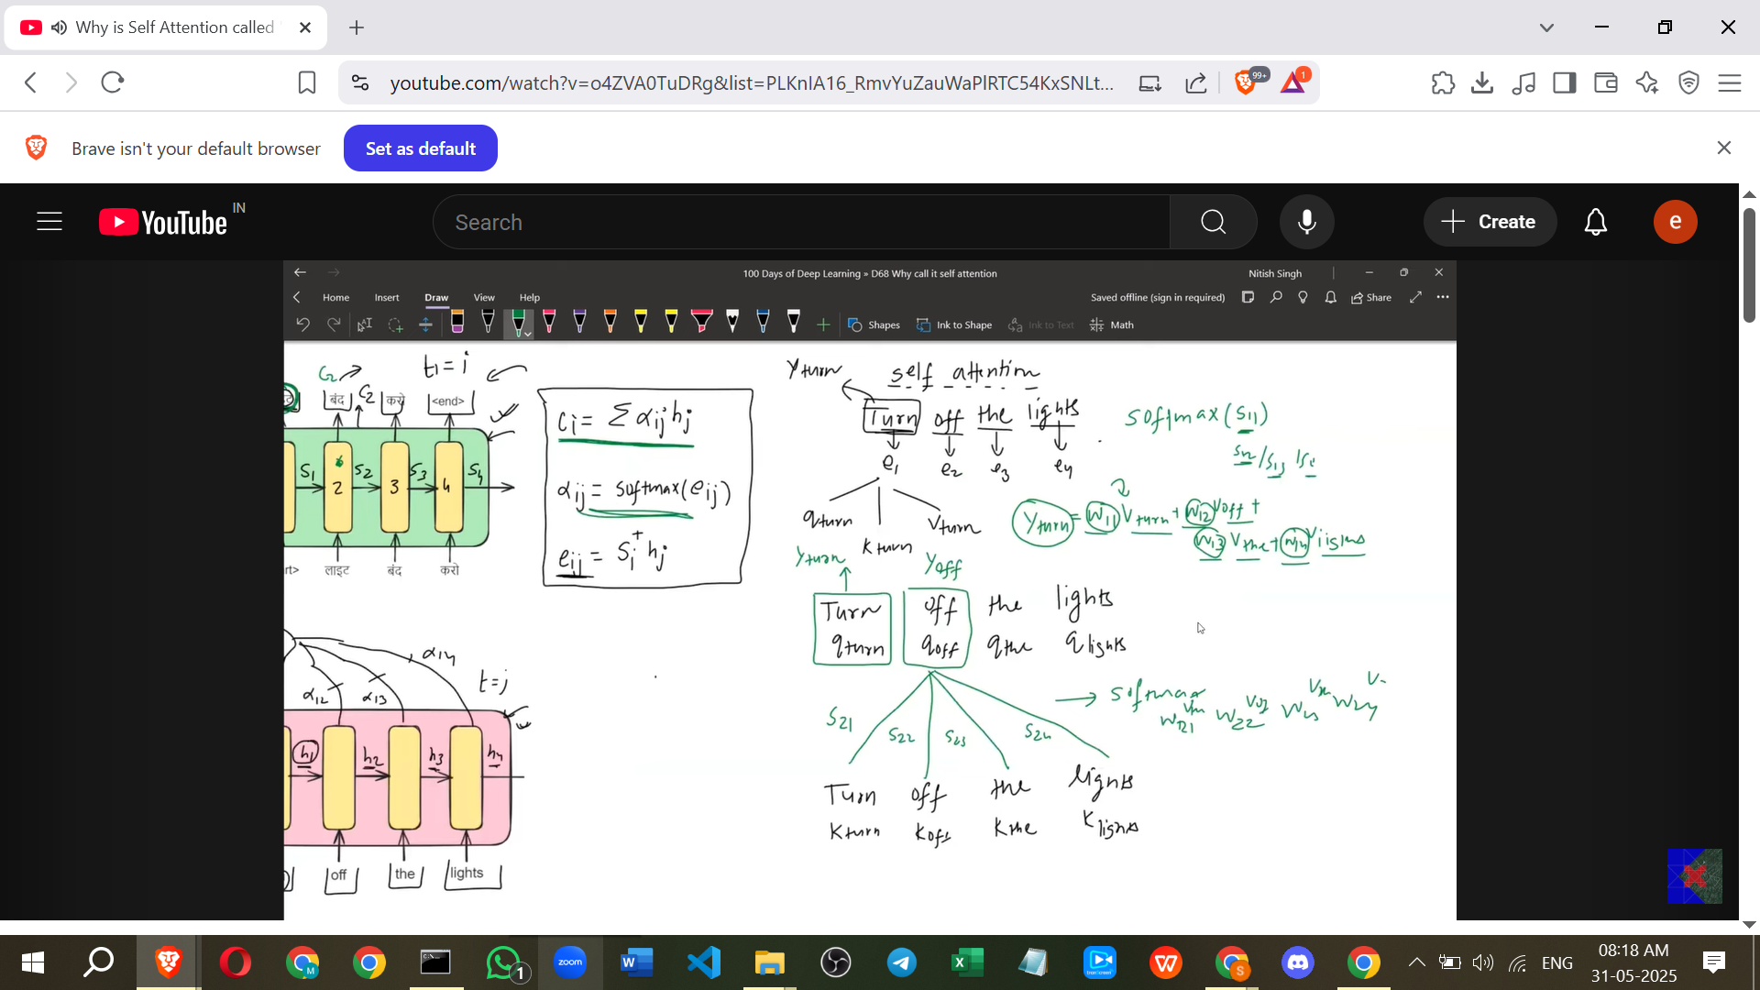

* **Process in Self-Attention:**
  + For each word's embedding, create three new vectors: a **Query (Q)** vector, a **Key (K)** vector, and a **Value (V)** vector. For "Turn", you get Q_turn, K_turn, V_turn; for "Off", you get Q_off, K_off, V_off, etc..
  + To generate the contextual embedding (Y) for a word (e.g., "Turn"), calculate a **weighted sum** of the **Value (V) vectors** of *all* words in the sequence. Y_turn = w11*V_turn + w12*V_off + w13*V_the + w14*V_lights. (Note: The source uses 'w' for weights in Self-Attention, similar to 'α' in Luong).
  + **How Weights (w) are Calculated:** The weights (wij) are obtained by applying a **softmax** function to corresponding **similarity scores** (sij). wij = Softmax(sij).
  + **How Similarity Scores (s) are Calculated:** The similarity score (sij) between the *current word's Query (Qi)* and *another word's Key (Kj)* is calculated using a **dot product**. sij = Qi ⋅ Kj.
    - *Example:* To find s11 (for Y_turn and V_turn), you calculate the dot product of Q_turn and K_turn. To find s12 (for Y_turn and V_off), you calculate the dot product of Q_turn and K_off.

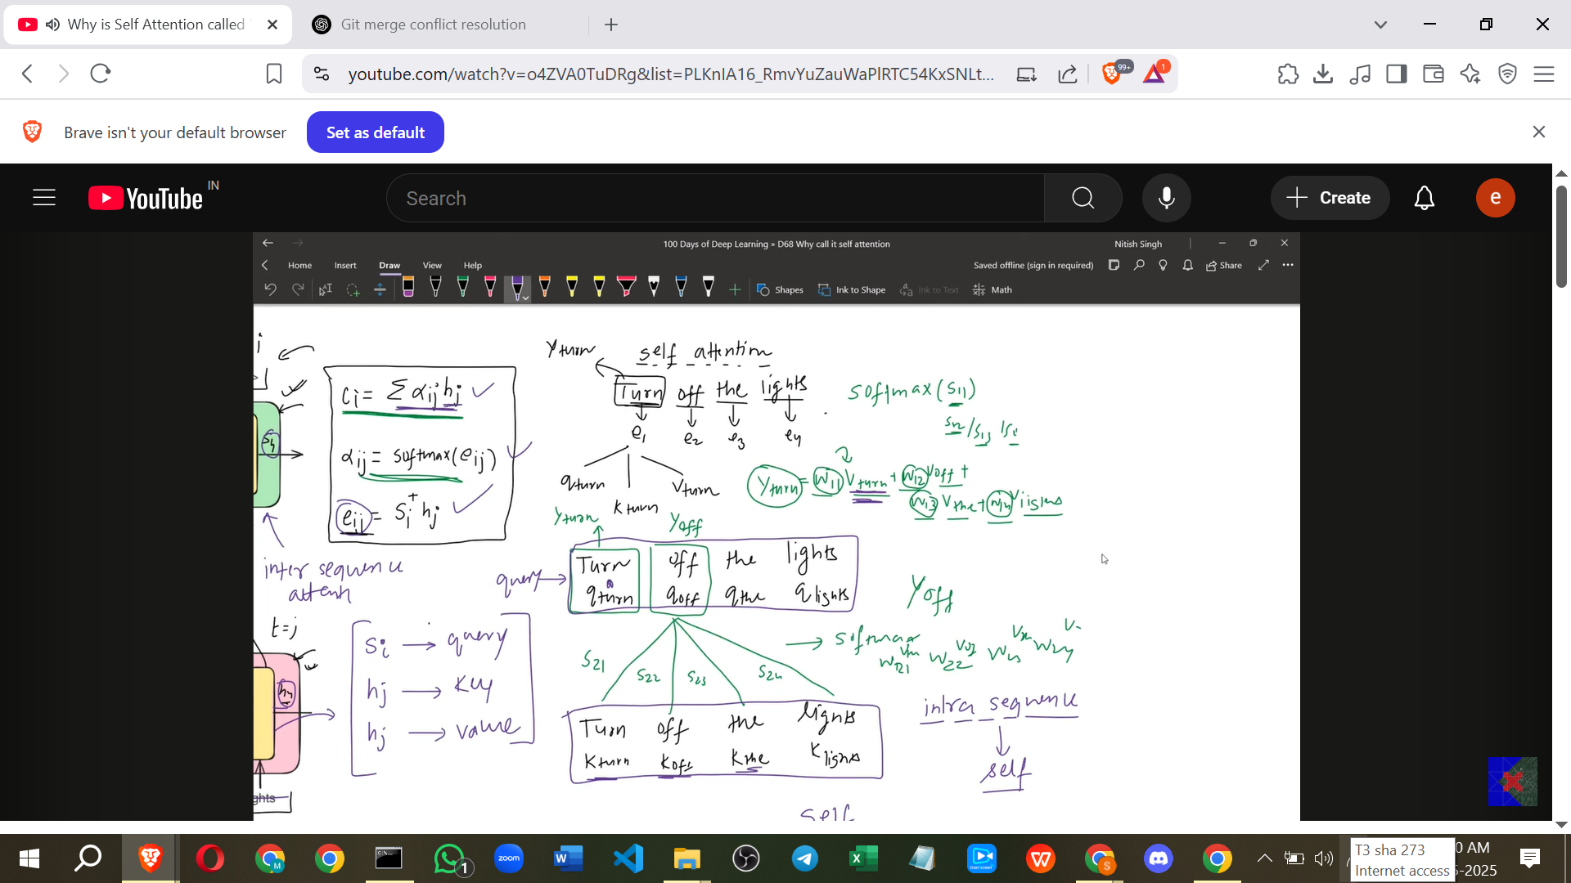

* **Drawing Parallels:**
  + The Decoder's hidden state (s) in Luong is conceptually similar to the **Query (Q)** vector in Self-Attention. It represents what information you are looking for.
  + The Encoder's hidden state (h) in Luong, when used to calculate alignment scores, is similar to the **Key (K)** vector in Self-Attention. It helps determine relevance or similarity.
  + The Encoder's hidden state (h) in Luong, when used in the weighted sum, is similar to the **Value (V)** vector in Self-Attention. It holds the actual information that is being summed up.
  + The Alignment scores (e) in Luong are similar to the **Similarity scores (s)** in Self-Attention.
  + The weights (α) in Luong are similar to the **weights (w)** in Self-Attention.
  + The Context Vector (C) in Luong is similar to the **Contextual Embedding (Y)** in Self-Attention.

Because the underlying mathematical formulation involves the same steps – **calculating scores (Query ⋅ Key)**, normalising scores using **softmax** to get **weights**, and using these weights to take a **weighted sum of Value vectors** – Self-Attention is indeed an attention mechanism, even though the architecture looks different.

**2. Why is it Called "Self"?**

This is the key distinction.

* Standard attention mechanisms like Luong or Bahdanau calculate attention **between two *different*** sequences. For example, finding the alignment between words in an English sentence (input) and words in a Hindi sentence (output) during translation. This is referred to as **Inter-sequence Attention**.
* Self-Attention, on the other hand, calculates attention **within the *same*** sequence. The Query, Key, and Value vectors all come from the *same* input sequence. It allows each word in the sequence to attend to (and learn from) every other word in the *same* sequence. This is referred to as **Intra-sequence Attention**.

Therefore, it's called "**Self**" Attention because the attention is computed within the sequence itself – a word attends to other words in the "self" or same sequence.

Understanding Self-Attention thoroughly is crucial for subsequent topics like Multi-Head Attention, Positional Encoding, and ultimately, the Transformer architecture.

===================================

# **Class 6. What is Multi-head Attention in Transformers | Multi-head Attention v Self Attention | Deep Learning**

**Recap: Self-Attention**

* Self-Attention is a technique used to generate **contextual embeddings**.

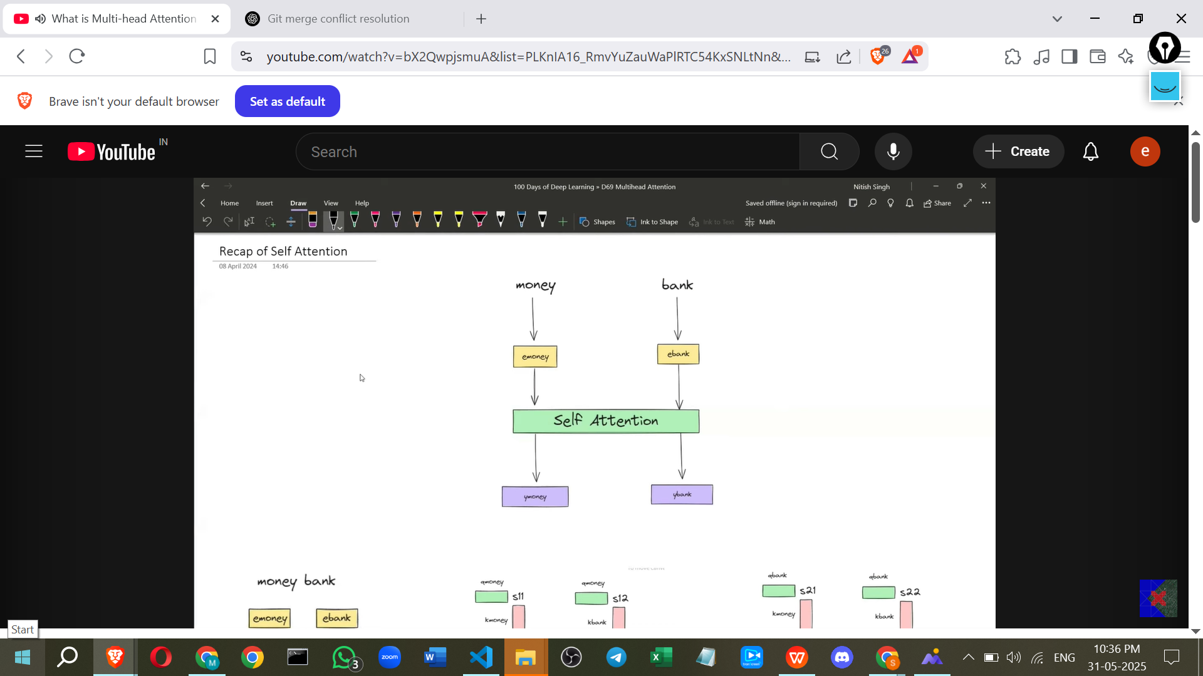

* Unlike static embeddings (like those from Word2Vec), which have a single value for a word regardless of context, contextual embeddings change based on the sentence they appear in.
* For example, the word "bank" would have different embeddings when used with "money" versus "river".

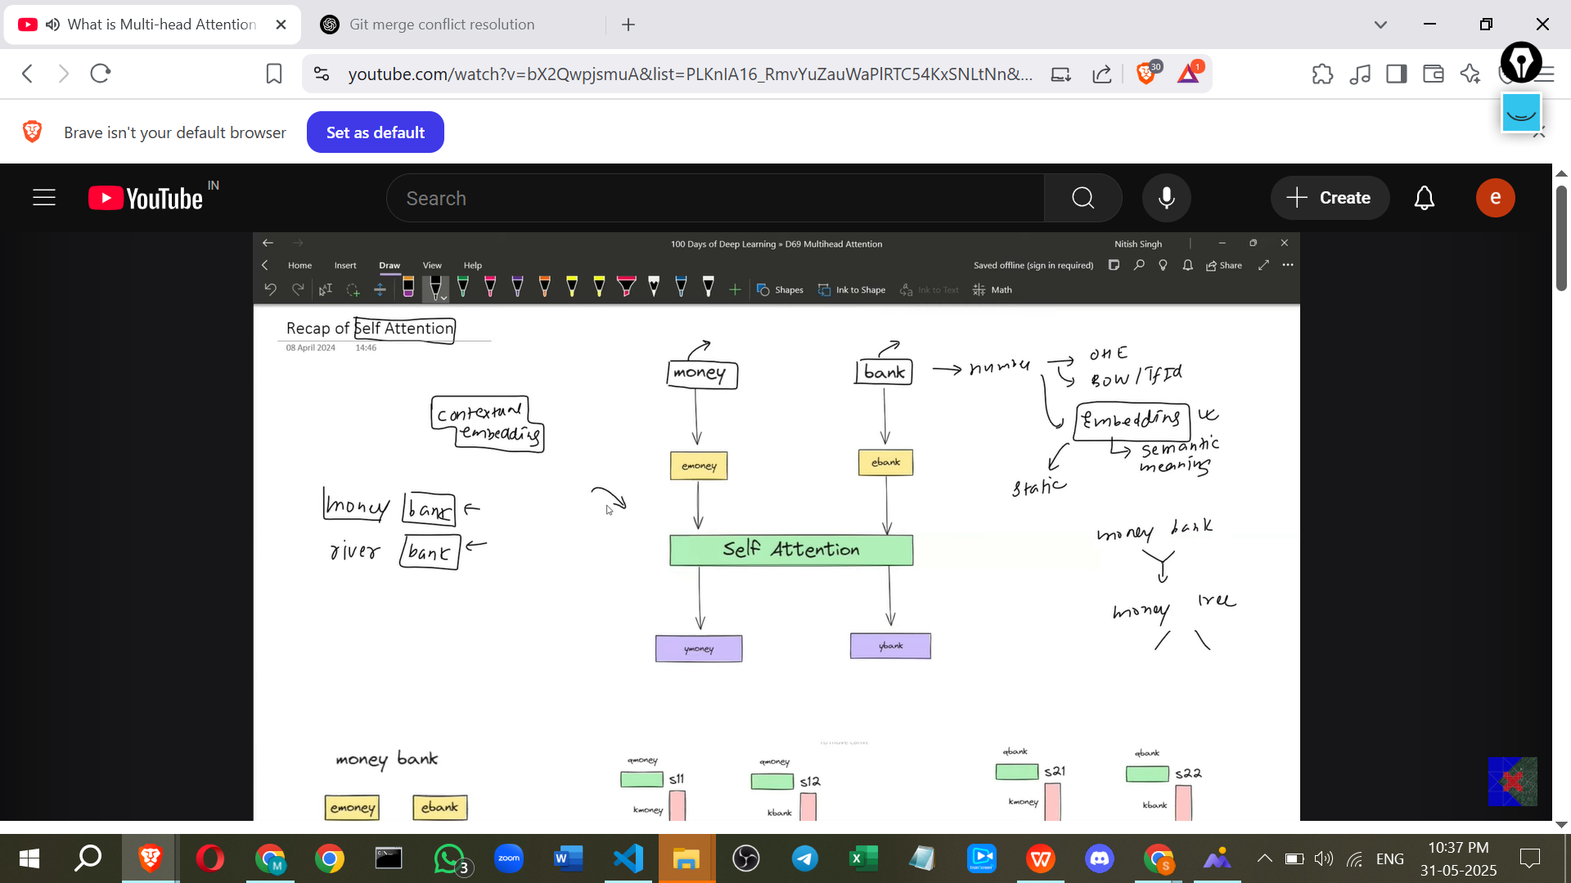

* Self-Attention achieves this by considering the relationship of each word to every other word in the sentence.
* The process involves:
  + Taking the input embeddings for each word.
  + Generating **Query (Q), Key (K), and Value (V) vectors** for each word by multiplying the word embedding by learned weight matrices (Wq, Wk, Wv).
  + Calculating **similarity scores** between the Query vector of one word and the Key vectors of all other words (including itself) using a dot product.
  + Scaling these scores.
  + Applying a **Softmax** function to normalise the scores into weights. These weights indicate how much attention each word should pay to others.
  + Multiplying the Value vectors by these weights and summing them to get the **contextual embedding** for the word.

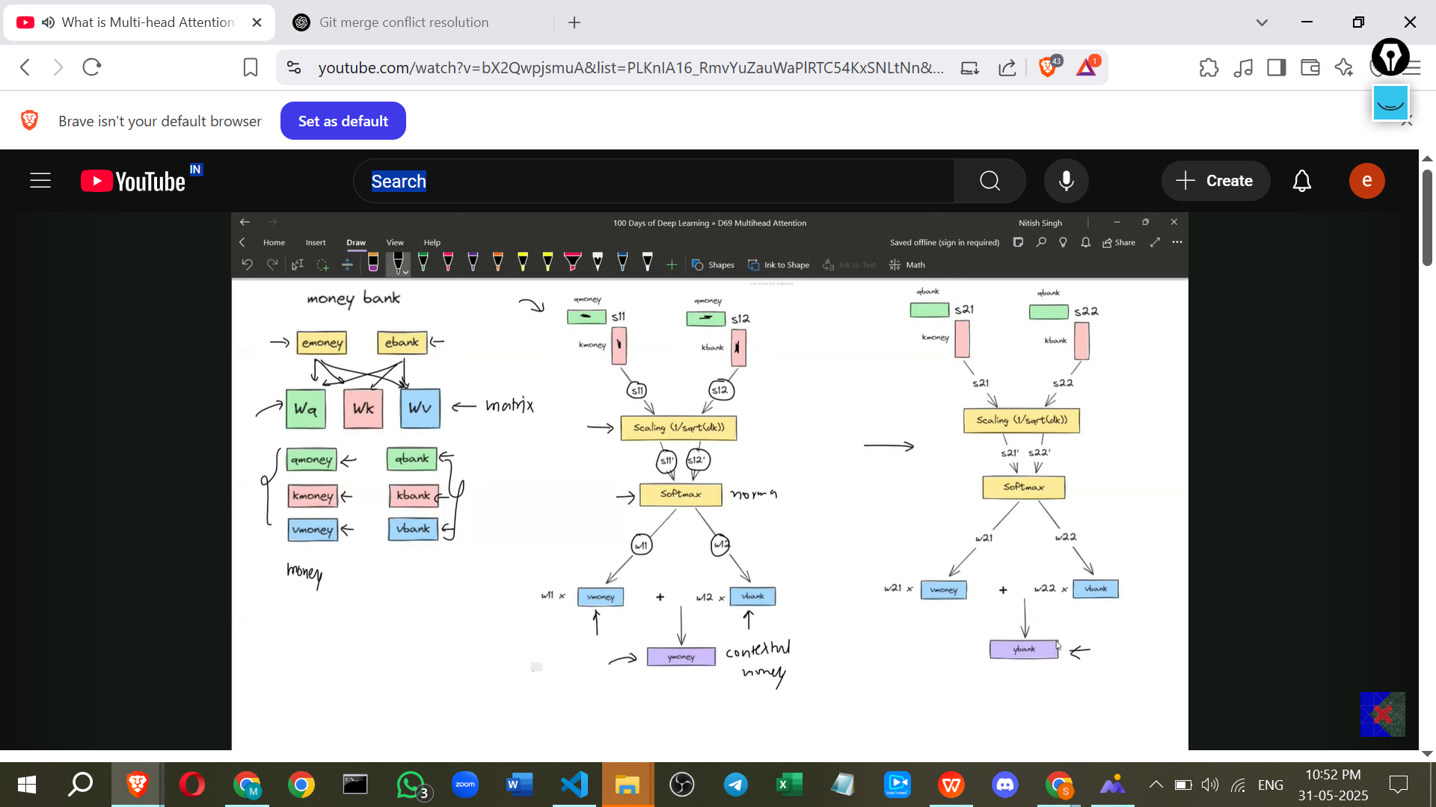

**Problem with Single Self-Attention**

* The main problem with standard Self-Attention (or a "**single head**") is that it can only capture **one perspective** or interpretation of a sentence or document at a time.
* **Example:** Consider the sentence "The man saw the astronomer with a telescope". This sentence is ambiguous and has at least two possible meanings:
  1. The man used a telescope to see the astronomer (the man has the telescope).
  2. The man saw an astronomer who was holding a telescope (the astronomer has the telescope).

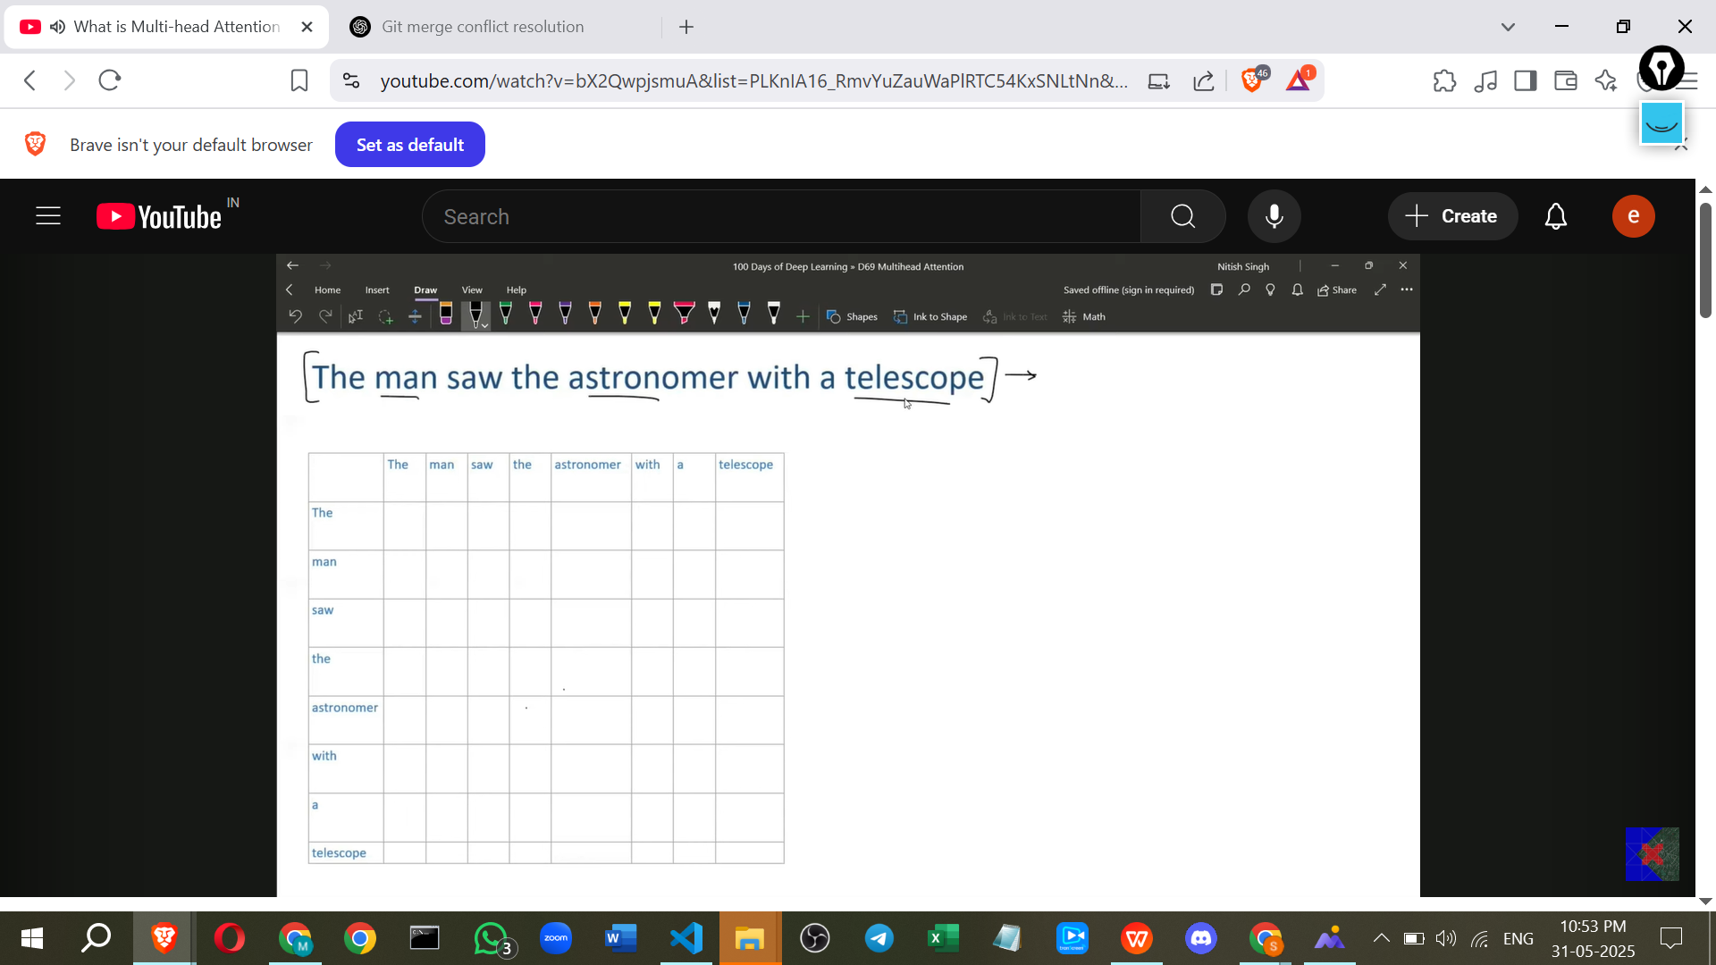

* Self-Attention calculates similarity scores between all word pairs. With a single head, it might yield high scores between "man" and "telescope" (capturing the first meaning) *or* high scores between "astronomer" and "telescope" (capturing the second meaning), but typically not both interpretations strongly in the same output.
* In Natural Language Processing tasks like document summarisation, it's often necessary to capture **multiple perspectives** or hidden meanings from the text. A single Self-Attention head struggles with this.

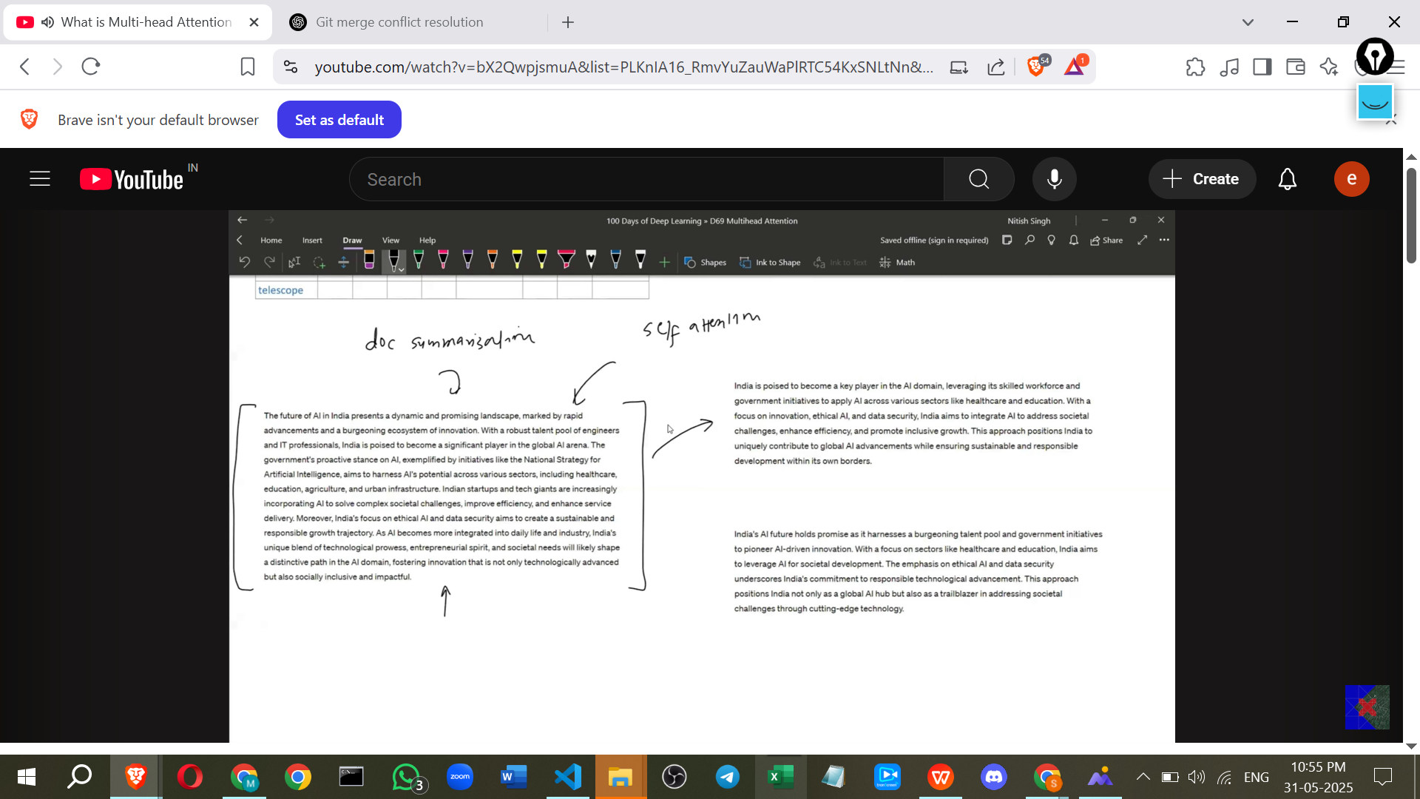

**Multi-head Attention: The Solution**

* Multi-head Attention is a mechanism designed to overcome the limitation of single Self-Attention by allowing the model to **process information from different perspectives simultaneously**.
* It does this by running **multiple Self-Attention modules (called "heads") in parallel**.
* Since more than one head is used, it's called "Multi-head" Attention.

**How Multi-head Attention Works**

* Instead of using just one set of weight matrices (Wq, Wk, Wv), Multi-head Attention uses **multiple, independent sets of these matrices** – one set for each head.
* **Example with two heads:** If you have two heads, you would have two sets of matrices: (Wq1, Wk1, Wv1) for the first head and (Wq2, Wk2, Wv2) for the second head. There's no restriction on the number of heads you can use.

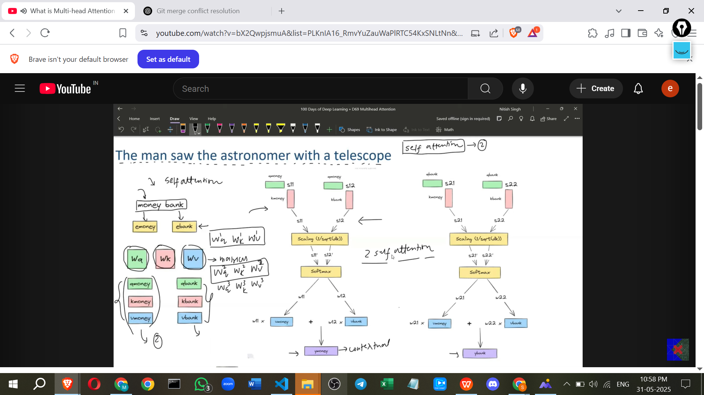

* For each input word embedding, the embedding is multiplied by **each head's set of weight matrices**.
* This results in **multiple sets of Q, K, and V vectors** for each word – one set for each head. So, for the word "Money" with two heads, you would get (Q_Money_1, K_Money_1, V_Money_1) and (Q_Money_2, K_Money_2, V_Money_2).

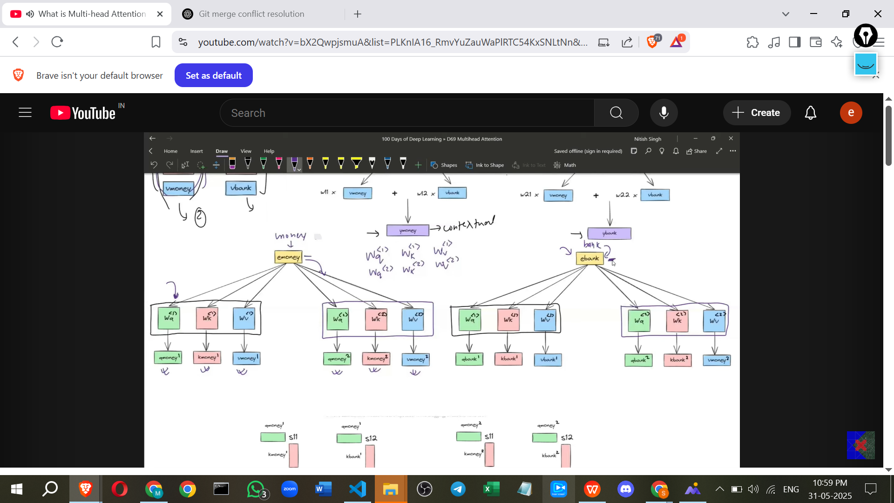

* Each head then performs the standard Self-Attention calculation **independently** using its own sets of Q, K, and V vectors.
* This produces **multiple sets of contextual embeddings** (outputs) for each word – one output from each head. If you have two heads, you get Output_Money_1 and Output_Money_2 for the word "Money".

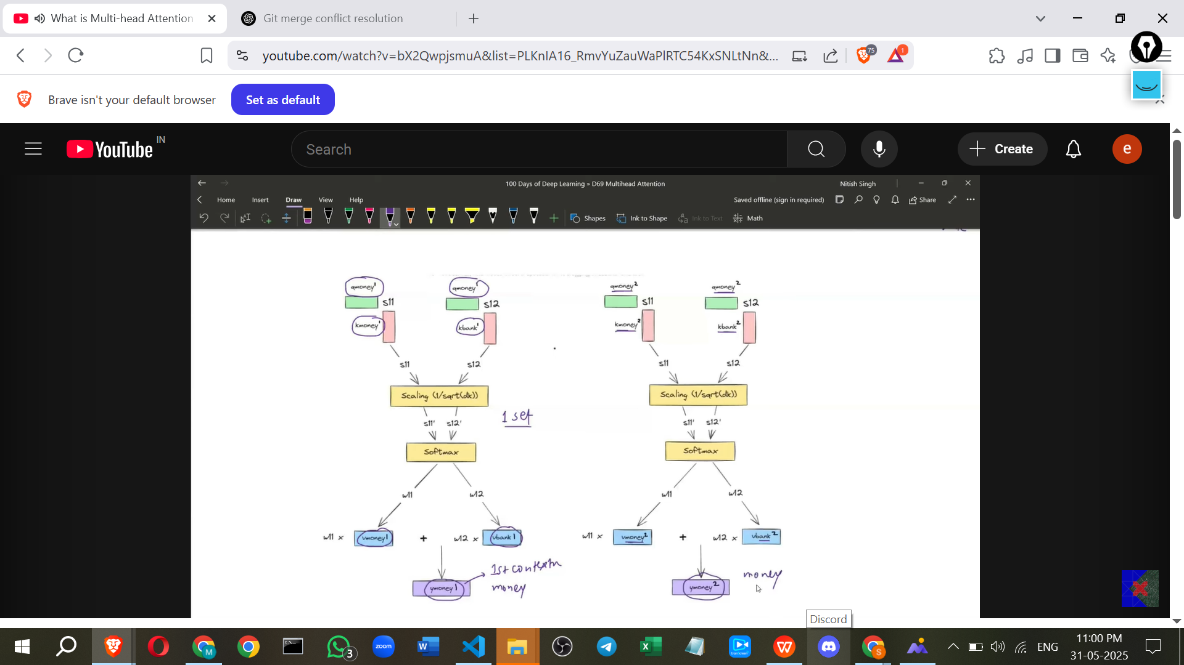

* These multiple output vectors for each word (one from each head) are then **concatenated** (joined together).
* **Example:** If Head 1 produces a 4-dimensional vector for "Money" and Head 2 produces a 4-dimensional vector for "Money", concatenating them would result in an 8-dimensional vector.
* This concatenated vector contains the combined outputs from all the heads, representing information captured from different perspectives.
* Finally, a **linear transformation** is applied to the concatenated vector using another learned weight matrix (W_output).
* The purpose of this final linear transformation is to combine the concatenated outputs in a way that produces a final output vector with the desired dimension, typically the same dimension as the original input embeddings.
* This final linear transformation also helps to **balance the importance** of the different perspectives captured by each head.

**Implementation Details from "Attention Is All You Need" Paper**

* The original Transformer paper (Attention Is All You Need) used **eight Self-Attention heads**.
* Input embeddings in that paper were 512 dimensions.
* To manage computation, they reduced the dimension of the Q, K, and V vectors *within each head*. Instead of the full 512 dimensions, each head worked with vectors of 64 dimensions (512 / 8 heads = 64).

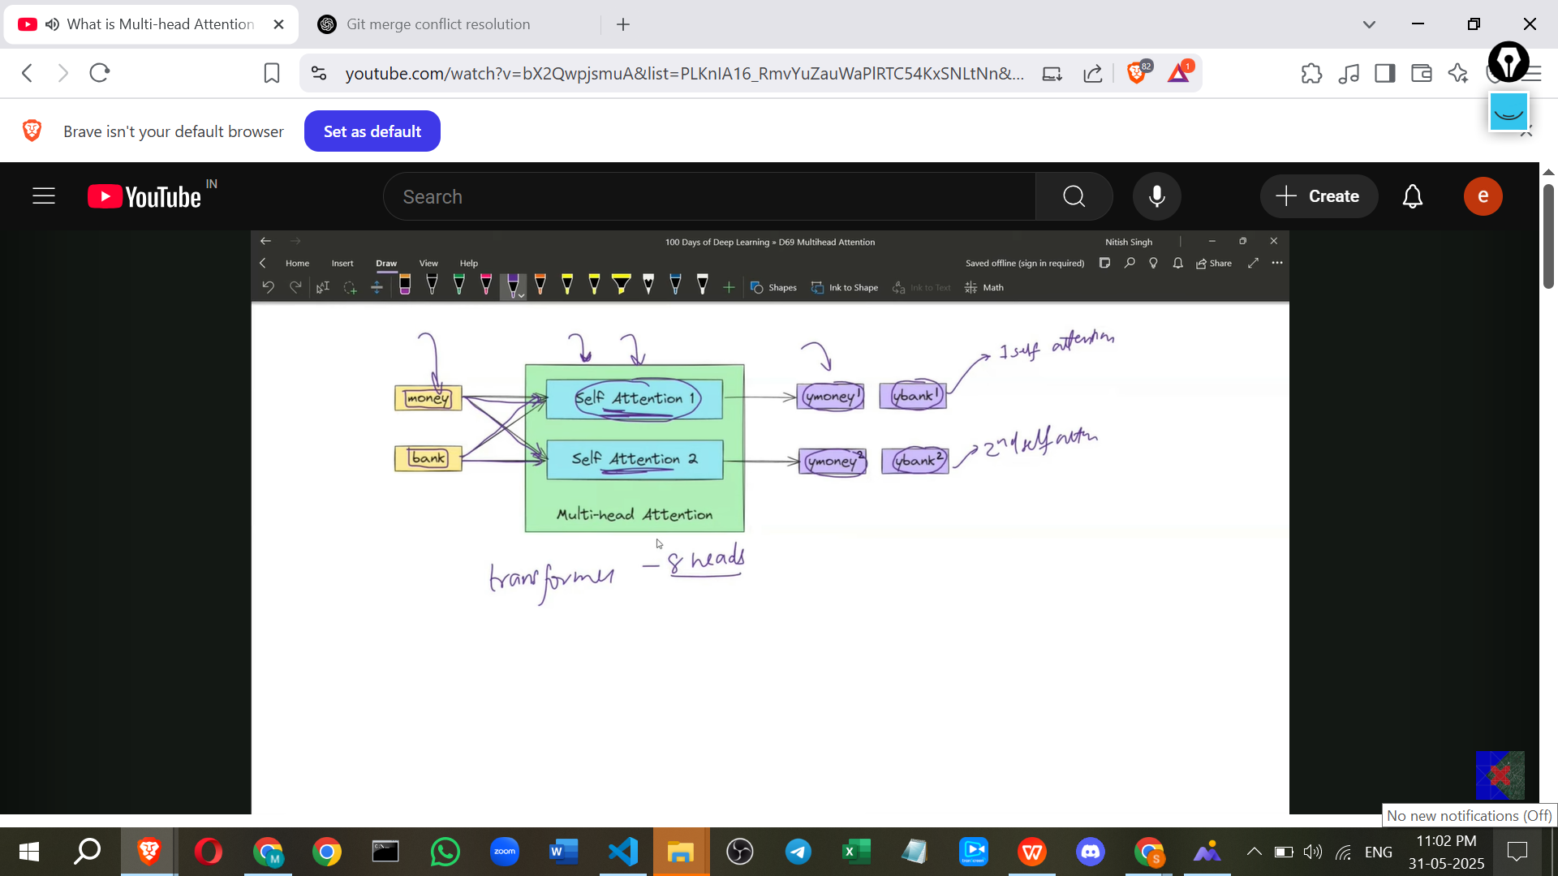

* The weight matrices (Wq, Wk, Wv) for each head were therefore shaped to project the 512-dimensional input embedding down to 64 dimensions (e.g., 512x64).
* After each head calculated its output (a 64-dimensional vector per word), these outputs were concatenated. Since there were 8 heads, each producing a 64-dimensional vector, the concatenated vector was 8 * 64 = 512 dimensions.
* The final linear transformation used a W_output matrix of shape 512x512. This returned the final output vector for each word to the original 512 dimensions.
* This dimensionality reduction within heads ensured that the **overall computational cost** of Multi-head Attention with 8 heads was similar to that of a single Self-Attention head working with the full 512 dimensions, while gaining the benefit of multiple perspectives.

**Benefits of Multi-head Attention**

* Captures **multiple perspectives** or relationships within the data simultaneously.
* Allows the model to focus on different aspects of the relationships between words.
* **Example:** As shown in the visualisation, one head might capture the "man-telescope" relationship, while another head captures the "astronomer-telescope" relationship in the ambiguous sentence.
* Leads to more robust and expressive representations of the input sequence [Implicit in source, not explicitly stated as a benefit *from* the source].

**Additional Points for Leaning (Not from Sources)**

* Imagine each "head" is like a different expert looking at the same sentence. One expert might focus on who is performing the action, another on who has the object, another on temporal relationships, etc. Multi-head Attention allows the model to gather insights from all these different "experts" simultaneously.
* The final linear transformation combines the "opinions" of these experts into a single, informed perspective. The learned weights in W_output determine how much weight is given to each expert's perspective.